POOLE MARITIME TRUST IN CONJUNCTION WITH THE COASTAL CRUISING ASSOCIATION
POOLE HARBOUR EXPLORER CRUISE TUESDAY SEPTEMBER 9TH 2025
Aboard M.V. “DORSET QUEEN”
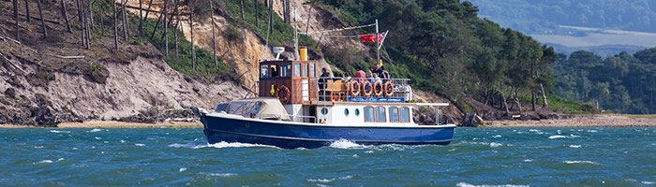
09.30 Poole Quay – Embarkation from 09.15 – opposite the foot of the High Street
10.45 – 11.45 Wareham Quay – an hour ashore to explore the historic town
12.45 – 13.00 Lake Pier – a brief photo opportunity at this historic site
13.00 -14.30 Extended harbour and islands cruise – with a fully informed commentary
14.30 – 15.30 Royal Motor Yacht Club – Land for Tea/Coffee & Cake - a brief history will be presented.
16.00 Poole Quay (Approx) – Passenger dis-embark
Fare inclusive of Royal Motor Yacht Club refreshments £48
NOTES
- “DORSET QUEEN” is a registered historic ship that has been restored to a very high standard.
- The boat is NOT wheelchair friendly.
- “DORSET QUEEN” has ample covered accommodation & a licensed snack bar and toilet facilities
- Passenger numbers limited for customer comfort.
PASSENGERS CONVEYED SUBJECT TO THE CONDITIONS OF CARRIAGE OF DORSET CRUISES
.……………………………………………………………………………………………………………………………………………………
BOOKING FORM

NAME :____________________________ Address :_____________________________________

__________________________________E-Mail :_______________________________________

Tel :________________. Number of tickets required :____
INDICATE MODE OF PAYMENT : POST/BACS (DELETE AS NECESSARY)
BY POST : Please complete this form and enclose a cheque payable to the COASTAL CRUISING ASSOCIATION to Peter Lamb : 11 Uplands Road, Bournemouth BH8 9SR. Be sure to enclose a SAE in order tickets may be issued.
BACS PAYMENT : Please make payment directly into the CCA bank and e-mail a copy of this form to : swade@breathemail.net . A confirmation mail will be sent and tickets issued at the gangway. Bank details : BANK OF SCOTLAND Account title : The Coastal Cruising Association Sort Code : 80-06-74 Account number : 00268983 Please provide reference : POOLE
FOR FURTHER INFORMATION – PLEASE E-MAIL : karllamb1@aol.com OR CALL 07718934425

