MONDAY AUGUST 26TH
SPECIAL EXCURSION ABOARD
“SHIELDHALL”
EUROPE’S LARGEST REMAINING OPERATIONAL STEAMSHIP
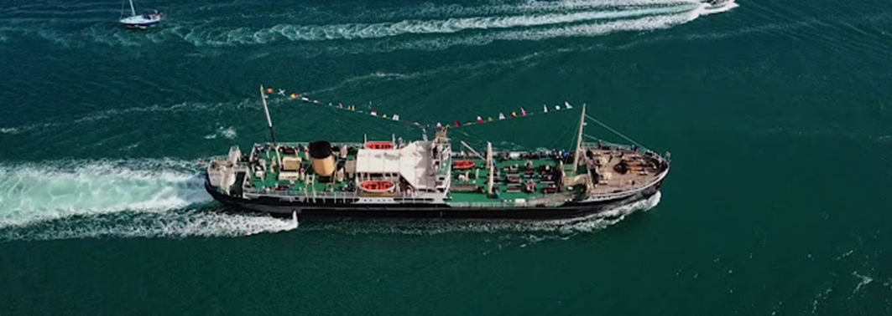
SAIL FROM SOUTHAMPTON TO POOLE WITH SPECIAL COACH FROM POOLE & BOURNEMOUTH – PASSENGERS ENJOY DISCOUNTED CRUISE RATES
EXPERIENCE THE GOLDEN AGE OF STEAM ABOARD THE REMARKABLE “SHIELDHALL”
WIDE OPEN DECKS, COMFORTABLE SALOON, BAR & REFRESHMENTS.
PASSENGERS HAVE FULL ACCESS TO THE WONDERS OF THE ENGINEROOM AND BRIDGE
TIMES
Coach departs : Poole – Old Orchard (adjacent to the Quay) 08.00, Westbourne (Bingo Hall) 08.15, Wessex Way (Bus pull-in alongside the golf course) 08.25.
SHIELDHALL : Sails from Southampton (Berth 110) at : 10.00 – Due Poole 16.00
FARES : Combined coach and boat : £59.50, Cruise only £49.50 (If booked through the C.C.A.)
Coach only (for pre-booked boat passengers) £12.00
………………………………………………….BOOKING FORM…………………………………………….
NAME…………………………………. ADDRESS………………………………………………………………………………….
………………………E-MAIL :…………………………………….TEL (Mob if poss)…………………………………………..
I/We will be joining the coach at :……………………………………………
Please send me……….. Tickets for the coach and cruise @ £59.50 = £……………………

Please send me…….tickets for the coach only @ £12 = £…………

Please send me …..tickets for the cruise only @ £49.50 = £………..
Tickets : Please make cheques payable to : COASTAL CRUISING ASSOCIATION and send (along with a SAE) to: Peter Lamb, 11 Uplands Road, Bournemouth BH8 9SR. For more information, please e-mail : karllamb1@aol.com or call : 07718934425 (please leave message if no response).
Coach patrons MUST indicate boarding point.
AND DON’T FORGET THE STAMPED ADDRESSED ENVELOPE.
EXCURSION PROMOTED, JOINTLY, BY THE COASTAL CRUISING ASSOCIATION AND POOLE MARITIME TRUST

