FRIDAY MAY 10th
DELIGHTFUL FIVE HOUR KENNET & AVON CANAL CRUISE FROM
BRADFORD ON AVON
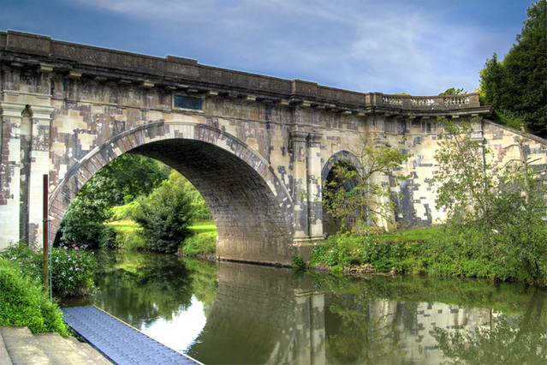
Depart 10.00 return 15.00 – 15.30 (depending upon canal traffic)
Cruise the very scenic Kennet and Avon canal aboard the “Barbara McLellan” from BRADFORD WHARF BA15 1LE to the historic and dramatic DUNDAS AQUADUCT where members may dis-embark for a photo opportunity and exercise. The boat is enclosed and has light refreshments (card payment preferred) and toilet facilities. Fare: £28 for members & £29 for guests. Snacks and light packed lunches many be purchased prior to embarkation from the adjacent canal café. Passengers board and disembark using steps. There is a lift for anybody with mobility issues.
Nearest car park is Baileys Barn BA15 1BW (off Moulton Drive).
For passengers arriving by rail : Bradford On Avon Station is a 10-15 minute stroll from the departure point.
TOILETS : Whilst there is a toilet aboard, the toilet block by the boat is currently closed. Nearest public toilets are in Station Car Park, 56 Frome Rd, Bradford-on-Avon, Wiltshire BA15 1LA – three mins drive away or a return walk of approx 25 mins. Boarding begins 20 mins prior to departure.
To book and for more details please contact Peter Lamb at karllamb1@aol.com or by Tel : 07718934425.
Please enclose an SAE and a mobile (if possible) phone number.
…………………………………………………….BOOKING FORM………………………………………
Name……………………………………..Address……………………………………………………………………………
E-Mail :……………………………………………………… Tel (Mob if poss)…………………………………………..
Please send me ……tickets @ £28 & ……tickets @ £29 = £………..
MAKE CHEQUE PAYABLE TO THE COASTAL CRUISING ASSOCIATION
& POST TO : K.P. LAMB, 11 UPLANDS ROAD, BOURNEMOUTH BH8 9SR
PLEASE DON’T FORGET TO ENCLOSE A STAMPED ADDRESSED ENVELOPE.
CRUISE JOINTLY PROMOTED BY POOLE MARITIME TRUST & THE COASTAL CRUISING ASSOCIATION

