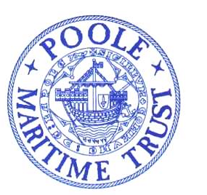
AFTERNOON TEA CRUISE AROUND POOLE HARBOUR
ABOARD THE DELIGHTFUL
“DORSET QUEEN”
(A registered historic ship)
THURSDAY JUNE 13th
13.30 – 15.00
FARE : £35
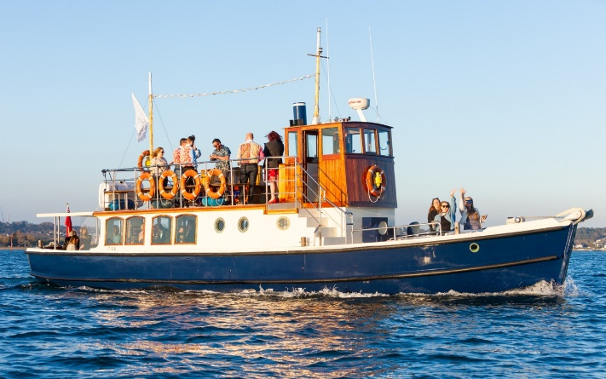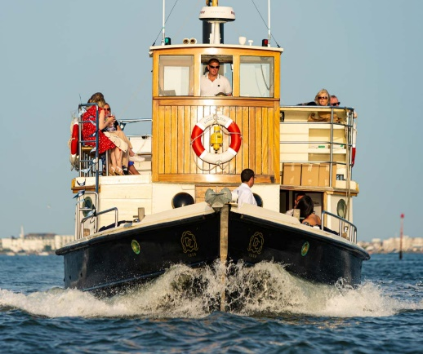
- Afternoon high tea cruise aboard The Dorset Queen a 1938 vintage Motor Yacht
- Welcome glass of chilled Prosecco
- Enjoy a high tea comprising homemade sandwiches, scones and cakes served with Dorset tea
- Cruise around the back of Poole's five islands
- If wind conditions on the day are suitable the cruise will also take you into Poole Bay
- On the return to Poole Quay you will pass Millionaire's Row at Sandbanks.
- Soul and Jazz background music will be played as you cruise
TICKETS ARE LIMITED
…………………………………………………………………………..BOOKING FORM…………………………………………………………………..
TICKETS MAY BE PURCHASED BY POST OR ONLINE
Name :………………………………………………………. Address :…………………………………………………………………………………………………………….
e-mail : ………………………………………………………. Phone (Mob if poss) :………………………………………………………………………………………..
Please send me ……. Tickets @ £35 for the afternoon tea cruise on Thursday June 13. Total £……………………..
By Post : Enclose a cheque made payable to POOLE MARITIME TRUST with a stamped addressed envelope to :
Poole Maritime Trust – Tea Cruise, First Floor, Canford Cliffs Library, 6 Western Road, BH13 7BN
Online : Please e-mail this booking form to : poolemaritimetrust@aol.com and make payment to :
Lloyds Bank : Sort Code 30-99-50 A/C : 17098962 Reference : Tea Cruise
Tickets will be sent by e-mail
PASSENGERS ARE CONVEYED SUBJECT TO THE CONDITIONS OF CAARIAGE OF DORSET CRUISES

