POOLE MARITIME TRUST
NEWSLETTER
DECEMBER 2023
CHAIRMAN’S REPORT
It is the time of year when one reflects on the work of the Poole Maritime Trust over the past twelve months.
As ever it has been busy, not only in coping with an ever-increasing volume of donations to the Trust, all of which are most welcome, but also the task of recording items in the archive, largely through electronic means. The weather has precluded much in the way of surveys in the harbour although a few trips have been made. The web site has been expanded significantly and work will continue to be undertaken to provide as much information, both for members and for ‘visitors’ to the site, regarding the ongoing work of the Trust. It is evident that the site is visited regularly as is our Facebook page. In the case of the latter there are over 12000 members and over 5000 active participants both in UK and around the world. Our programme of lectures over the Autumn/Winter period continues to be popular and there is still more to come. In terms of administration, the committee has made some changes to our financial management in terms of the accounts, but members will be kept informed as matters progress. In addition, as has been mentioned before, the whole issue of location for Trust continues to be scrutinised. While the work on the library has now been completed, the volume of material held by the Trust is becoming such that more space is required beyond what is currently available in the existing offices. Hopefully by the time of the AGM next April, more information can be provided.
A very happy Christmas and New Year to you all
Commodore G H Edwardes OBE, Chairman
A SEASONAL IMAGE OF H.M.S. “VICTORY”
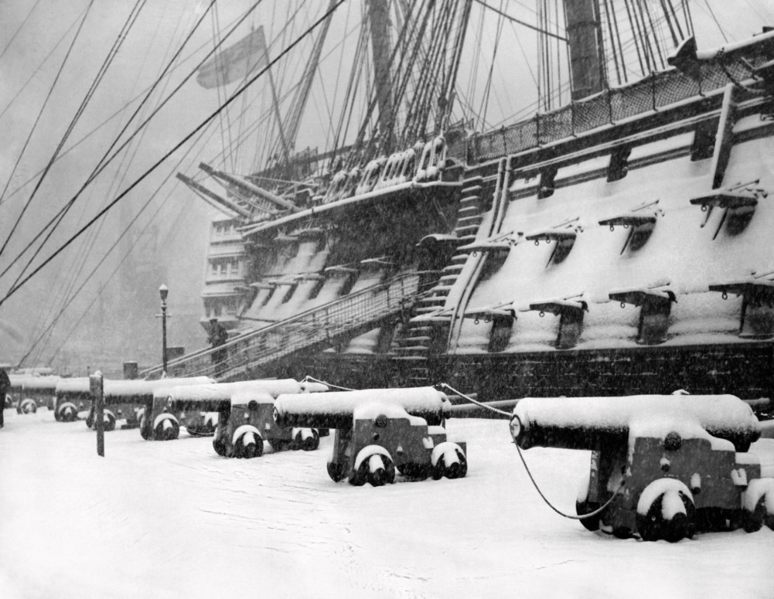
POOLE MARITIME TRUST
Autumn/Spring Programme 2023/24
Travellers’ Tales / Poole Maritime Trust Talks at the
Royal Motor Yacht Club Sandbanks, Poole BH13 7RE
4th January 2024 Poole Maritime New Year Luncheon at RMYC (PMT Members ONLY)
12 for 12:30pm Richard Hutley will give a talk on ATLANTIS
The Myth, Legend and Facts about the antediluvian lost
civilisation of Atlantis first reported by Plato 3000 years ago.
What do we know, where could it be? Is there evidence that exists
today?
11th January 2024 Peter Burt and Robert Heaton (Poole Maritime Trust) Talk
8pm ‘Underwater with PHHP in ‘23’ – An archaeological update for work
in and around Poole Harbour over the last year with our own
PMT team from Poole Harbour Heritage Trust.
8th February 2024 David Bailey (Wild Life Photographer) will give a talk entitled
8pm ‘Good Hare Days’. David is an author and fabulous photographer.
7th March 2024 Leigh Merrick and Richard Balmforth (Reuters – Eastern Slav
8pm Specialist and Bureau Chief) will give a talk on the Ukraine.
(Full details to follow)

The Upstairs Bar at the Royal Motor Yacht Club will open from 7:30 pm the talks will start at 8pm. (RMYC members only allowed in the main bar downstairs).

There are disabled facilities on the ground floor and facilities on the first floor.

If you arrive by car there is parking on the main road, Panorama Road. If arriving by Taxi the main entrance to the RMYC is off Old Coastguard Road.
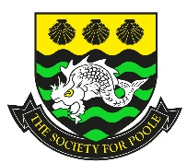
SOCIETY FOR POOLE
PROGRAMME Jan-Apr 2024
Meetings at Oakdale Conservative Club
92 Darby’s Lane, Poole BH15 3EU
7.30pm

16th January 2024 Punching the Tide – pleasure boats from Bournemouth Pier
Peter Lamb
20th February 2024 Secret Poole (spies of East Dorset and Poole)
Ed Perkins
19th March 2024 Narrow Guage Clay Railways of Purbeck Peter Sills
16th April 2024 AGM and History of Society for Poole Jan Marsh

CONVICT HULKS & 'FIRST FLEETERS'
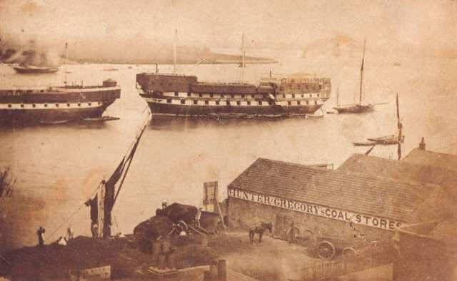
Hulks were decommissioned (and often unseaworthy) ships that were moored in rivers and estuaries and refitted to become floating prisons. There were usually three decks, each containing between 500 and 600 prisoners.
Some 44,000 convicts were sent to out to our American colonies during the 1700s until the American Revolutionary War (1775-83). The hulk in the picture was taken on the River Thames in 1856.We were forced to turn our eye to Australia as a destination for our convicts. The prisoners would be held until they departed on transportation ships.
Many Australians are proud of their heritage and ancestors who are termed as 'First Fleeters as their people arrived in Sydney Cove with the First Fleet on 26 January 1788. So much so that there is an organisation called About Fellowship of First Fleeters: 'The Fellowship was formed in 1968, and since then over 9167 descendants have established their lineage, and joined the Fellowship. Links have so far been established in 137 families to no fewer than 195 individual First Fleet Ancestors. There are currently over 1650 active members'. On a local level to me - the famous Tolpuddle Martyrs were sentenced and sent to Australia. From their smoke-filled, stinking cell below the Crown Court in Dorchester, five of the convicted men were taken in chains to the prison hulks, York and Leviathan, lying off Portsmouth. George Loveless was too ill to travel but on 5th April 1834 he was declared fit and taken to the York hulk, six weeks later, on 17th May, he sailed aboard the William Metcalfe for Van Diemen's Land' .

SUNDOWNER
Sundowner is a motor yacht formerly owned by Charles Lightoller, who was Second Officer aboard the RMS Titanic ...
Length: 58 ft (18 m)
Speed: 10 knots (19 km/h; 12 mph)
She participated in the Dunkirk evacuation as one of the "little ships" as well as a number of commemorations of the event, and is now a museum ship at the Ramsgate Maritime Museum in Southern England.

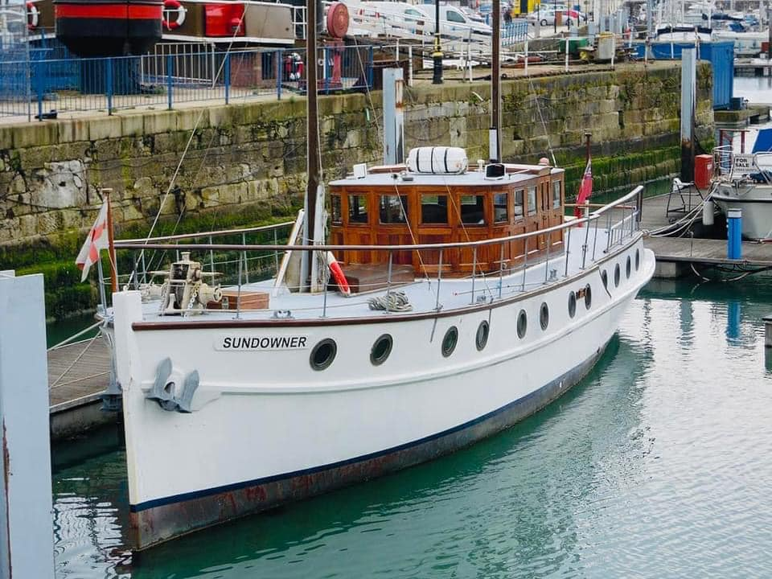
HAMWORTHY PIER
By Rob Williams
Recently, BCP have dismantled the ‘hammerhead’ section of the WW2 fuelling pier at Lake, Hamworthy.
There used to be pipes running up to a huge underground fuel reservoir at the top of the hill. I believe this was targeted by German bombers who succeeded in causing a leak that allowed 1000s of gallons of fuel into the harbour. The pipes were removed several years ago, just the brackets remain.
I think this was the refuelling pier for the barges coming from the Naval cordite factory at Holton Heath? I hope they do restore it as it’s a very little known part of Poole’s wartime history.(and site of many of my misspent teenage hours!)
UPDATED photo. The council have actually restored it!
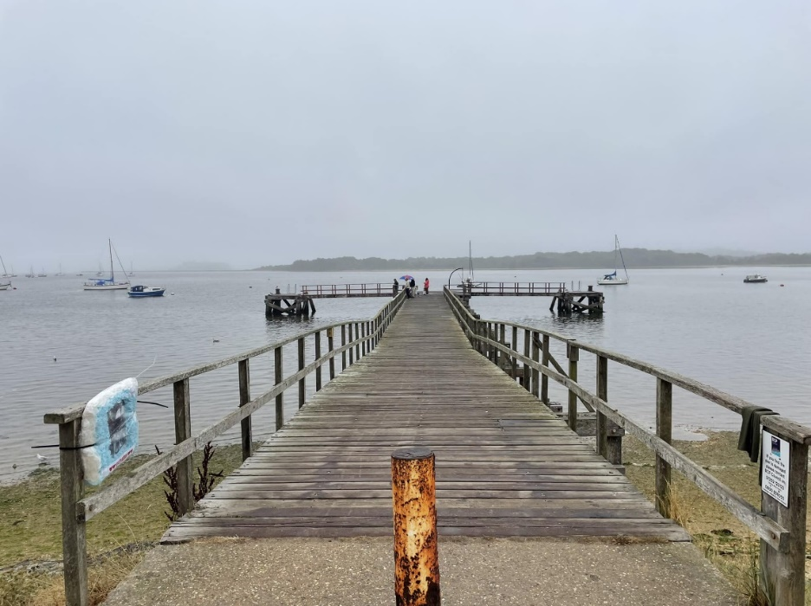
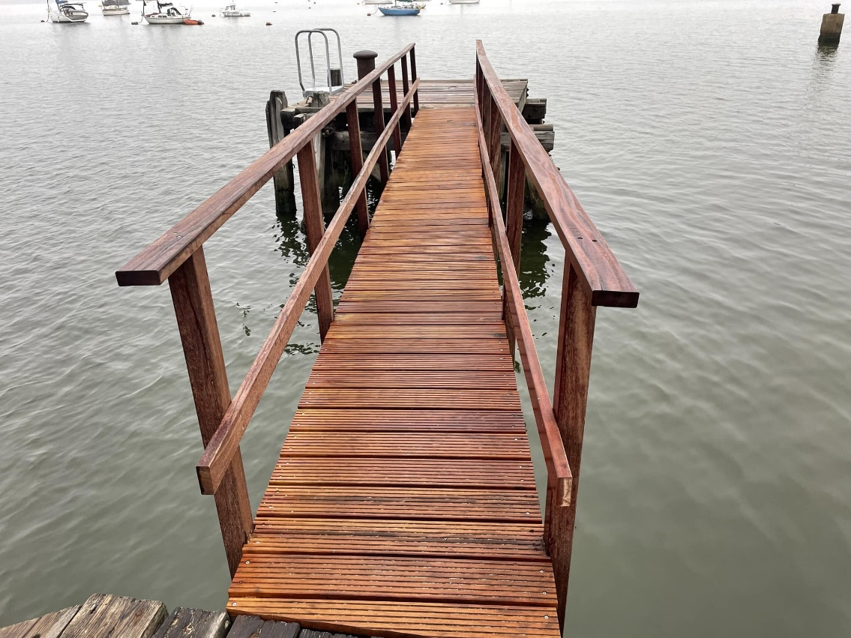
LAKONIA
Greek Line.
Another tragedy, in 1963, the old Greek Line cruise ship fell victim to a serious fire in the middle of the Atlantic Ocean off the coast of Madeira. It was on an 11-day Christmas cruise departing Southampton, where it had been based since it came into service under the Greek flag in April that year.
Built in 1928 the ship was named in 1930 as JOHAN VAN OLDENBARNEVELT, known as JVO (we understand why) she was owned by the Dutch company Netherland Lloyd Line and operated a regular liner service to the Caribbean and the Dutch colonies including Guyana (now Surinam). During WWII JVO was used by the Allies as a troop transport and armed merchant ship. She was assigned to service to Batavia, currently Jakarta and other Dutch possessions in Indonesia. JVO’s twin sister MANIX VAN ST ALDEGONDE was less fortunate having been torpedoed and sunk during the conflict. She enjoyed a similarly complicated name ! After release from the war, JVO resumed the service to Indonesia, before being transferred to the service to Australia and New Zealand carrying immigrants. The service proved such a success that the accommodation was upgraded in 1958 with additional cabins. Alas, the JVO was competing with larger aircraft, and predictably ended her career under the Dutch flag in 1962 before being sold to Greece. Transformed, further cabins, and a new lido with a large pool that were added. But safety aboard is very relaxed. During the fire, the security alarm system fails to work and the siren is barely audible in some parts of the ship. In addition, some lifeboats caught fire whilst still in the davits. Two othersfell into the water with their occupants as some of the winches were inoperative. The fire that broke out in the hair salon spread quickly, even as it was tackled by some brave sailors. It quickly became out of hand. 128 victims, 95 passengers and 33 crew members are mourned. More than half are victims were as a result of the fire, and the remaining victims drowned or lost in the shipwreck. The subsequent investigation revealed that the cruise ship should never have been issues a passenger certificate. The Captain and a large number of the shore staff were prosecuted for negligence and went to jail. The company continued to operate other ships and replaced the LAKONIA with the ARKADIA undertaking cruises from Southampton. LAKONIA was a ship measuring 186 meters in length and of almost 20,000 tons. JVO originally carried less than 800 passengers but with its many transformations the capacity increased to 1200. Devastated and drifting, the old LAKONIA slipped beneath the waves on December 29th.

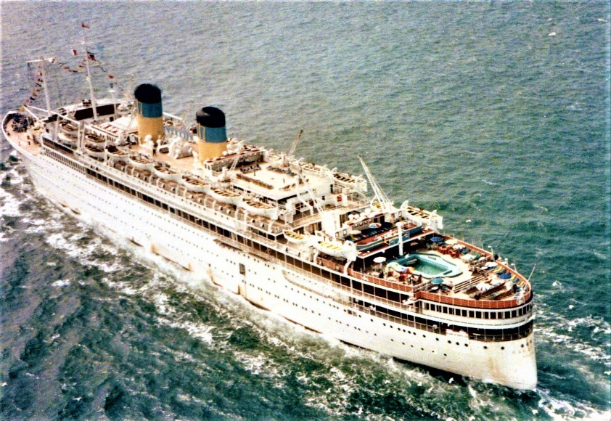

LAKONIA after her final re-build

THE TITANIC ENGINEERS... – Anthony Nicholas

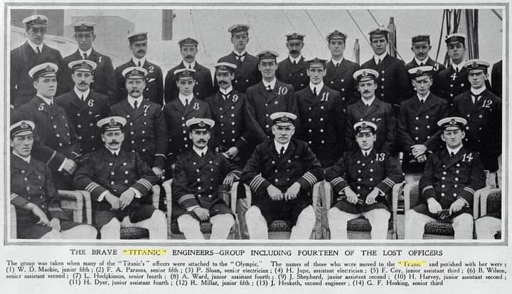
This group photo, taken on board the White Star liner Olympic, features no less than fourteen of the engineer officers that would be transferred over to the brand new Titanic in due course. Not one of them would survive the subsequent sinking of that ship. It was normal practice to embed 'old hands' from a first-of-class ship such as the Olympic in a younger sibling, as was the case with Titanic. The debut of the Olympic in June 1911 shattered a whole street full of glass ceilings in quite spectacular style. She was quite literally the biggest man made moving object on the face of the planet, and her sheer scale- Olympic was nearly half as large again as her nearest rivals- raised scores of new challenges right across the spectrum. These ranged from catering considerations right through to a mass of mechanical and technical issues. There were new lessons to be learned regarding the on board accommodation and facilities for both passengers and crew alike. And handling a ship of such unthinkable size, both in ports and out on the open ocean, required radical rethinking. The loading and unloading of passengers, cargo and mail from brand new tenders had to be rehearsed, too. Taken collectively, all of these things took painstaking time and practice. None the less, by early 1912 the Olympic was safely bedded down in successful commercial service, and thoughts now turned increasingly to the upcoming Titanic, then in the final phase of fitting out at the Harland and Wolff shipyard in Belfast. To 'bed down' this upcoming, second-of-class ship, a whole host of key department heads from the Olympic were seconded to similar roles on board the Titanic. These, it was reasonably assumed, would smooth her arrival into service considerably. The ship's surgeon, Chief Purser, Chief and Second Stewards, plus the Chief Engineer were among the crucial appointments. Many senior stewards, plus a handful of stewardesses, also migrated from the Olympic to the Titanic .In terms of the bridge officers, both Captain Smith himself and Chief Officer designate William Murdoch came over to Titanic directly from Olympic. Clearly however, Smith himself did not think that this was enough. Once the Titanic was safely shackled to her Southampton berth, Smith acquired the services of another old Olympic hand, Henry Wilde. His accession to the role of Chief Officer of the Titanic meant Murdoch's temporary demotion to the rank of First. The original First Officer, Charles Lightoller, stepped down to the next level. David Blair, the original Second Officer, left the ship; with him went the key to the locked box containing the binoculars for the lookouts. Blair had inadvertently pocketed the key, and simply forgotten the fact. In terms of the engineers, the fourteen men marked out in this sad little 'family portrait' all made the move from Olympic to Titanic. They would be lost to a man. The fact that the Titanic was merely seen as a slightly tweaked version of the Olympic also explains the low key nature of her first departure for New York. Such headlines as it garnered were nowhere near on the sensational scale of those accorded to the Olympic on her maiden voyage. None the less, the Titanic herself would make headlines soon enough...

THE SHIP THAT NEVER WAS

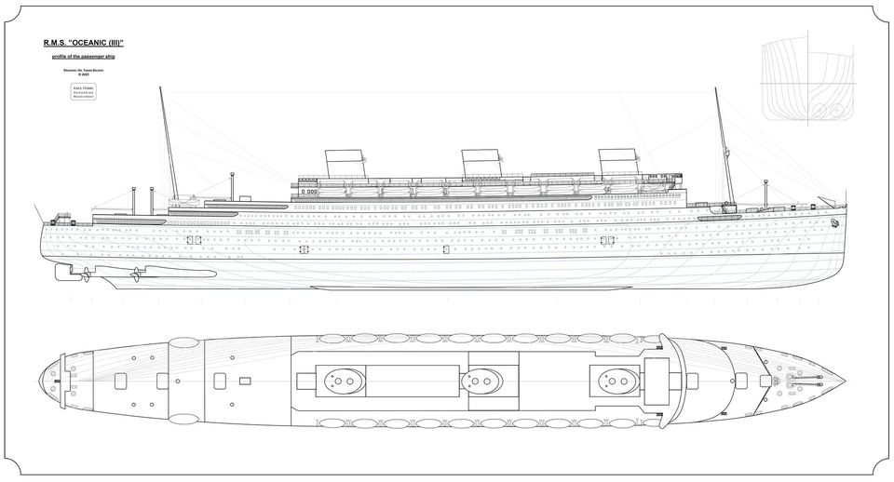
Eighty-six years ago, at the age of seventy-four, died Joseph Bruce Ismay, a British shipping entrepreneur, who was the CEO of the White Star Line (WSL) from 1899-1913, which was originally a British shipping company, but from 1903 the majority of its shares fell into American hands; and who was the managing director of the US-owned International Mercantile Marine (IMMC) trust from 1903-1913. During his presidency, the famous OLYMPIC-class liners (OLYMPIC, TITANIC, BRITANNIC) were built. After the tragedy of the TITANIC, he resigned from his positions in shipping companies, he could no longer undertake tasks in them, even though the White Star Line, founded by his father, became British again in November 1926. The company's new owners wanted to make the line a market leader again by building a revolutionary ocean liner. The design and construction program of the OCEANIC (III) was the last major effort of the White Star Line, which was planned to be carried out between 1926-1929, but in the midst of the increasing world economic crisis, the ship was ultimately left unfinished and her completed parts were dismantled. The huge ship of unprecedented size would have been an unparalleled masterpiece if built, and thanks to her unique propulsion system, she would have represented such a great advance in her time that it would not have been possible to surpass, until the inauguration of the liner QUEEN MARY (II) in 2004. Along with the dreams incarnated in the concept of the OCEANIC (III), the future of the White Star Line also shattered: for its new owners, the company meant something different, than to the founders, and It seems that no one other than family members has been successful with the Ismay-company. The gentle Joseph Bruce Ismay tried several times to regain the family company, but his initiatives proved to be weak, so they were unsuccessful. His former company, which was threatened with bankruptcy, was broken up, and its most profitable transatlantic lines were bought, along with the company name, by its greatest rival, the Cunard Line, while the rest were gained by other companies. Ismay had to watch it all. In return, he survived all his rivals, and eventually went to the grave together with the family business, which even the large-scale plans of OCEANIC (III) could not breathe life into.

POOLE MARITIME TRUST MEMBER, MIKE CULLEN, RECENTLY VISITED THE RIVER MEDWAY AND TOOK TIME TO STEP ABOARD A SHIP WITH A REMARKABLE HISTORY.
“MEDWAY QUEEN”
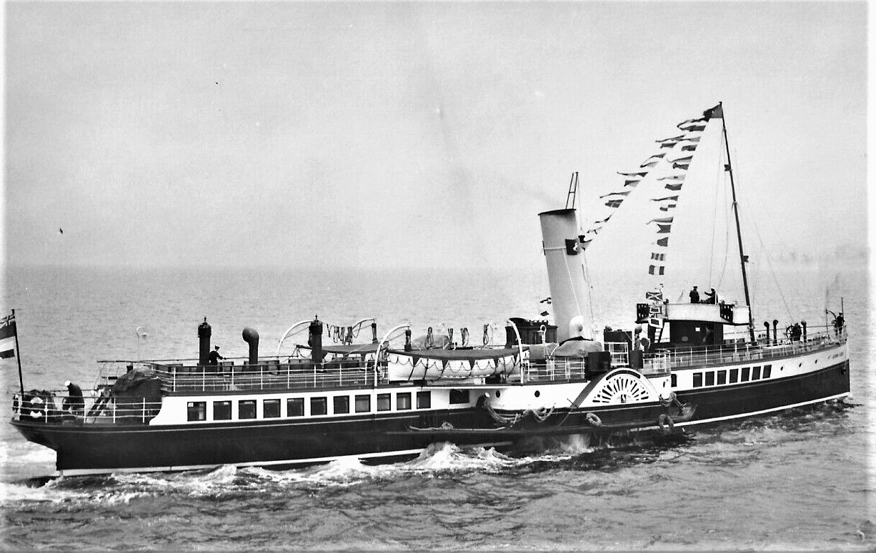
“MEDWAY QUEEN” IN HER ELEMENT
Mike at the helm for the bow rudder that was used to assist navigation in rivers, avoiding the shoals on the approach to Clacton and when going astern
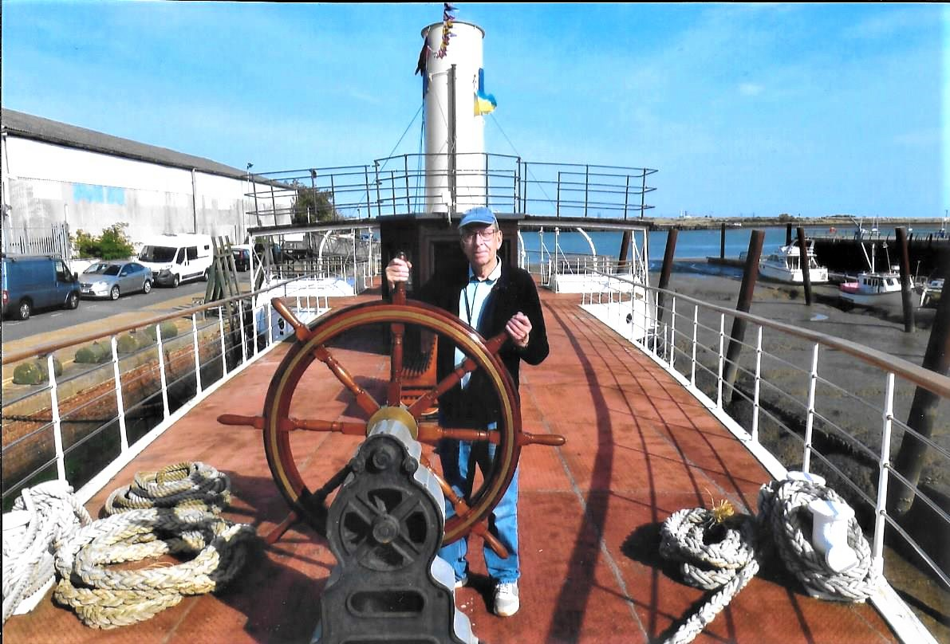

THE BEAUTIFULLY RESTORED INTERIOR
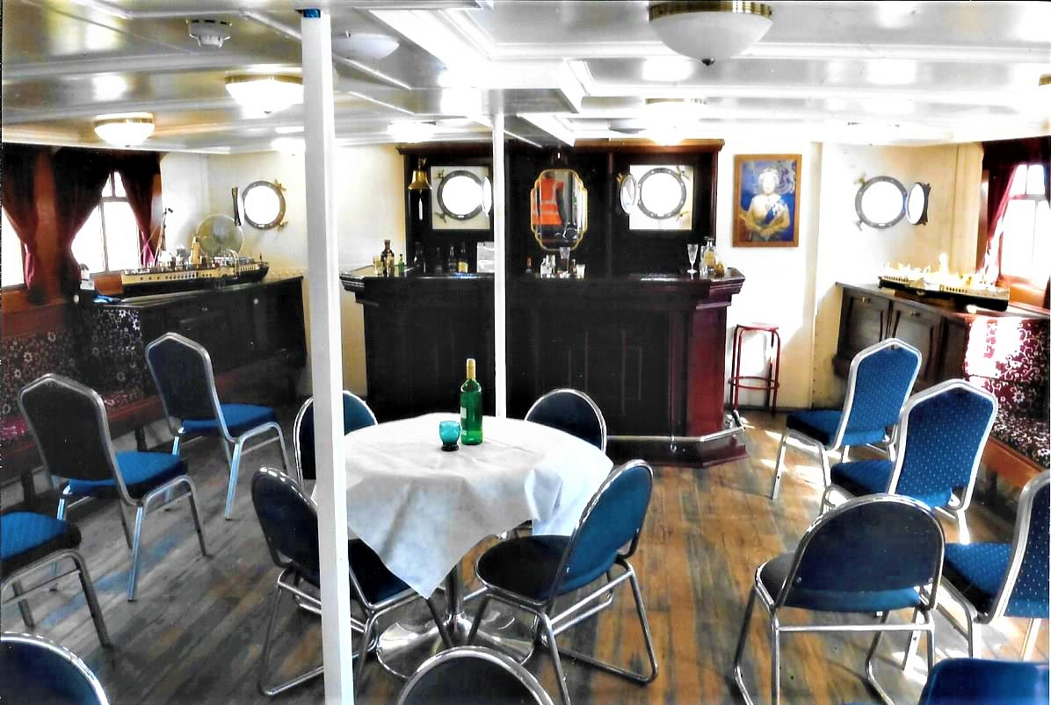
PS Medway Queen was built by the Ailsa Shipbuilding Company at Troon, Scotland, in 1924 for service on the River Medway and in the Thames Estuary. Trialed on the River Clyde, she was delivered to be part of the "Queen Line" fleet of the New Medway Steam Packet Company based at Rochester, Kent. She steamed on routes from Strood and Chatham, to Sheerness, Herne Bay and Margate in Kent, and to Clacton and Southend in Essex. On 3 August 1929, Medway Queen collided with Southend Pier, Essex, and suffered extensive damage to her bows. After attending the Coronation Fleet Review for King George VI at Spithead, Medway Queen was converted to oil-fired steaming by Wallsend Slipway & Engineering Company in 1937

World War II
Requisitioned by the Royal Navy on 9 September 1939, her first task was evacuating Kent children from Gravesend to East Anglia. She was refitted at the shipyard of the General Steam Navigation Company in Deptford Creek as a minesweeper, her stern being modified to take sweeping gear, being fitted with a 12-pounder gun and two machine guns, and allocated pennant number J 48 (N 48) She served for the duration of World War II in the 10th Minesweeping Flotilla, patrolling the Strait of Dover and the English Channel. In May 1940 Operation Dynamo was launched to rescue retreating British Army soldiers from Dunkirk in northern France. HMS Medway Queen became part of the flotilla of little ships. She left with paddle steamers Sandown, Thames Queen, Gracie Fields, Queen of Thanet, Princess Elizabeth, Laguna Belle and Brighton Belle. She made seven crossings. On her first trip, approximately 600 soldiers were taken off De Panne beach in lifeboats and ferried to the ship. On her return to Dover, her arrival coincided with an air raid. She shot down a German aircraft outside the harbour. The Brighton Belle ran over sunken wreckage and began to sink. All of her passengers and crew were rescued by the Medway Queen without loss of life and, heavily overloaded, she made the harbour safely. On her second trip she took about 450 soldiers directly off the beach. This required remarkable skill, but was much faster. Soldiers used a technique with oily bags to conceal their distinctive wash from patrolling aircraft. On later trips, the Medway Queen penetrated the damaged Dunkirk port and took off men from the concrete mole. Men were discharged at Ramsgate rather than Dover, where the vessel was refuelled and reprovisioned. On Monday 3 June Vice Admiral Ramsey gave the order that all ships were to leave Dunkirk by 2.30 the following morning. This was the Medway Queen's seventh trip. She was at the mole in Dunkirk when a destroyer moored astern of her was driven forwards by an explosion and smashed her starboard paddle box, she sustained considerable damage. Medway Queen limped back to Dover with 400 French soldiers on board. On arriving back at Dover the crew of the Medway Queen discovered that the Admiralty had reported their ship as having been sunk (news which reported throughout the UK); the Admiralty published a correction the following morning. Her crew gained seven awards for gallantry – having made seven crossings and rescued 7,000 men. In view of this remarkable achievement in rescuing so many Allied troops from France, she earned the title of "The Heroine of Dunkirk". After repairs in Portsmouth Dockyard, she returned to minesweeping duties, and in 1942 she was converted to a minesweeping training ship, serving out the war in this capacity, and was returned to her owners in January 1946.

Return to service
Rebuilt by Thornycrofts of Southampton in 1946, she returned to civilian service with New Medway Steam Packet Company for the 1947 season. Medway Queen attended the 1953 Coronation Fleet Review at Spithead. She made her last commercial sailing on 8 September 1963, and was scheduled to be scrapped in Belgium. The Belgian ship-breaker, upon discovering that the vessel he was expecting to break up was "The Heroine of Dunkirk", declined to continue (it is reported that he felt that no one should dare to destroy such a gallant and important little ship). The Daily Mail campaigned to save her.

Use as nightclub
Having been saved from scrapping, Medway Queen was eventually sold for use as a nightclub and marina clubhouse, and was moored at the Medway Queen Marina (now known as Island Harbour)) on the Isle of Wight. The club opened in 1966. In 1970, a larger ship, PS Ryde, renamed as Ryde Queen, joined Medway Queen at the marina site, also operating as a nightclub. The two premises operated alongside one another for a period, until the Medway Queen was eventually closed and fell into disrepair.^{[19]}

Preservation
In 1978 the Medway Queen was bought by private owners with the aim of preserving her. She was moved out of the marina to the adjacent River Medina, but sank in the river when the hull sprang a leak. There she remained, in a state of increasing deterioration, until in 1984 she was salvaged, moved to Cowes at the river’s mouth, and thence towed back to Chatham in Kent on a salvage barge. In 1985 the Medway Queen Preservation Society formed, with the intention of preserving the historic ship. In 1987 she was moved to Damhead Creek, Kingsnorth on the Hoo Peninsula, but the trust lacked funds to bring her back to service, and struggled to preserve the structure. After a series of near disasters, in 2006 the National Lottery Heritage Memorial Fund agreed a £1.8 million funding package to restore her structure, subject to the society raising £225,000. Although the funds were raised, neither the insurance company nor marine engineers were confident that her hull was seaworthy and able to sustain lifting on to a pontoon. In October 2006, the Trust agreed to the deconstruction of the hull, and salvageable pieces were moved to Gillingham Pier (and a National Lottery funded warehouse) in Chatham Dockyard, in preparation of the hull being professionally restored to seaworthy condition. In October 2008, the society signed a contract with David Abels Shipbuilders to restore the hull at the Albion Dry Dock in Bristol, using plate riveting. Work began in April 2009 and was due to be completed in the summer of 2010. On 27 July 2013 the ship was rededicated. She was floated out of the Albion Dock during the summer of 2013 and towed back to Gillingham where she is to this day.
P.S. “WAVERLEY” PREPARING TO SWING IN THE RIVER MEDWAY HAVING PAID “MEDWAY QUEEN” A VISIT AND GIVING HER A WELL DESERVED WHISTLE SALUTE
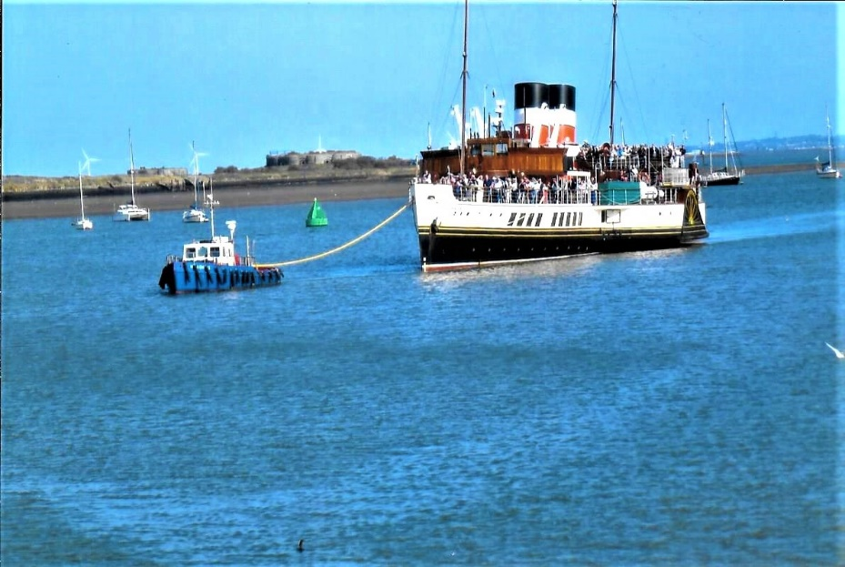
SHORT SUNDERLAND FLYING BOATS
The RAF Short Sunderland had a feature not many warplanes in WW2 had; a galley with a eating area, this area was even heated for those cold North Atlantic anti-submarine patrols. These pictures, showing life onboard were taken in a Short Sunderland Mark I based at RAF Mountbatten whilst on a North Atlantic Patrol in 1940.
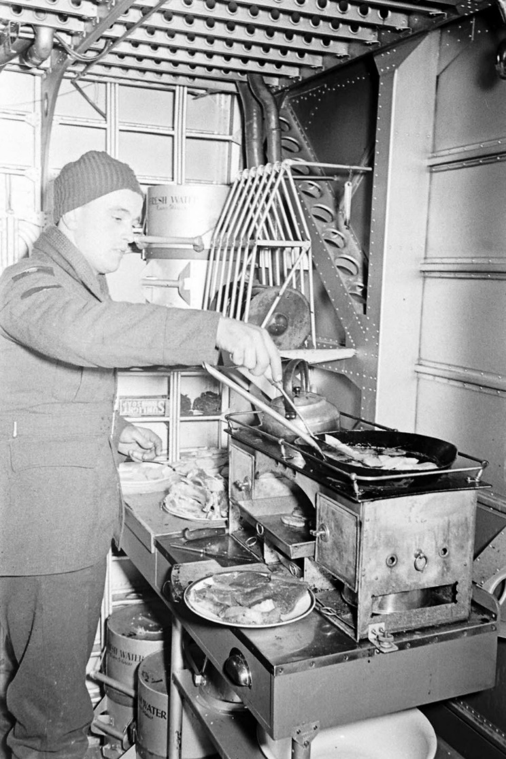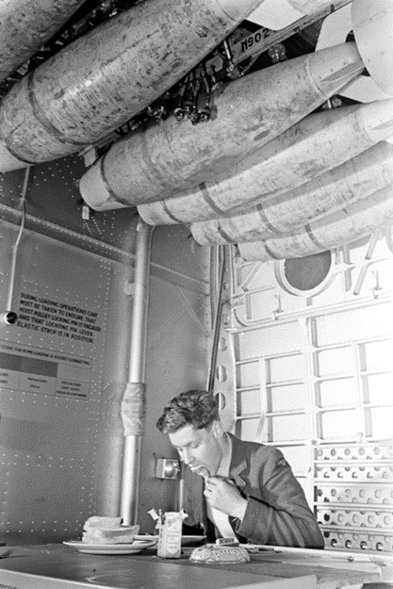
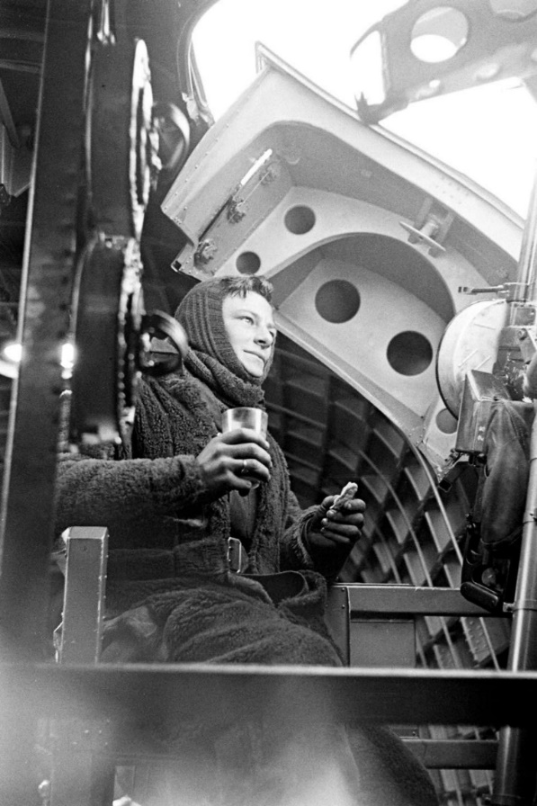

TITANIC’S ILL-FATED SISTER
By Tony Johnson
HMHS Britannic was the third and final vessel of the White Star Line's Olympic class of steamships and the second White Star ship to bear the name Britannic. She was the youngest sister of the RMS Olympic and the RMS Titanic and was intended to enter service as a transatlantic passenger liner. She was operated as a hospital ship from 1915 until her sinking near the Greek island of Kea, in the Aegean Sea, in November 1916. At the time she was the largest hospital ship in the world. Britannic was launched just before the start of the First World War. She was designed to be the safest of the three ships with design changes made during construction due to lessons learned from the sinking of the Titanic. She was laid up at her builders, Harland and Wolff, in Belfast for many months before being requisitioned as a hospital ship. In 1915 and 1916 she served between the United Kingdom and the Dardanelles. On the morning of 21 November 1916 she hit a naval mine of the Imperial German Navy near the Greek island of Kea and sank 55 minutes later, killing 30 people. There were 1,066 people on board; the 1,036 survivors were rescued from the water and lifeboats. Britannic was the largest ship lost in the First World War. After the First World War the White Star Line was compensated for the loss of Britannic by the award of SS Bismarck as part of postwar reparations; she entered service as RMS Majestic. The wreck was located and explored by Jacques-Yves Cousteau in 1975. The vessel is the largest intact passenger ship on the seabed in the world. It was bought in 1996 and is currently owned by Simon Mills, a maritime historian.

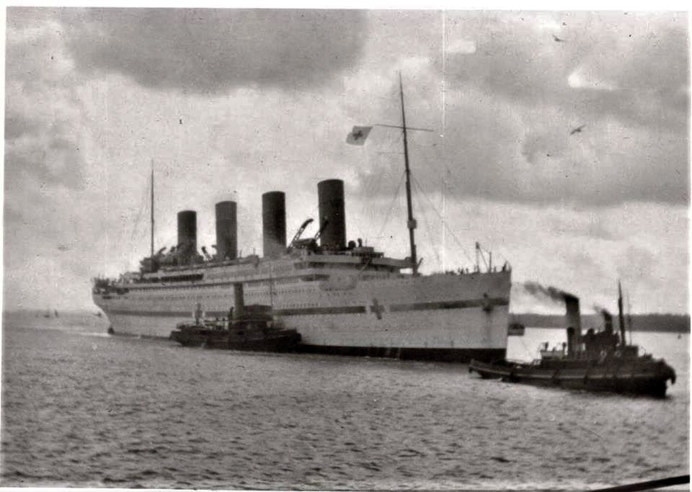

Possibly the earliest aerial photos of the New Forest and Solent.
Taken off the Mouth of the Beaulieu River and Cowes week.
Photographs taken by the Hon Charles Rolls of Rolls Royce fame from his balloon The Imp.

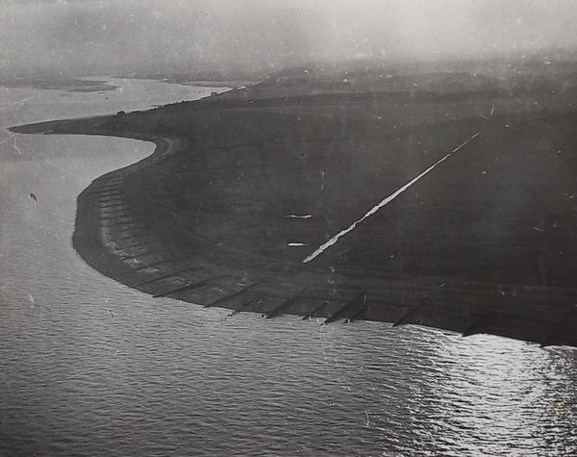

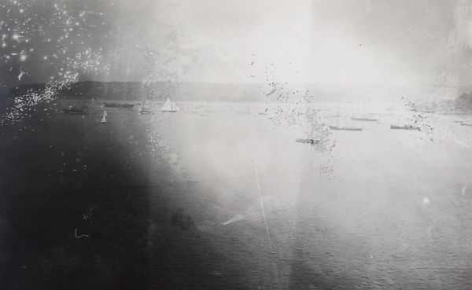

On the 10th November 1943 The Flower class corvetteHMS Coreopsis(K32) became the Greek corvette HHMS Kreisis(K32).
Built by A. & J. Inglis Ltd, Glasgow she was ordered on 25th July 1939, laid down on 19th September 1939, launched on 23rd April 1940 & commissioned into RN on 17th August 1940. In Royal Navy service, Coreopsis was employed on convoy escort duty in the Atlantic. On 20th October 1940, she rescued 33 survivors from the British cargo ship MV La Estancia sunk by the German submarine U-47 south of Iceland. In early November 1942 she participated in Operation Torch being part of the escort for the RFA tankers (Force R), which refuelled Force H (the forces covering the North African landings).On 16th November 1942, she rescued 169 survivors from the British merchant ship SS Clan MacTaggart that was sunk by U-92 off Cadiz. On 5th March 1943, she picked up survivors from the British merchant ships SS Fidra, SS Ger-y-Bryn and SS Trefusis which had been sunk by U-130 northwest of Lisbon.Coreopsis was transferred to the Royal Hellenic Navy on 10th November 1943, one of several British escort vessels transferred to Greece after April 1941. Renamed Kriezis (Greek: Κριεζής, after the naval hero Antonios Kriezis) but retaining her K32 pennant number, she served as a convoy escort out of Liverpool and on 13th June 1944, escorted Convoy ECM6 which was part of Operation Neptune, the maritime element of the Normandy Landings. She joined the British Mediterranean Fleet in October 1944. She remained with the Greek navy after the war and was finally returned to the Royal Navy on 1st June 1952.She is perhaps best known for her film role. While awaiting disposal at Malta in 1952, Coreopsis was acquired by Ealing Studios for the film The Cruel Sea, in which she took the part of the fictional Flower-class corvette, HMS Compass Rose. During filming at Plymouth, she collided with the destroyer HMS Camperdown causing some damage to the latter.[5] In the film, she wore the pennant number K49, actually the number of HMS Crocus. She finally arrived at the breaker's yard of Thomas Young & Sons in Sunderland on 22nd July 1952 where she was scrapped.
Photographs;- The blessing of HHMS Kriesis by the Very Rev Archimandrite James Vivros at Liverpool on 3rd December 1943 and the Greek Admiral Mezeviris addressing the ship's companies from the forward gun position & Also, Admiral Max K Horton, KCB, DSO, Commander in Chief, Western Approaches, wishing the officers and men "good luck and good hunting". all four photographs are from the collection of the Imperial War Museum.
E] to H] I'm unable to find a decent photograph of her either in Royal Navy or Royal Hellenic Navy service so here are some stills of her as HMS Compass Rose(K49) in 'The Cruel Sea'.

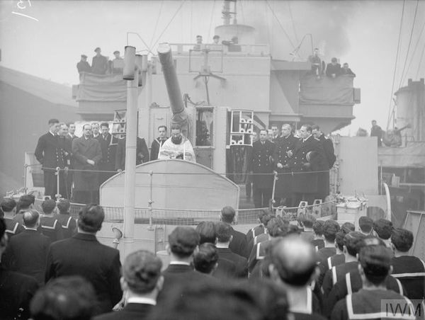

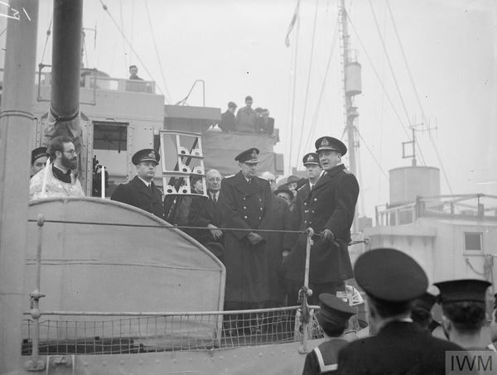

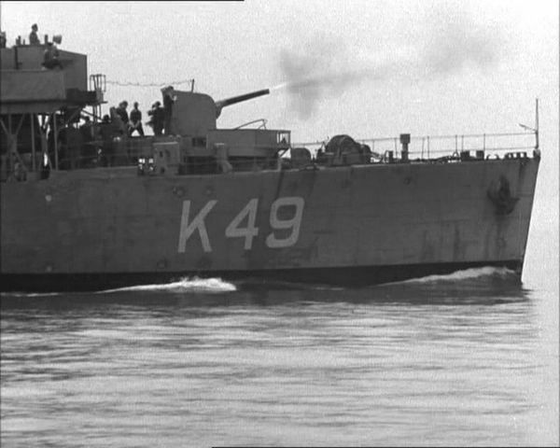
HM Submarines and Poole Harbour
By Michael (Jack) Hawkins
Poole Harbour has been associated with the Royal Navy as a Naval Base for centuries. As a Natural Harbour it has been supportive from its local population to its strategic position on the South Coast. Predominantly the Royal Navy used Poole’s natural resources to base surface vessels of small to medium size with specific tasking to protect the South Coast during conflict. This meant large quantities of vessels used for Mine Laying, Mine Sweeping and the training of Landing Craft Crews and general Coastal Forces. Little has been documented about the visits of The Silent Service, HM Submarines. This was due mainly because of the covert tasking of the Submarines and the unique logistics required to support these vessels. Even today the position and tasking of the current submarines of both conventual and particularly our Nuclear-powered vessels and their capability is kept secret. However, over the years various submarines have visited Poole Harbour at various stages of their deployment or tasking. Some even enemy vessels which caused local interest.During WW1 The German U Boat became the ultimate weapon at sea. Poole saw after hostilities ceased in 1918 the U Boat fleet which was disbanded and re allocated and Poole saw the visit of some such vessels post WW1.The Poole & East Dorset Herald newspaper, reported an unusual event – the visit of two German U-boats to Poole in January 1919; one accidental and one planned.U 143 was being escorted to Japan by two Japanese destroyers, Kanran and Kashiwa, as part of the compensation settlement between Japan and Germany. The newspaper has a brief report of U 143 becoming stuck on a sandbank in Poole Bay and being recovered with great difficulty. Another source records that the U-boat, which was being crewed by Japanese sailors, was taken into the Harbour for assessment and repairs. During this time, the destroyers were docked at Poole Quay much to the interest of on-lookers. U 143 eventually set sail for Japan where it was renumbered O 7. It served in the Japanese Navy until it was scrapped in 1921. Although the newspaper described it as U 143 it is more accurately known as UB 143 because it was a Type UB III submarine.
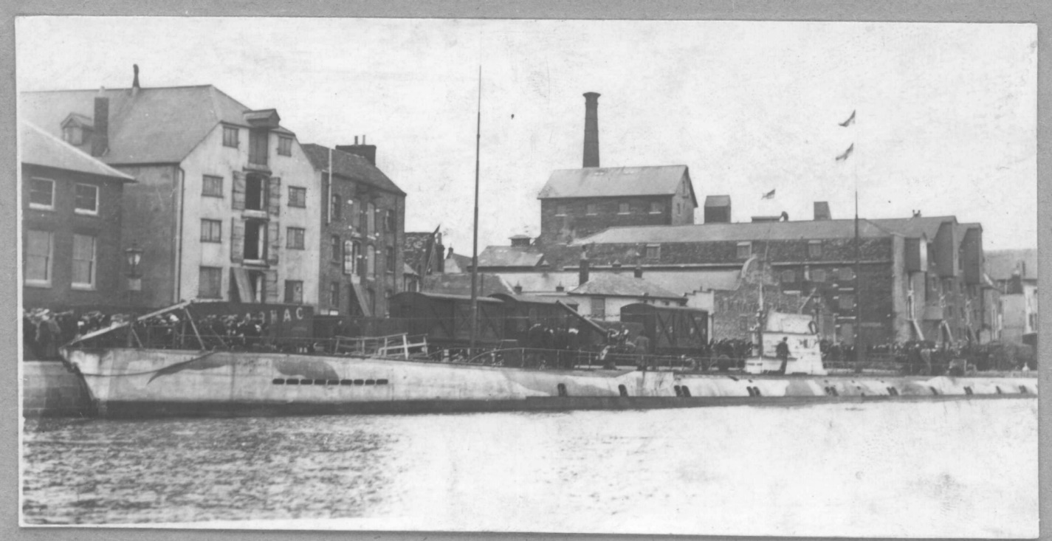
The other German submarine in Poole during January 1919 was U 107. A Royal Navy crew had sailed the U-boat from Portland to Poole for a planned 11 day visit from January 6. Over 10,000 people, including many schoolchildren, took advantage of the U-boat’s stay to explore the submarine, with donations going to the King’s Fund for Disabled Officers and Soldiers. A reporter from the Poole & East Dorset Herald gave a layman’s description of the inside of the submarine, such as sleeping arrangements, and mentions that at the bow there were ‘four 19.5 torpedoes in position’. The submarine returned to Portland on completion of its visit and Herbert Carter, a former Mayor of Poole, was on the return trip. He explains that one reason for being on-board was that he could translate the German ‘control notices. He notes that the submarine only sailed on the surface and did not submerge.The R-class submarines were a class of 12 small British diesel-electric submarines built for the Royal Navy during World War I, and were forerunners of the modern attack submarine, in that they were designed specifically to attack and sink enemy submarines, their battery capacity and hull shape being optimized for underwater performance.With a submerged speed of 14 knots (26 km/h; 16 mph), the class set an underwater speed record not broken until the experimental Japanese Submarine No.71 of 1938, which was capable of more than 21 knots (39 km/h; 24 mph) submerged. Ordered in December 1917, the R class were designed to be faster underwater than on the surface, achieving a submerged speed of 14 knots (26 km/h; 16 mph) versus a surfaced speed of 9 knots (17 km/h; 10 mph). They were well-streamlined, having no external ballast tanks, casing, or deck gun, and a streamlined spindle-shaped hull of circular cross-section (not reproduced until the American USS Albacore) which tapered sharply towards the stern and allowed only for a single screw. The bulbous bow contained five sensitive hydrophones and the lightened conning tower was also well-streamlined. Thirty-five per cent of the space inside the pressure hull was occupied by machinery. A single 8-cylinder 480 hp (360 kW) diesel engine was installed for surface propulsion, while high underwater speed was given by two large electric motors arranged one behind the other to drive the single propeller shaft, and powered by a 200-cell battery of the same type fitted to J-class submarines. The large battery was, however, sufficient for only about an hour at full power. In addition, the engine took a full day to charge the batteries, using half its power. Charging was therefore undertaken in harbour, using a supply of electricity from the shore or from special battery charging vessels. Despite being designed for maximum underwater performance, the R-class submarines were extremely difficult to control submerged, especially at high speeds. Surfaced, they had poor seakeeping and were slow. Minor modifications were made to R4 the only submarine of the class to survive into the 1930s, which made it more manageable on the surface, but reduced its submerged speed to a maximum 13 knots (24 km/h; 15 mph)
Armament
The R class were the first Royal Navy submarines to be fitted with six bow torpedo tubes, number of torpedoes being considered more important than range or size of warhead carried when attacking U-boats. The torpedo tubes were originally the smaller 18-inch (457 mm) but later changed to 21inch (533mm) As designed, one spare torpedo was allowed for, but in operation six reloads were carried in place of the senior ratings' accommodation. It was originally intended to fit a 4-inch (102 mm) gun on the foredeck, but this was dropped due to the adverse effect it would have had on submerged speed.
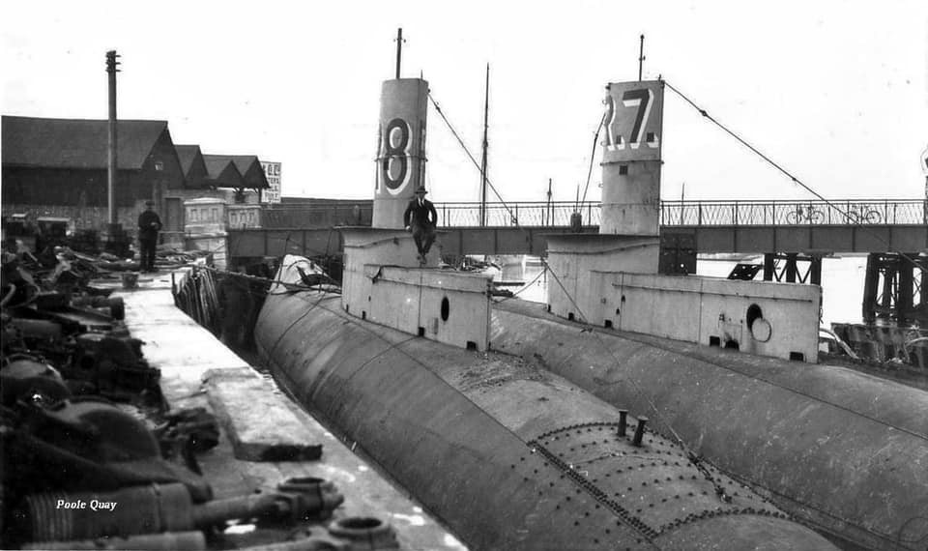
R7 and R8 were brought into Poole for decommissioning and breaking up.
HMS M2 was a Royal Navy submarine monitor completed in 1919, converted in 1927 into a submarine aircraft carrier. She was wrecked in Lyme Bay, Dorset, Britain, on 26 January 1932. She was one of three M-class boats completed. The cause was that the hanger doors were left open when she dived.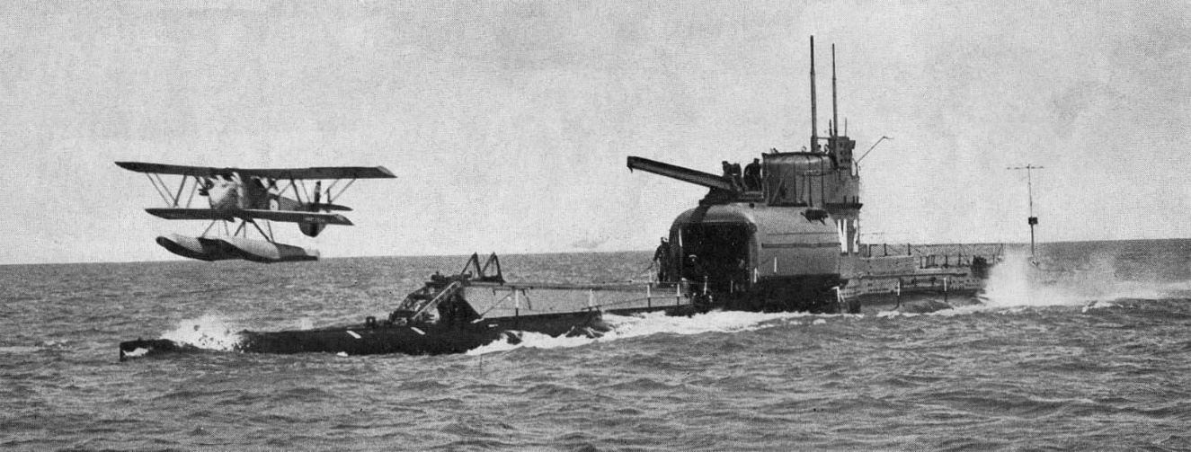
In happier times an S Class HMS Soythian made an official courtesy call into Poole and was hosted by the town council. The S Class were the work horses of WW2 and distinguished themselves through the bravery and expertise of the crews.
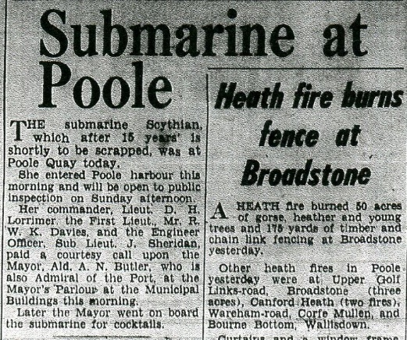

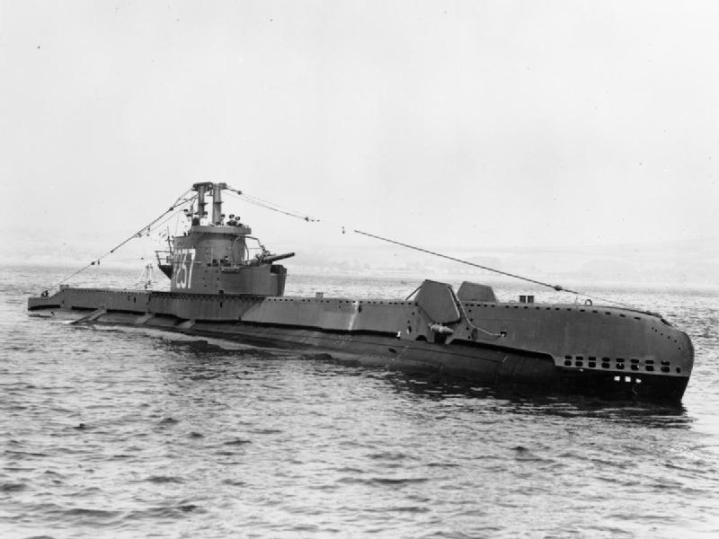
Port Update by Kevin Mitchell
The PHC port tug Herbert Ballam arrived back at Poole on 5th October following overhaul and a fresh coat of paint at Portland. In other tug news, Jenkin Marine’s Handfast is away in the Channel Islands providing assistance at the port of St Helier, Jersey.
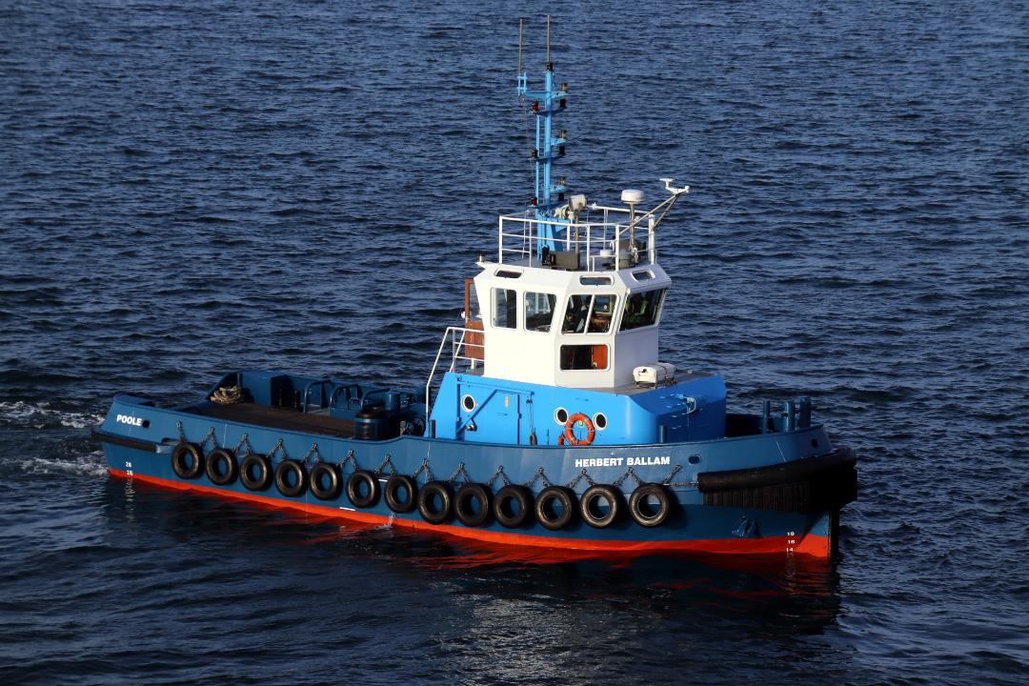
On 6th October the cargo vessel Onego Duero arrived at South Quay after a 21-day voyage from the US east coast port of Wilmington (North Carolina) to unload around five containers. She sailed to the Norwegian port of Ardalstangen that afternoon.
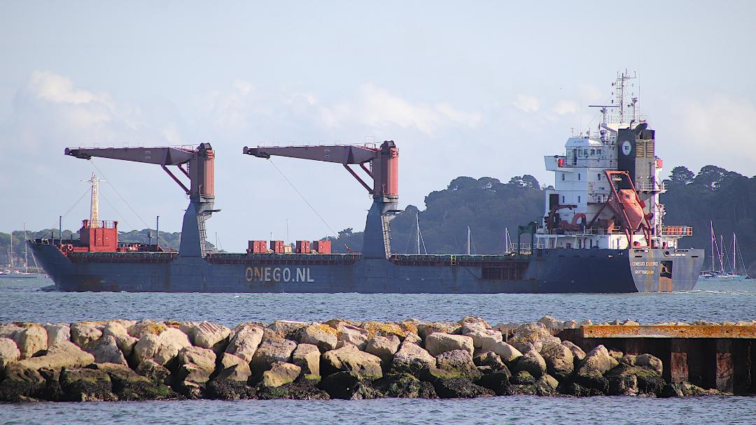
The cargo ship Verity has visited Poole several times in the past, operated by Faversham Ships and used on Channel Seaways duties. Sadly, the Verity sunk on the morning of 24th October following a collision with the larger bulk carrier Polesie in the North Sea off the coast of Germany. Of the seven crew, two were rescued whilst five tragically lost their lives.
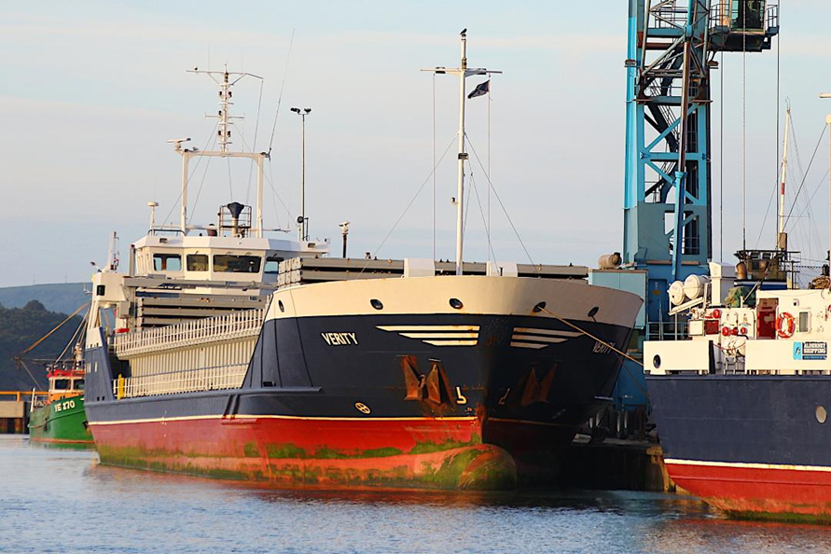
A familiar sight at the port for ten weeks undergoing a complete internal refit and preparations for a new career with Condor Ferries, Condor Islander sailed for Portsmouth on the afternoon of 20th October. She was supposed to start commercial operations to the Channel Islands that evening, however Storm Babet saw all Condor sailings cancelled on 21st October. The Islander finally started service the following day, but she soon encountered technical difficulties including failure of a bow thruster which resulted in her heading for a shipyard in Birkenhead later that month for repairs. Condor Liberation went off to Falmouth on 31st October for dry-docking and overhaul, which is reported will include the fitting of new engines. She will provide some sailings from Poole over the Christmas period. Meanwhile, the Barfleur completed its Cherbourg sailings for this year on 6th November, followed by her usual lay-up berth in the Bassin Calix along the Caen Canal. Following a period of relief work out of Portsmouth early next year, Barfleur is due back with us next March.
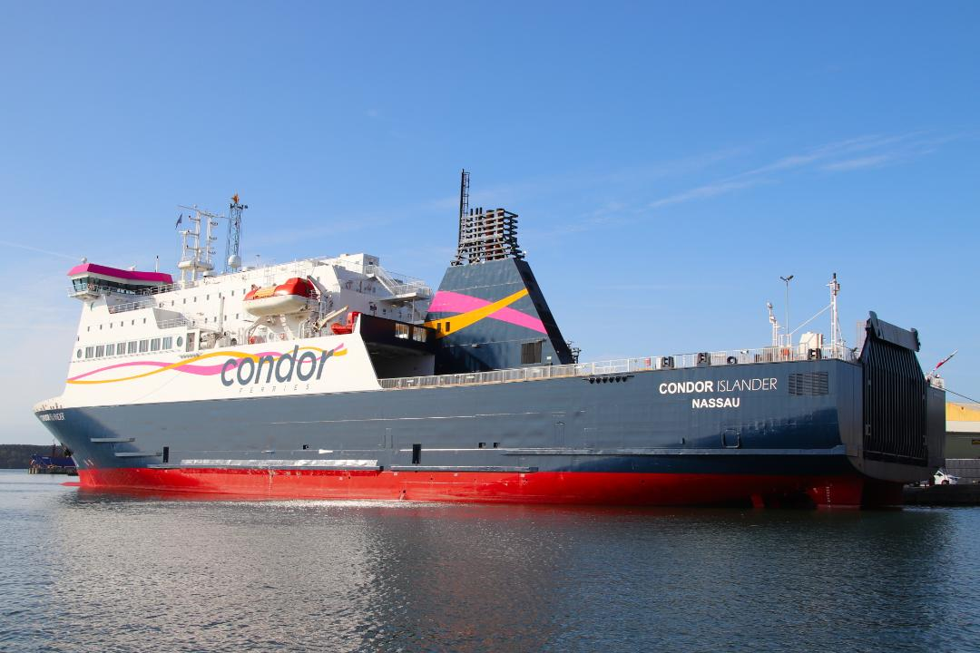
Local boat operators City Cruises and Dorset Cruises were amongst the winners at this year’s DMB Tourism Awards, presented at a gala ceremony at the Bournemouth Pavilion on 9th November. The usual winter overhaul of the local pleasure boat fleet is in full swing, the smaller boats being dry-docked at Lake Yard in Hamworthy whilst the larger ones usually travelling to Portsmouth or Southampton.
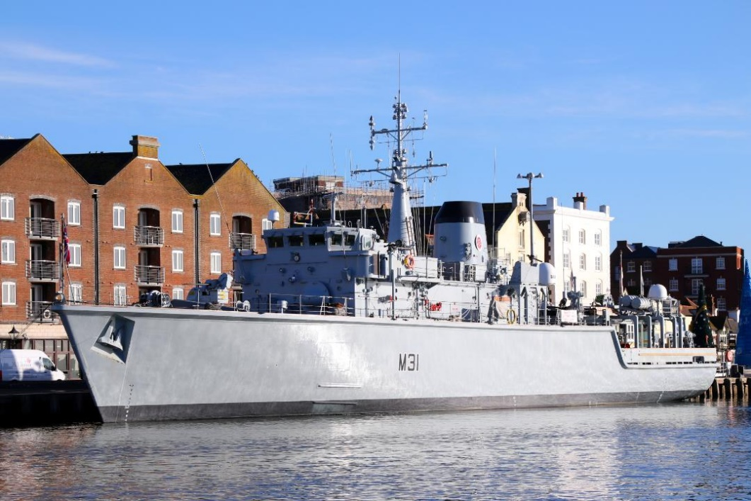
On 10th November the Royal Navy’s Hunt class mine countermeasures vessel HMS Cattistock arrived at Poole Quay for the town’s Remembrance Day events. At 11am on 11th November the ship’s crew signalled the start and end of the two minute silence.
New Era for the Hythe Ferry
By Andrew Cooke (all images copyright Andrew Cooke)

On 7th September 2023 at midday a new era began on the historic Hythe-Southampton passenger ferry service when the reigns of the operation were passed from Blue Funnel Ferries to the Red Funnel Group. This purchase will help maintain the historic route that the ferry operates across Southampton Water and will protect the many local jobs it supports. The trading name of Blue Funnel Ferries has been replaced by the Hythe and Southampton Ferry Company Limited, now part of the Red Funnel Group. The name change recognises the 1874 company that built and operated the Hythe Pier and Ferry. The ferry berth pontoon at the pier, linkspan, piles at the pontoon, the kiosk at Town Quay, the staff and the ferry Hythe Scene were the primary assets in the sale. At that time, the pier remained the property of Blue Funnel 2005 Ltd. The relief vessel Jenny Blue resides at Solent Cruises’ base in Cowes but can be chartered in as and when required, and she saw her first recall to duty in September 2023. The Southampton Isle of Wight and South of England Royal Mail Steam Packet Company Limited (trading as Red Funnel) has been operating a lifeline service to the Isle of Wight for almost 162 years and the Hythe Ferry also has a deep-rooted connection with the Solent area with a ferry service operating between Hythe and Southampton since the Middle Ages, first being marked on a map in 1575.
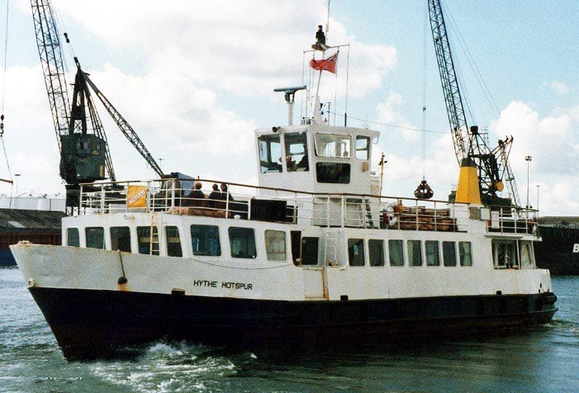

THE “HYTHE HOTSPUR” (LATER RENAMED “POOLE SCENE”) OFFERING CRUISES FROM POOLE

The first recorded scheduled crossing between Southampton and Hythe is shown as in 1830 using the wooden steamship, the Emerald. The operation faltered in 1832 with the iron-built Forester resuming the link in 1835. The pier opened in 1881 with the ferry then provided by the Hythe Pier and Hythe and Southampton Ferry Company Ltd. The name changed to the Hythe Pier Company in 1923 with services provided by the General Estates Company, formed in 1900. This was owned by the Percy family, a famous member of which had been known as Harry Hotspur. The Hotspur naming trend is linked to Harry with this being applied to the ferries as early as 1889 when the paddle driven Hotspur I was delivered.
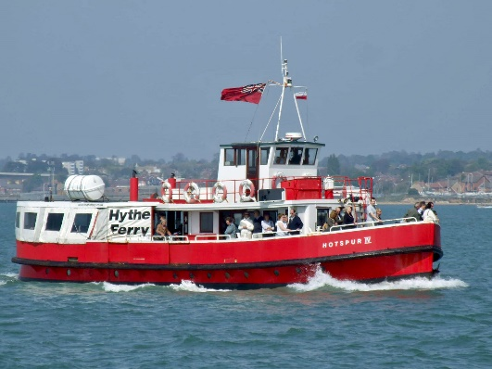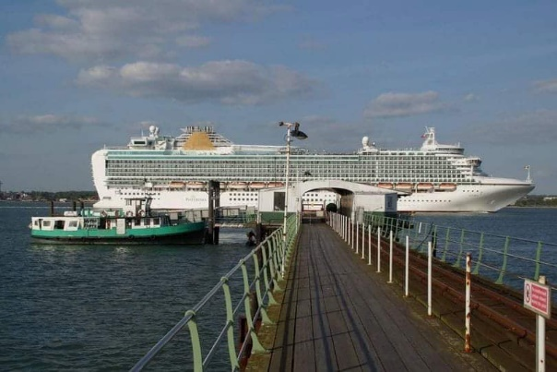

“HOTSPUR IV” IN HER ELEMENT TOWARDS THE END OF HER CAREER.
The Hotspur II was added in 1927, built by Samuel White at Cowes, then the Hotspur III in 1938, followed by the Hotspur IV in 1946. The multi-purpose Hythe Hotspur (ex-Southsea Queen) was acquired in 1978 (now the Cruiser and sold to Jetstream Tours in 2023) followed by the waterbus-style New Forester in summer 1982 (now operating on the River Thames as the golden Star).
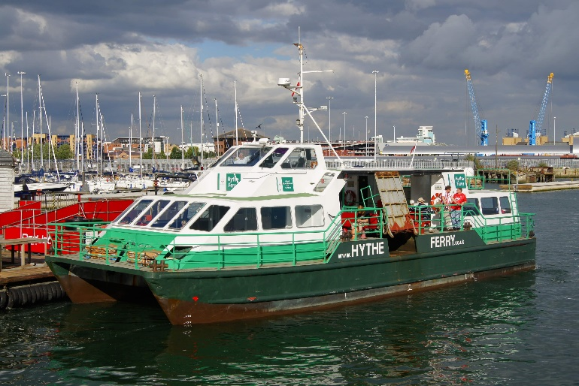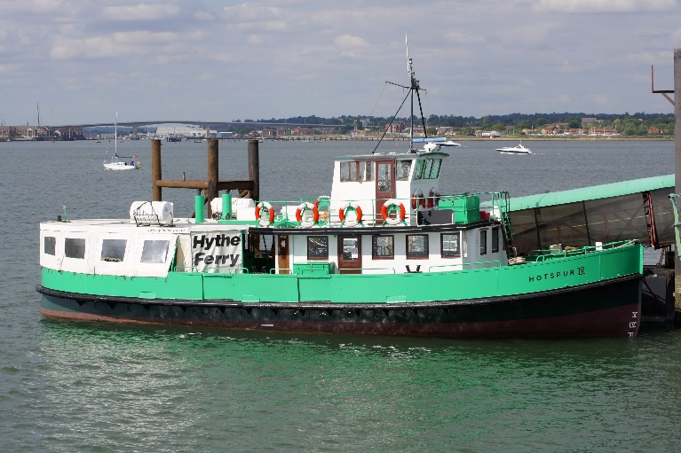

“GREAT EXPECTATIONS” UNDER THE OWNERSHIP OF WHITE HORSE FERRIES AND THE OLD “HOTSPUR IV” THAT WAS RESERVE VESSEL FOR MOST OF THE TIME
Ownership changes for the service in the 1980s concluded with White Horse Ferries who transferred the 1992-built Great Expectations to the service in 1995. Blue Funnel Ferries took over in 2017, with the Great Expectations being renamed Hythe Scene (the Writer actually won the naming competition!).
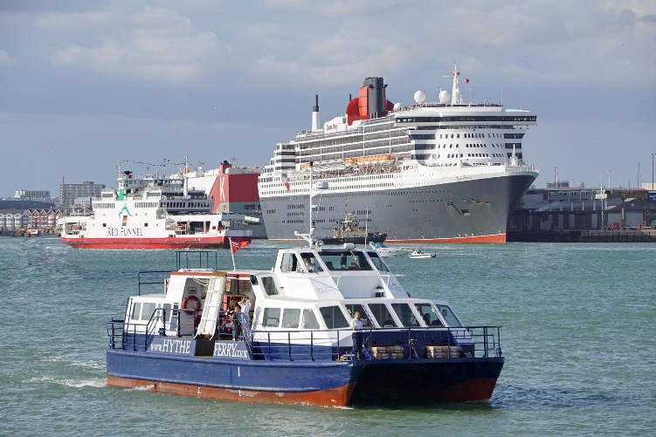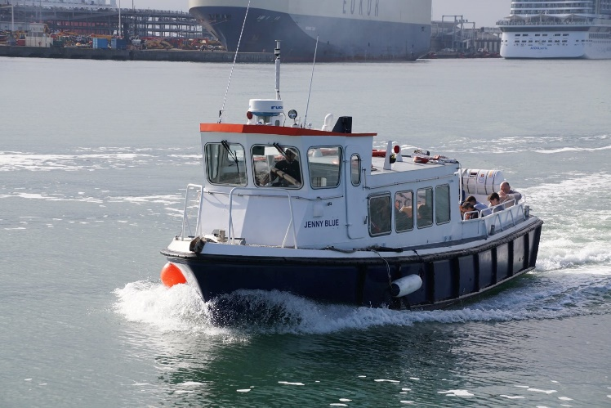

A BUSY SOUTHAMPTON PORT WITH THE “HYTHE SCENE” UNDER THE OWNERSHIP OF BLUE FUNNEL CRUISES AND BACKUP FERRY “JENNY BLUE”

The Jenny Blue was then added as back-up vessel, effectively replacing the Hotspur IV, withdrawn back in 2014. The first crossing of the Hythe Ferry under Red Funnel ownership was the 12.15 departure from Hythe (from the 12.10 pier train) to Town Quay, Southampton on 7th September. The Writer was invited to be present on this historic occasion and the ferry was greeted by Red Funnel CEO, Capt. Fran Collins, at Town Quay. The 640m long Hythe Pier is Grade II listed and carries an electric railway that is the oldest continuously operating public pier train in the world.

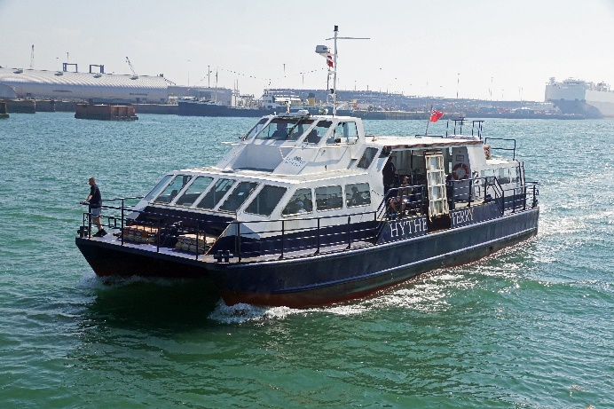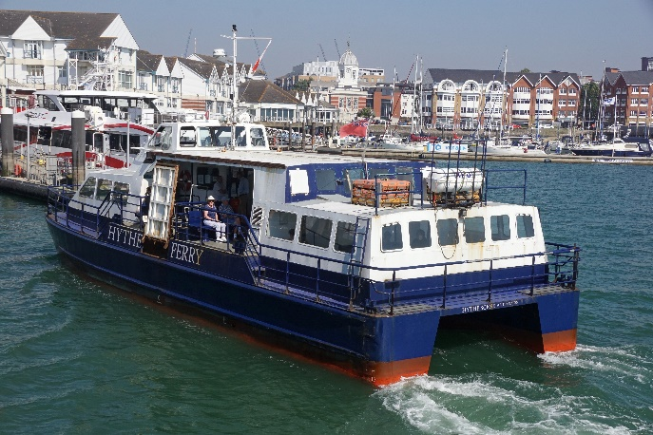

“HYTHE SCENE” MAKING HER FIRST FERRY CROSSING UNDER THE RED FUNNEL FLAG

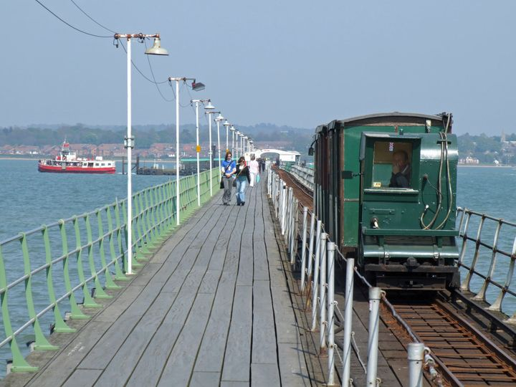

A TIMELESS SCENE AT HYTHE THAT, THANKFULLY, HAS BEEN PRESERVED
