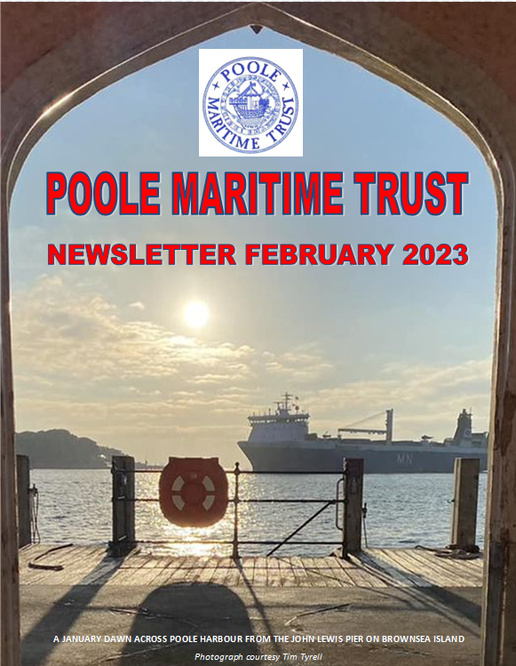

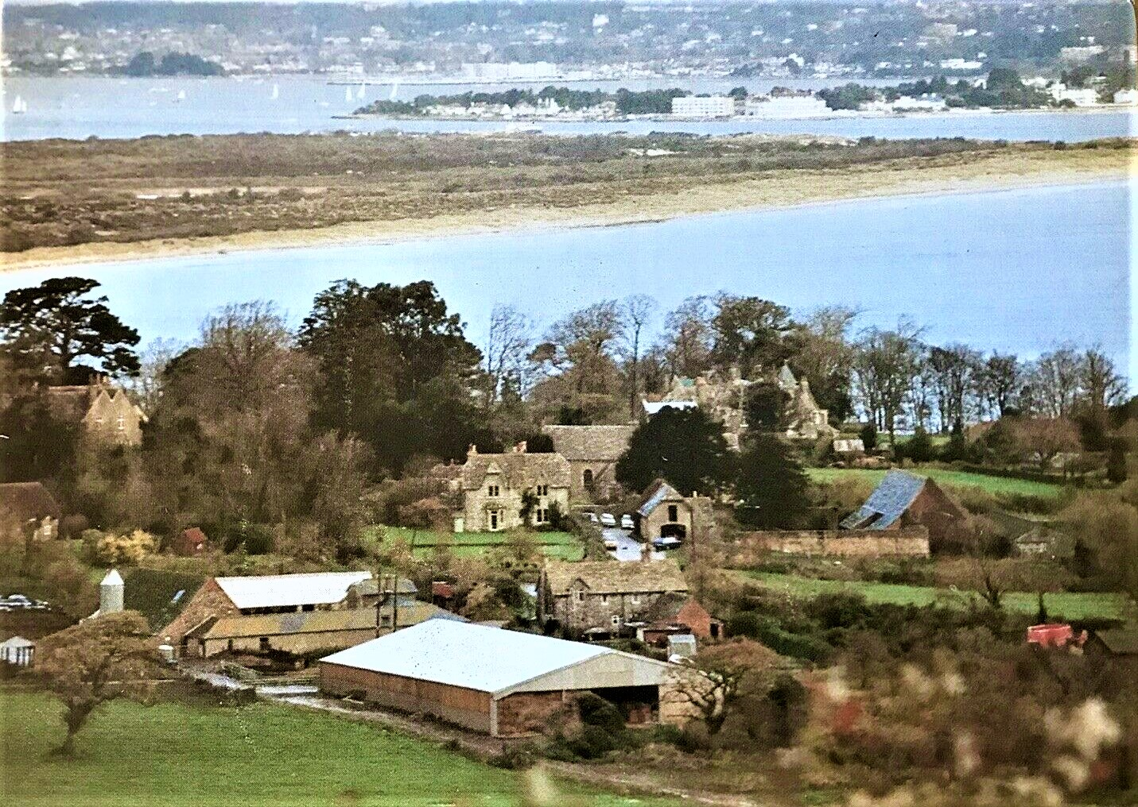
An interesting harbour view Photo : Andrew Hawkes
LIBRARY NEWS
A selection of the books donated and added to the library recently. They show the wide range of subjects that are included in the library. All these books are available to borrow from the office above Canford Cliffs Library as well as the other 2800 books that we have in stock!! See the PMT website for a complete list.
PUSHMAN. David The loss of the S S Treveal – a Dorset shipwreck mystery (70/2808)
LE PARD, Gordon Dorset then & now from the air (68/2728)
GRICE, R B & HUTCHINGS, D F Southampton shipping with Portsmouth, (68/2729)
Poole & Weymouth
CAMERON, Ian Riders of the storm: the story of the RNLI (70/2812)
FARRINGTON. K & CONSTABLE, N Mayday! Mayday! The history of coastal (70/2810)
rescue in Britain & Ireland
BAILEY, Maurice & Maralyn 117 days adrift (70/2795)
NORTON, Trevor Stars beneath the sea: the extraordinary lives of the (70/2789)
pioneers of diving
DIVINE, David These splendid ships: the story of the Peninsular & (69/2770)
Orient Line
GRAY, Edwyn Few survived: a comprehensive survey of submarine (68/2748)
accidents & disasters
JESSOP, Keith Goldfinder: the true story of one man’s discovery of (69/2775)
the ocean’s richest secrets
SHANKS, R, YORK, W & SHANKS, L W US Lifesaving service: heroes, (71/2835)
rescue and architecture of the early coastguard.
JANE'S FIGHTING SHIPS 1965-66 (71/2840)
COCKSEDGE, A E Ships built at Poole Volumes 1-5 (7 / 4-8)
ARCHIVE REPORT
The past couple of months have proved extremely busy for the archive team. The Trust has been fortunate in being in receipt of some very notable and historic donations. We are indebted to those who have elected to favour the Trust and ensure treasured family items are secure for the benefit of future generations.
- Tom Wareham has generously donated an, almost, unique collection of Royal Navy related books covering the past three centuries. This is a very important and welcome addition to our vast collection of books. We have previously, but a few, covering the history of the Royal Navy and the collection plugs a few very important gaps in our recorded history.
- Duncan Nicholson has added to his earlier donation of his late Father, John’s, remarkable work. John was an accomplished artist and maritime historian. We are in receipt of an extensive archive of John’s work and a large number of personal photograph albums with images dating from the 1950’s. The images are, in many cases, very rare and benefit from the meticulous written detail John added to each image. Here is an example of John’s remarkable talent.
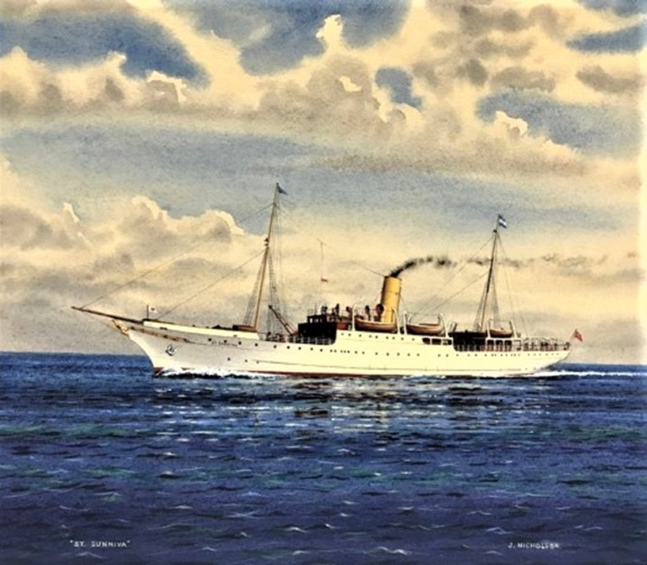
S.S. St. SUNNIVA
The “SUNNIUVA” enjoyed a remarkable career, the history of which, is captured here.
SS St. Sunniva was one of the first purpose-built cruise ships. Converted into a ferry in 1908, she operated as the Lerwick mail steamer until 10 April 1930, when she ran aground off Shetland and was a complete loss. SS St. Sunniva was ordered by the North of Scotland, Orkney & Shetland Steam Navigation Company (more commonly referred to as "The North Company") after the success of their earlier cruise vessel, the St. Rognvald. She was ordered from Hall, Russell & Company of Aberdeen for delivery in time for the 1887 season. The ship was designed to resemble a classic steam yacht in form and carried a small steam launch for landing passengers when necessary. The accommodation comprised 16 x two berth cabins on either side of the main deck, with a further two berth cabin and a twelve berth ladies' cabin on the centreline. A bathroom and three toilets was sited on either side of the main deck with an additional bathroom and two toilets provided for the ladies' cabin. The ladies' cabin was fitted with two washbasins and all the other main deck cabins were fitted with their own washbasin. 8 x four berth cabins were sited aft on the lower deck, each with a washbasin, and forward of the machinery space were 2 x four berth and 4 x six berth cabins with a common bathroom and two washbasins. No toilets were provided on the lower deck.The main saloon could hold 132 people per sitting, with a piano provided for the use of the passengers, while a deckhouse aft of the mainmast held a ladies' lounge and a separate men's smoking room. The St. Sunniva was a great commercial success as a cruise ship. However, in 1907–1908, the North Company reduced the number of the ship's cruises, and entirely withdrew from the market at the end of August 1908. It was subsequently decided to convert the ship into a ferry and to that end the lower deck accommodation was removed and cargo holds created. The main deck accommodation was also completely remodelled and the superstructure was extended. Following this remodelling, the St. Sunniva entered service as a mail steamer on the Lerwick route, operating a weekly service from Leith and Aberdeen. She remained on this demanding service until 10 April 1930 when, while sailing north in fog, she ran aground on the uninhabited island of Mousa, Shetland. All passengers and crew were rescued but the ship was a complete loss
- Mr Peter Arnold recently called into the library, bringing with him a remarkable collection of superb pen and ink drawings produced by his Step-Father. Trust members were absolutely thrilled and amazed by such incredible detail and fine drawings besides the intricate paint work. We are hoping to display them with great care and precision so that others might also enjoy this excellent work.

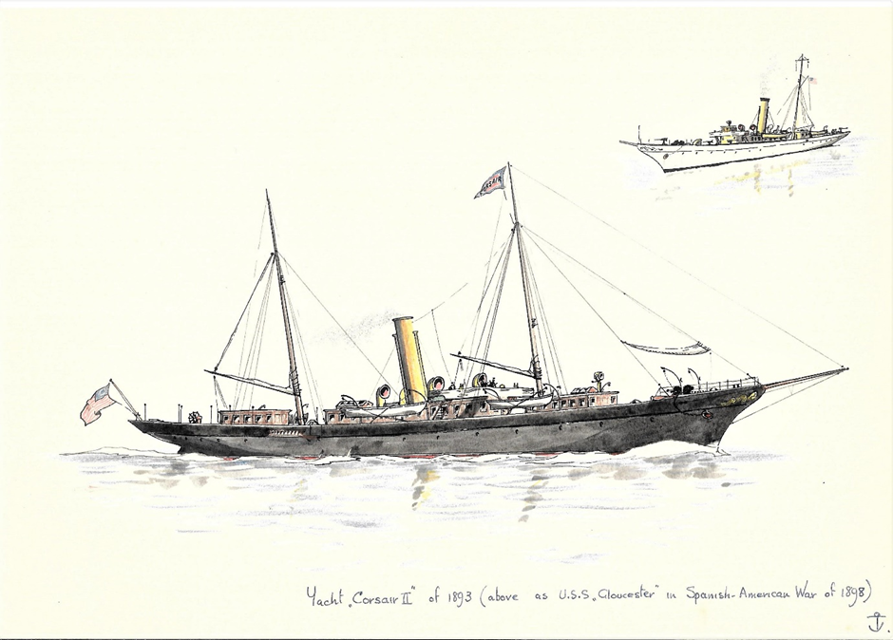
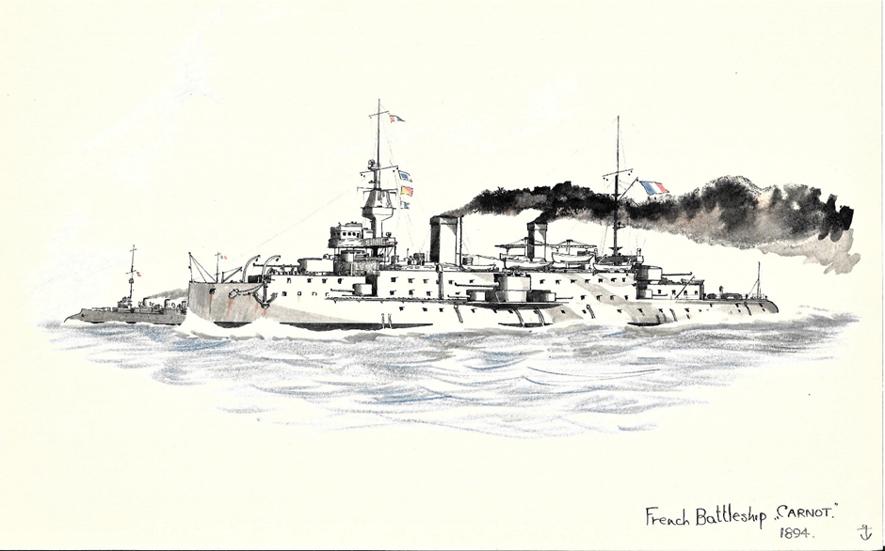
- Our appreciation goes to Chris Wood who has painstakingly brought our recently donated wonderful model of the paddle steamer “LORNA DOONE” back to it’s best.
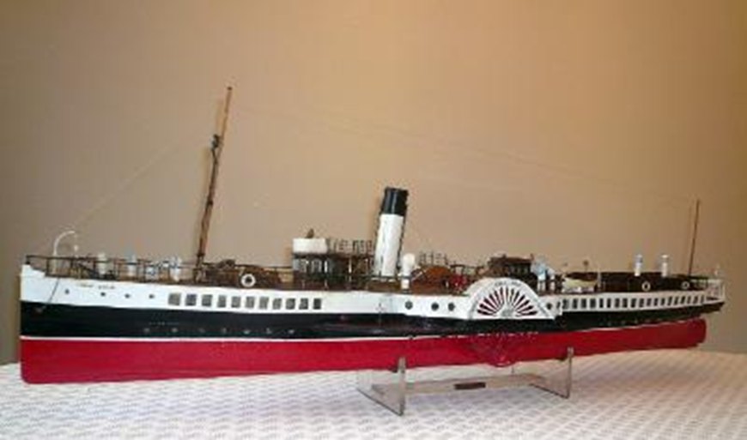

- We are, also, indebted to John Megoran for donating further valuable publications and maritime ephemera from the estate of the late Stafford Ellerman
- Our diving specialist, David Sewell continues to bring in some remarkable and rare books that are a welcome and major boost to the library.
Donations are always welcomed and appreciated. We can arrange for collection or donors are always welcome to the Trust offices. Please contact : poolemaritimetrust@aol.com or call 07718934425 should you wish to discuss possible donations.

MEMBERSHIP TO POOLE MARITIME TRUST
Becoming a Member of POOLE MARITIME TRUST gives us a wonderful opportunity to learn more about our magnificent harbour and its incredible history – a history which goes back 7,000 years to the end of the last Ice Age (and we have evidence to prove this). The raison d’etre of POOLE MARITIME TRUST is to protect and preserve the history of Poole Harbour, and its environs, for future generations – what a wonderful legacy. We are an active organisation that welcomes new members and have a great deal to offer. As well as arranging a full programme of lectures, trips, dinners and social events, it also provides us with access to an incredible library and archive. Membership to The Trust costs just £20 a year for Single Membership and £30 a year for Family Membership (and that includes couples). Application forms can be found online and once completed, should be sent to: The Membership Secretary, Poole Maritime Trust, 6 Western Road, Poole, Dorset, BH13 7BN.
We look forward to welcoming you.
THE ESSO ROAD TANKER BUNKERING THE
“PRINCESS ELIZABETH”
ALONGSIDE POOLE QUAY IN 1962
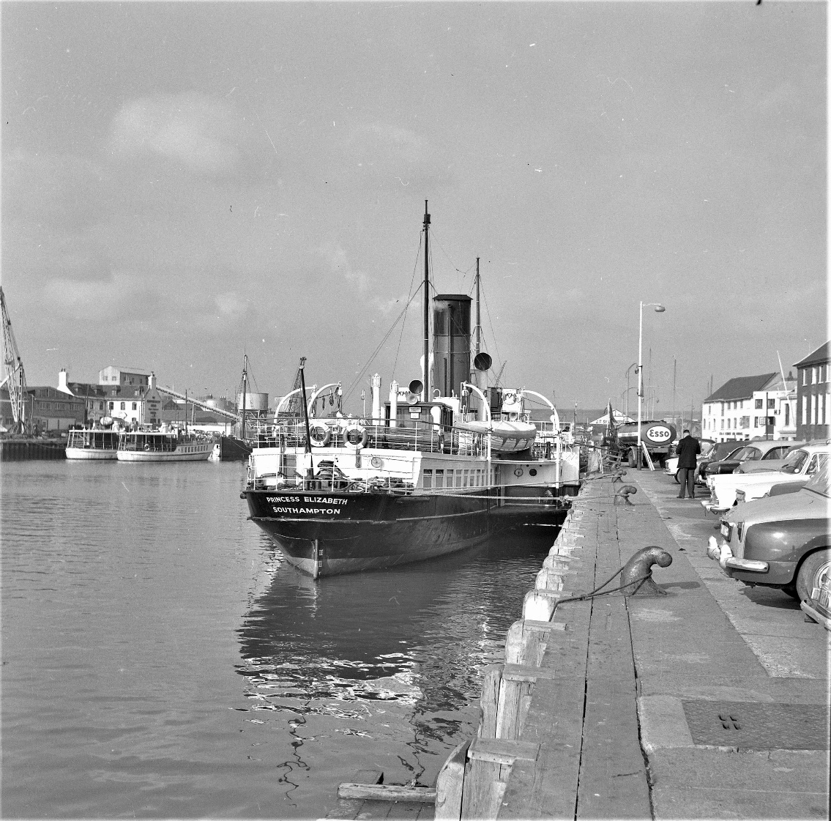
image – Poole Maritime Trust Archive
Poole Maritime Trust Newsletter February 2023
Port Update by Kevin Mitchell
Condor Liberation returned from its annual overhaul and repaint at Falmouth dry-dock during mid-December. However, its first sailing to the Channel Islands the next day was cancelled due to technical problems. This drone image of her was taken by Darryl Morrell.
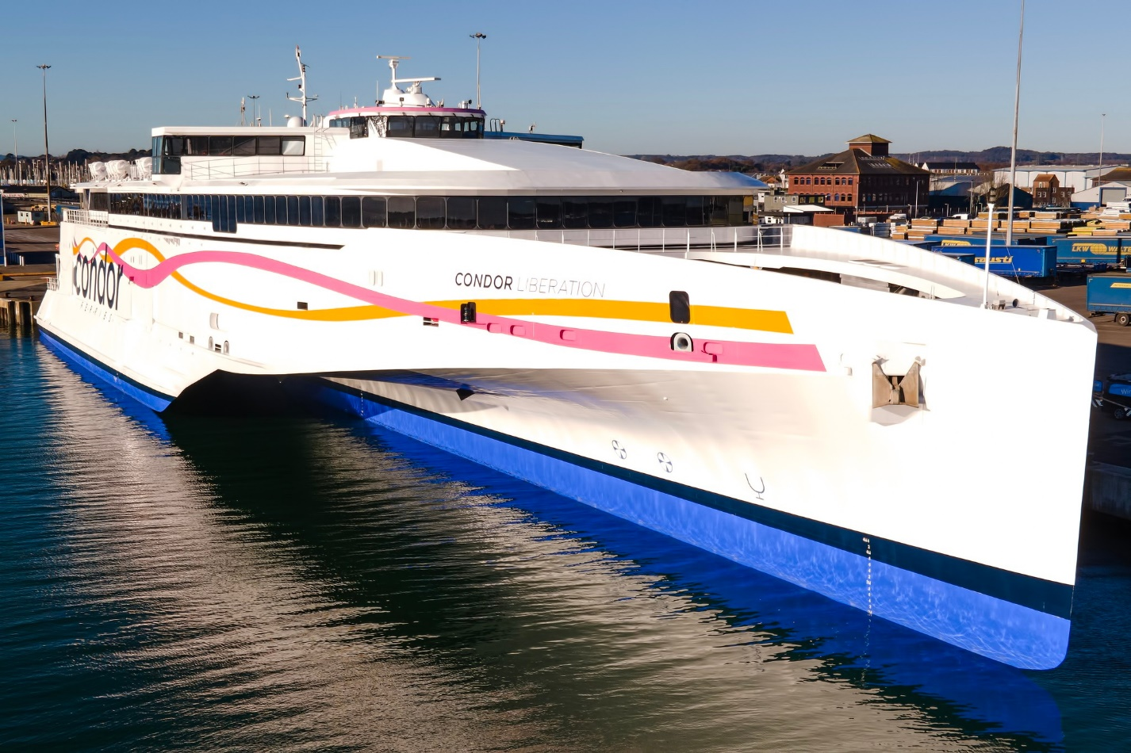

On 16 December Poole Harbour Commissioners held a fuel spill exercise. A boom was deployed off one of the cargo quays to test the response in case of a real fuel spill from a ship.
Having spent the summer bringing felled trees from Brownsea Island to South Quay at the Port of Poole, the barge Vodka III spent December taking gravel to the island as the National Trust are relaying the tracks and paths there. Thanks to Joseph Lambert for the photos.
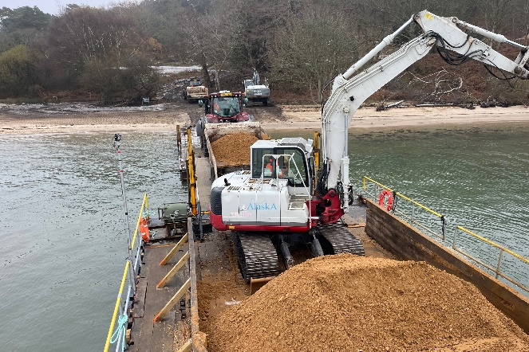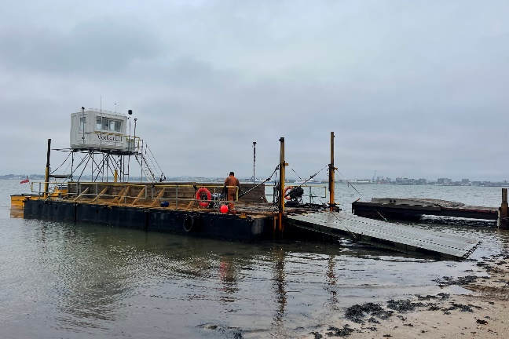
This year Poole ferry port (the Continental Freight Ferry Terminal to give its correct title) celebrates 50 years, having opened in June 1973 for Truckline’s freight service to Cherbourg, which started with the Poole Antelope, named after the pub in the Lower Hight Street!
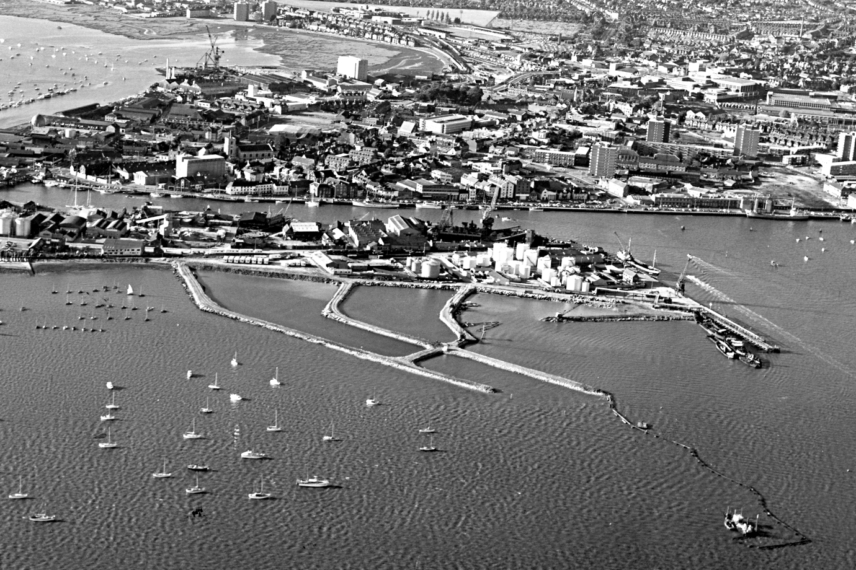
These photos show reclamation work at Lower Hamworthy to create the original port area, and a view during the early years.
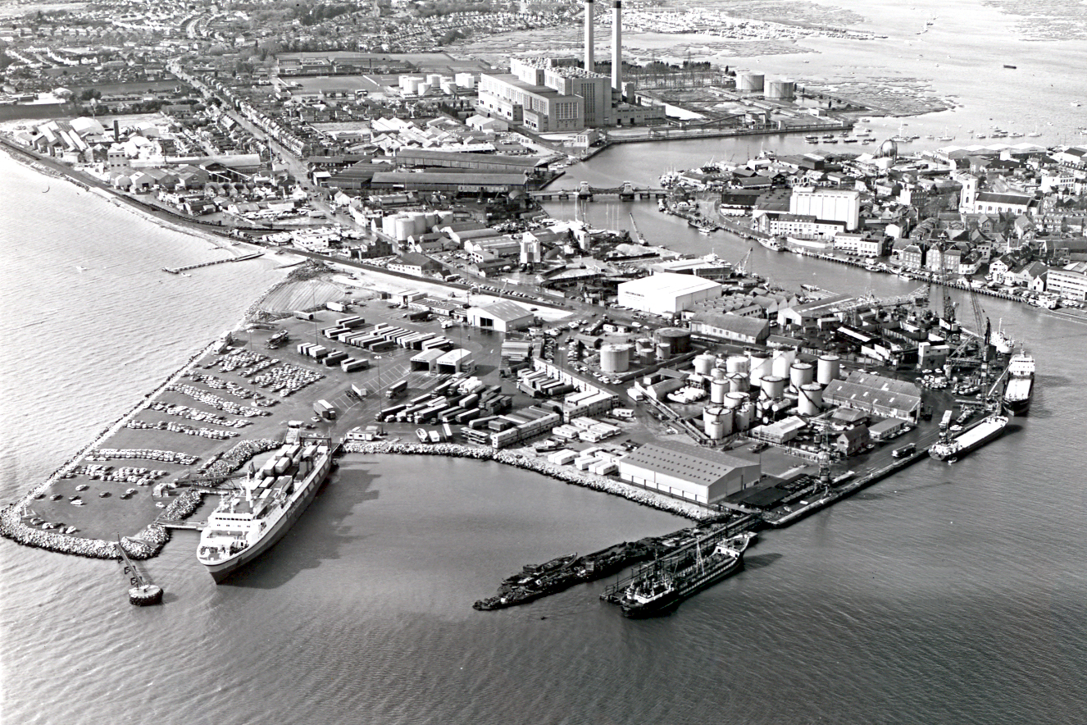
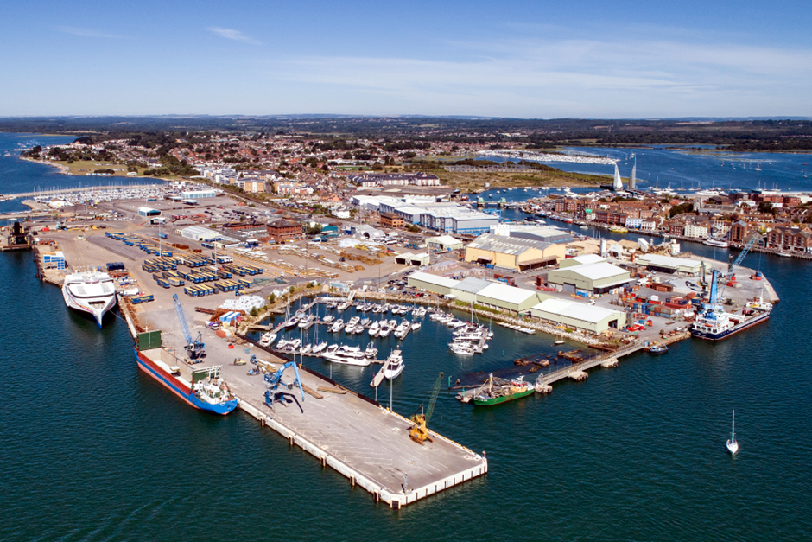

The port has been further extended over the decades to give the ferry port we know today. The very first passenger ferry called on 6 September 1983. Townsend Thoresen’s Free Enterprise V had been chartered by the Poole-Cherbourg Twinning Association for a special day trip carrying 899 foot passengers, this proving so popular that further such trips were organised. Free Enterprise V actually moored alongside Town Quay, as shown in these two photos.
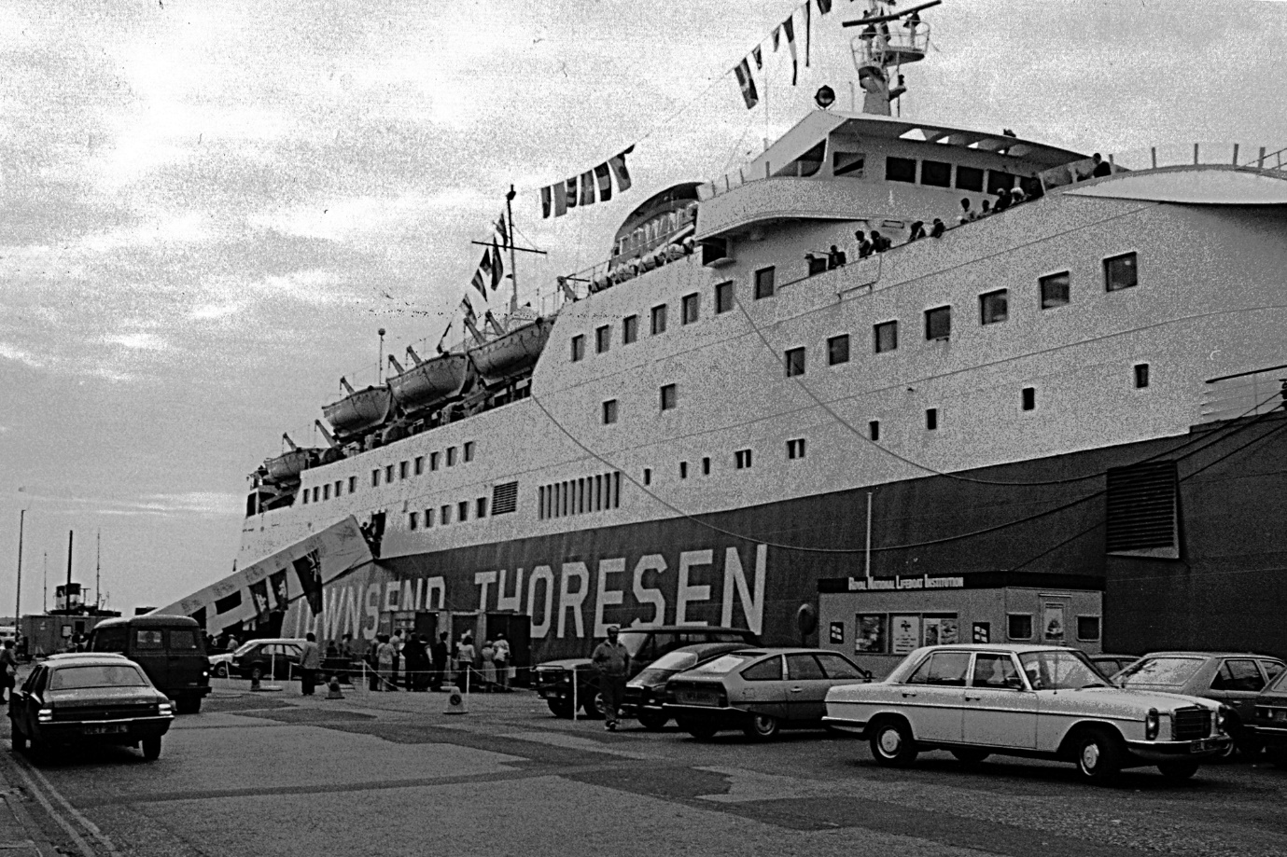
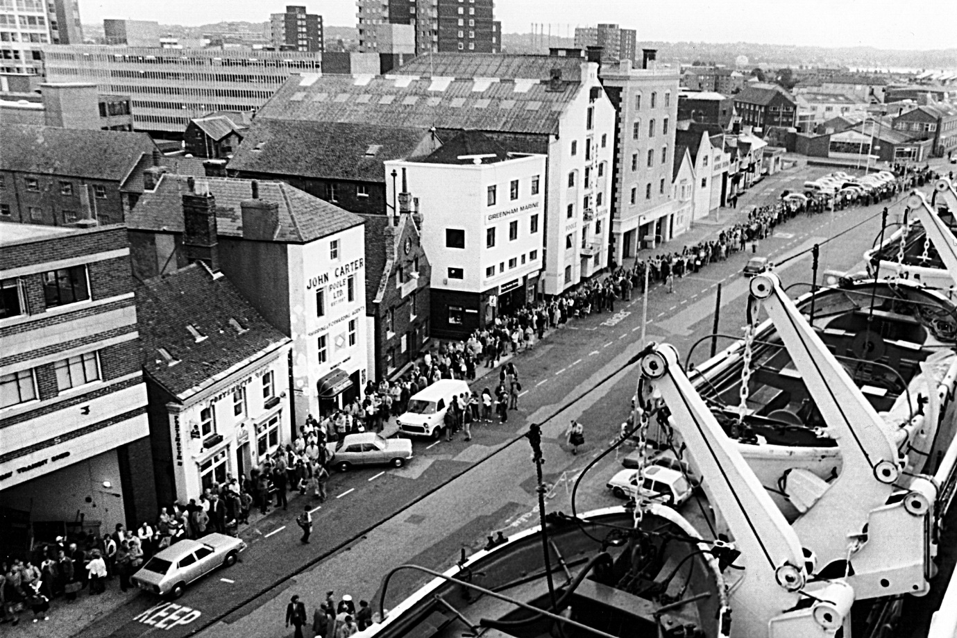
Truckline started regular passenger sailings to Cherbourg during 1986, the same year that Channel Islands sailings first started, whilst links with Iberia began the following year. Today, Barfleur provides a seasonal service to Cherbourg and MN Pelican sails year-round with freight to Bilbao. Condor Liberation and Condor Voyager link Poole with Jersey and Guernsey.
-------------------------------------------------------------------------------------------------
AN EXAMPLE OF THE PRE-WAR PROMOTION OF SOUTHAMPTON DOCKS
BY THE THEN OWNERS – THE SOUTHERN RAILWAY

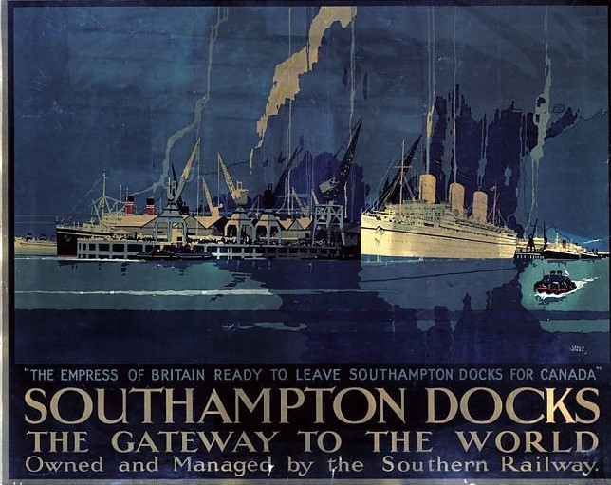
PARTICULARS
OF THE
LOSS OF THE WAREHAM AND POOLE PASSAGE BOAT
On THURSDAY, OCTOBER the 2nd, 1806
~~~~~~~~~~~~~~~~~~~~~~~~~

THE BOAT left Poole Quay between five and six o’clock on Thursday evening, deeply laden, and besides had on board twelve passengers (two men and ten women) besides Mr GILLINGHAM of Wareham the owner of the boat, and two boatmen (Wm. TURNER and CHARLES WHITE, Junr) in all fifteen persons; the wind was right ahead, - between six and seven o’clock it blew hard, darkness hastened on, with a thick fog and rain; just as they entered Wareham (at a place called the first and last boom) the boat ran aground and remained athwart the channel, the wind blowing so strong on her larboard side, and the sails being all up, caused the boat to dip several times: they perceived their danger and all crowded towards the mast and rigging, the men got aloft, in a few moments she sank! and the current racing against the sails drove all under water, so that those who had got to the top of the mast for safety were obliged to commit themselves to the mercy of the waves. Mr EVERETT of Wareham (the only man who escaped, and by whose humane exertions a poor woman of the name of WHITE was also saved) attempted to swim to the nearest shore, which was scarcely a hundred yards on the Purbeck side, but being encumbered with a great coat and the woman having hold of him, retarded his swimming so much that (self preservation so far getting the better part of humanity) he had formed the dreadful (tho’ necessary) resolution of shaking her off and leaving her to her fate, but at that moment one of the oars floated just before him which he eagerly caught at, and placed the woman upon it; and after struggling with the waves for one hour and a half he found himself on the shore with the woman, who was too exhausted to proceed a step. He hastened immediately to a house and requested their assistance, but they were deaf to his entreaties; he then went to the next house where he obtained it and went on to Wareham, about 2 ½ miles from where he landed where the humane exertion of Capt BARTLETT were eminently conspicuous, and who immediately hastened with everything necessary, to the relief of the poor woman, and brought her in a post chaise to his house, and every possible care was taken of her till she was restored to her grateful husband and children.
DROWNED
William Gillingham, of Wareham, aged 52
William Oxford 27
William Turner 52
Charles White Jun 33
Elizabeth Pindar 27
Betty Brown 33
Amelia Randall, Stobro 19
Edith Randall 24
Elizabeth Mintern 28
Elizabeth Forster 17
Mary New, Church Knowle 33
Mary Barnes 32
Sophia Davey, East Stoke 19
SAVED
Mr Edward Everett, of Wareham
Mrs White, Church Knowle
POOLE WAREHAM PASSENGER BOAT DISASTER
Location of accident from contemporary reports is stated as “off Swineham Point” or “Buoy WH12”
Further report from Salisbury & Winchester Journal, October 1806
…after struggling with the waves for upwards of two hours he gained the shore with the woman and after climbing up the bank he drew up the woman; but it was so dark and foggy that he did not know at that time whereabouts he was and he wandered about with the woman on the moor until she was quite exhausted and unable to proceed further and she laid down almost insensible among the rushes. He at length discovered a cottage (which proved to be at Keysworth, two and a half miles from Wareham), and made known to its humble tenants, a labouring man and his wife, the situation in which he had left Mrs White and with that humanity which is the characteristic of the English peasantry, the man proceeded, with two other labourers belonging to the farm, in search of the poor woman, while Mr Everett went on to Wareham, where he arrived about twelve o’clock and made known the melancholy accident to Captain Bartlett [Recorder of Wareham and Lord of the Manor of Stoborough, Captain of the Loyal Volunteers?], whose humane exertions were eminently conspicuous. He immediately hastened, accompanied by Mr Everett, with everything necessary to the relief of the poor woman (who had been found by the labouring men who went in search of her on the moor) and brought her in a post chaise to his own house and every possible care was taken of her till she was restored to her grateful husband and children.
“The Aftermath”
On 9th October 1806 a meeting was held at Wareham Town Hall between the Mayor, Corporation and the principal inhabitants of the town. They were to consider how best to help the relations of those lost in the disaster. A committee was appointed consisting of the John Calcraft, Rev Mr Hyde, Rev Mr Thomas, Rev Mr Bannister, John Barker, Thomas Bartlett, Captain Ellis, Thomas Brown, Richard Wright, Thomas Phippard, Robert Dugdale, Elias Dugdale, James Panton, Robert Tuck, Edward Dean, Edward Everett and other gentlemen as the town thought proper. The committee resolved that those involved in the search for survivors should give an account of their experiences at the next committee meeting. They also resolved to open a fund for the relief of the relations of those lost. The bodies of all those lost were found and buried mostly at Wareham. There were six burials at Wareham on 5th October and one at East Stoke, one burial at Wareham on 6th October and a further two burials at Wareham on 9th October. I have been unable to find a burial record for Elizabeth Mintern and Mary Barnes.
Sources
Dorset Shipwrecks David Burnett 1982
Somerset & Dorset Notes & Queries Vol 7, 1900
Bournemouth Evening Echo 28 Sep 1988

THE SOCIETY FOR POOLE ARE PLANNING TO REVIVE THE ANCIENT CEREMONY
“BEATING OF THE SEA BOUNDS” IN 2024
Beating the Sea Bounds of Poole
A brief history by Mike Pearce

The original purpose of the Beating of the Bounds of Poole Harbour was to check the various marks and boundaries of the original Winchelsea Certificate, awarded to Poole in 1364, to see that the “bounds” or boundary markers still exist, that they are in the correct position and that there has been no encroachment upon waters belonging to the Port of Poole. The Winchelsea Certificate was of prime importance to Poole as it confirmed the limits of the town’s maritime jurisdiction over the port. The Mayor being “Admiral of the Port” it was he who presided over the locally held Admiralty Courts and it was essential to know his jurisdiction.
Wareham was a particularly difficult neighbour with their fishermen accused in 1600 of driving all the fish out of the harbour. They were fined ten shillings! Although many of the boundary points were well known they weren’t all properly defined, however from approximately 1612 one boundary was deemed to commence at “Brome Hill” (now Broomhill in New Quay Road, Hamworthy) thence to “Shag Rock” above Russel Point “right against a little hill called Redcliffe Atwell” in the Wareham Channel some 3 miles from Poole. Indeed, various methods have been used to define the boundaries including in 1609 an Admiralty Court in Poole held that the “liberties, franchises and privileges of Poole extend from “the North Hauen Poynte as farr to seaward as a Humber barrell maie be seene and described in the sea” which is about 3 miles from shore. In 1661 it was recorded that an event to “beat the bounds” was done for enjoyment and public participation. Some 20 boats set out with drums beating and colours flying, and the town was saluted with a gun “The good company made merry with the good liquors and provisions they carried with them for that purpose” In 1778 ha’penny pieces were for the first time thrown by the Mayor to children and music started to be played with two bands accompanying the party recorded in 1834.
The event was growing, in 1821 several thousand were noted to be assembled at North Haven and a 21-gun salute fired from Brownsea Island. Indeed, the Council provided dinner for 500 people and a fireworks display was seen at Heckford Field lasting until midnight. Unfortunately, the ceremony lapsed in 1834 but was revived in 1921 as a consequence of legal action taken against local residents for trespass on parts of the Harbour Shores
Since 1921 the ceremony has been undertaken many times with hundreds of boats escorting the Mayor and with parties and entertainment provided. In 1961 the ceremony was joined by the Jolly Pirates of Poole who added spice and fun to the event whilst collecting for the Mayor of Poole’s Charities. The Society for Poole, which was then The Society of Poole Men, played a pivotal role in all ceremonies since 1924 by providing Jurors escorting the Mayor on his journey across the waters of the Harbour but also supporting each Mayor on every Organising Committee.
The Society for Poole aims to re-establish the event on Poole’s event calendar, restoring this ancient ceremony, unique to Poole, by creating the pageant, a spectacular and fun event with sea shanty music and stalls along the Quay as well as Pirate “fights” and the Jurors parade.

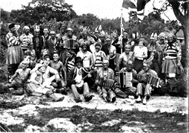
BEATING OF THE BOUNDS 1930

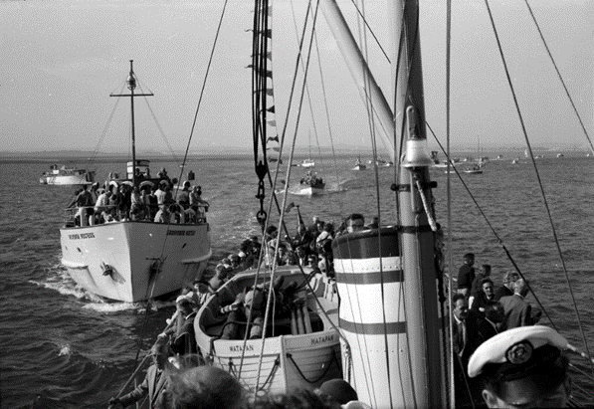

BEATING OF THE BOUNDS 1958
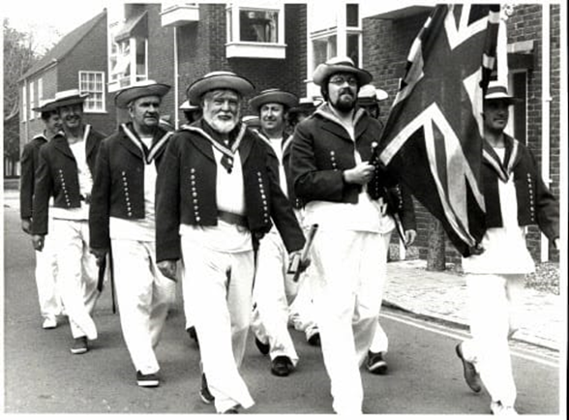

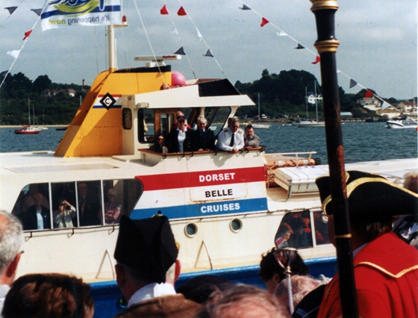

BEATING OF THE BOUNDS SEPTEMBER 2003

DUTCH AND BELGIAN REFUGEES ARRIVE IN POOLE.

In May of 1940 the war in Europe was escalating. Despite the efforts of elements of the French and Belgium Forces which were heavily supported by the British Expeditionary Force the Nazi German forces were rapidly advancing towards the English Channel. They reached Holland which led to many of the native civilian people evacuating their homeland. Most of them being women, children, and the elderly effectively making them refugees. The only safe destination that they could see was Great Britain across the water and their only immediate mode of transport was their local canal vessels called Schuyts (Skoots). These were flat bottomed shallow draft vessels between 15 metres and 40 metres originally sailed with a gaff rig, but most converted to motorised diesel engines. The main use for these vessels had been to transport goods around the canal system. Predominantly Cheese, Wine, Dry Goods, and liquids. Certainly not the number of human passengers that had to embark on this perilous journey. We can only imagine the fear, uncertainty and conditions these people had to endure in order to escape the tyranny that had invaded their country. Also, the sea worthiness of these vessels braving the North Sea and English Channel when they were only meant for the canals. The threats now coming from minefields, air attacks or Submarines must have concentrated the minds of the skippers and crews of these vessels.
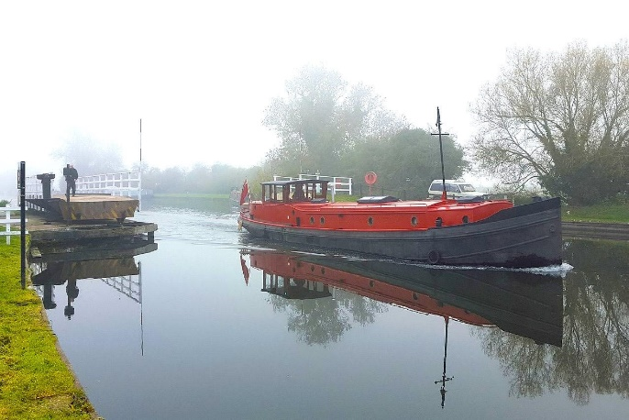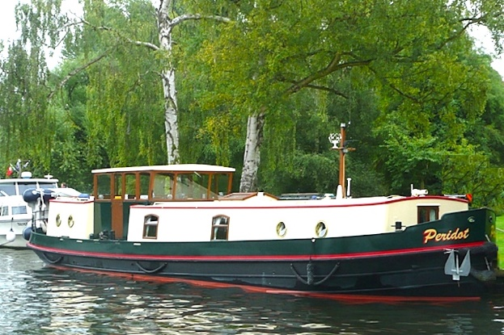
The first of these vessels arrived in Poole on 14th May 1940 and over the following 4 days up to 18 Dutch Skoots arrived bringing up to 3,500 Dutch and Belgium refugees. By then the Nazi German advance had taken Rotterdam and the Dutch Royal Family had fled to Britain. On arrival in Poole a refugee centre was set up on Brownsea Island by kind permission of Mrs Florence Bonham-Christie. This created a logistical challenge in supplying food, water, shelter and medical support. Also, the registration and assessment of everyone to ensure there was no infiltration of enemy agents. Once the refugees had been assessed they could then be moved on to safer areas within the country. This was a challenge the people of Poole took on and supported in every way. The vessels once they had deposited their passengers were then ordered to anchor in Studland Bay. One of these vessels was the Skoot SURSAM – CORDA. The Nazi German advance had taken Holland in 4 days and by the time the refugees had landed in Poole had crossed the Meuse River and three days later Antwerp had fallen and by 20th May had reached Amiens then Abbeville. Effectively splitting the defending forces who then had to make a tactical withdrawal. The destination being the beaches at Dunkirk. Therefore, two days after the Dutch vessels arrived the Naval Officer in Charge, Poole Commander Cosmo B Hastings commandeered the 18 Dutch vessels with 15 others from Poole fishing fleet, Ferries, Private yachts, and pleasure boats. The Dutch vessels were manned by Royal Navy Crews from Portsmouth and became a fundamental part of Operation Dynamo the evacuation of the BEF and French and Belgium troops from Dunkirk.
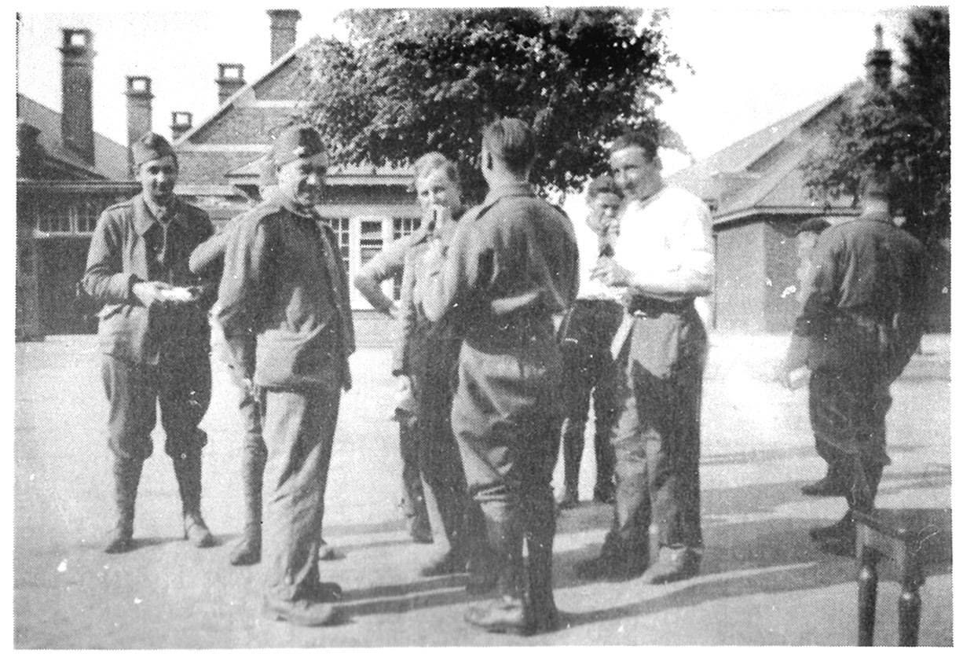
French Troops in Bournemouth June 1940
Sursam – Corda was Skippered by Lt C L G Philpotte RN. His 1st Lt was Lt Brooks. This vessel left Poole in company on 24th May and went on to rescue 370 Troops from the beaches before on its second trip floundering and finally being abandoned. This is the Skipper’s account of the vessel’s log.
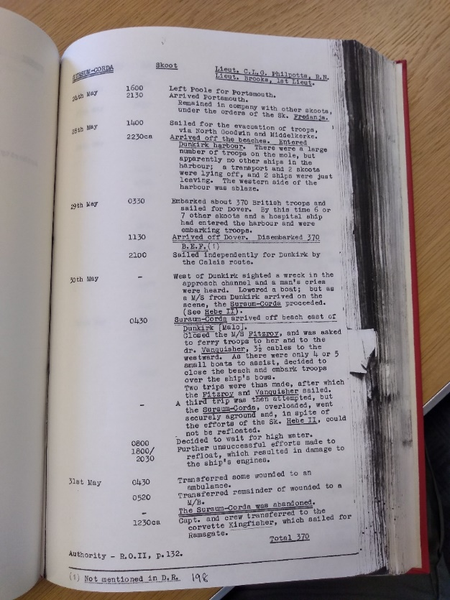
Ships log for Sursam – Corda.
Poole played a significant part in this Operation and others throughout WW2 at all levels which is something the people of Poole should be justifiably proud.
National Museum Royal Navy – Jack Hawkins
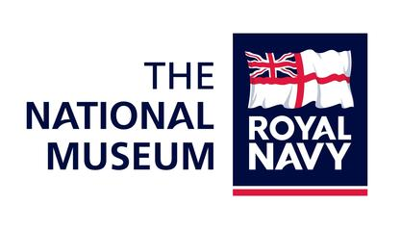
The need of creating an official historical legacy for the heritage and significance of the Royal Navy was first realised with the introduction of the Dockyard Museum at Portsmouth on 29th June 1911. From then on, several independent collections ensued around the country but relied on donations and visitors to sustain their existence. Even then this was on a relatively small scale and not sufficiently funded to preserve or maintain existing exhibits.
The National Museum Royal Navy was founded in September 2009. It was an amalgamation of several of these Naval Museums that had previously been operating on an independent basis. This allowed the heritage of the Royal Navy to be preserved in a co-ordinated organisation for generations to come. Still predominantly based in Portsmouth it now has a more National role allowing the whole nation to share in the knowledge of the rich history of the Royal Navy.
This new organisation had a vision. To be the world’s most inspiring Naval Museum linking Navy to the Nation.
Now under the Director General Professor Dominic Tweddle who leads teams of Academics, Archivists, Librarian’s and preservation and conservation specialists ensures that the Naval Heritage is acquired, catalogued, maintained and available for the public to access. It allows research to be carried out at all levels and an educational programme for students to be able to physically experience and see what they may only have learned in books. A large team of volunteers are also manning the exhibits to support and enhance the visitor’s experience. These volunteers offer personal and local knowledge around all aspects of the estate to bring alive the exhibits and inform the visitors of the Life and Times the exhibits represent throughout Naval History from 645AD to the present day.
NMRN Operations was formed which became the business arm of the organisation and is an integrated part of Portsmouth Historic Dockyard which has a shared distribution of sales revenue and costs with The Mary Rose Trust.

The NMRN assets and responsibility are spread across the UK.
Portsmouth Historic Dockyard
HMS Victory Nelson’s Flag Ship
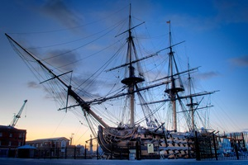
HMS Victory before the masts were removed.

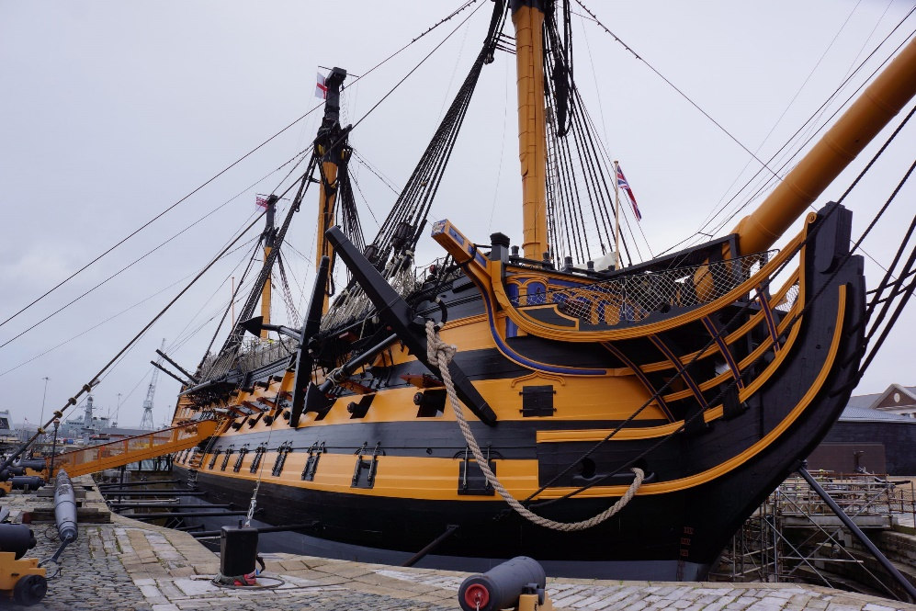
Masts removed as part of current restoration project.
HMS Victory is iconic in Naval History and still enthralls visitors with its unique stature within the Royal Dockyard. Walkways have been constructed in the dock so that the visitor can access under the vessel and appreciate her sheer size for its time. Launched in 1765 as 104 Gun Ship of the Line she is now in the process of a £35M conservation project but still open to visitors. It is an opportunity to see the vessel internally as no one has seen her before.
Victory Museum
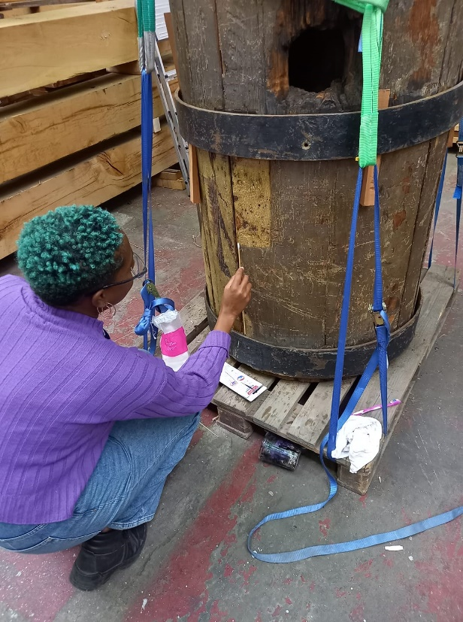
The Victory Museum holds many artifacts and displays and tells the story of HMS Victory from build to the present day. The current restoration project has meant the removal of the masts some of the originals are on display in the museum. This depicts a section of the foremast showing the damage done by a shot during the Battle of Trafalgar. This is now on display in the Victory Museum
HMS M33
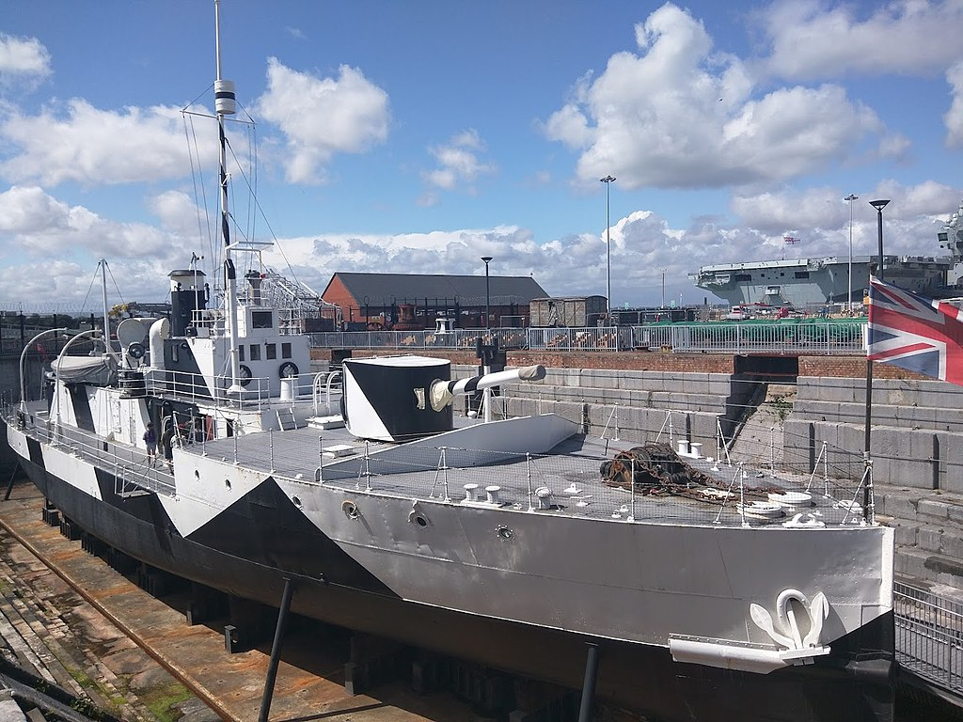
This is a WW1 Monitor which was launched in 1915 and saw service in the Gallipoli Campaign. Its primary use was for Shore Bombardment and Naval Gunfire Support.
HMS Warrior
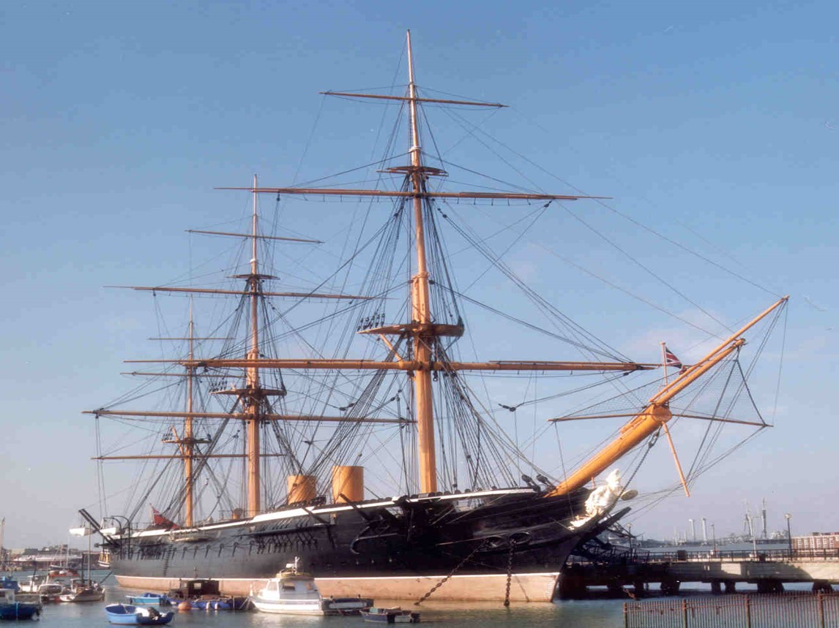
HMS Warrior launched in December 1860 is the first Iron Built Warship built for the Royal Navy. It is a fine example of Victorian engineering and how ‘Britannia Ruled the Waves’. She maintained the peace for over 10 years and with her steam engine and breech loading cannon was iconic for its time as the most powerful warship in the World.
Royal Navy Museum
This gives a graphic account through a series of original artifacts, film and interactive displays depicting the Royal Navy from the early days of sail to the present day. It gives personal experiences from “The Sailor” in My History and the important part that women played in the development of the Royal Navy as we know it today.
Royal Navy Library
The Royal Navy Library has a vast array of books, diaries, documents and records some of which can now be accessed online. It is not open to the General Public as it is situated behind the High Security fencing of HM Naval Base Portsmouth. However, there are opportunities to ask questions online or make an appointment to visit. 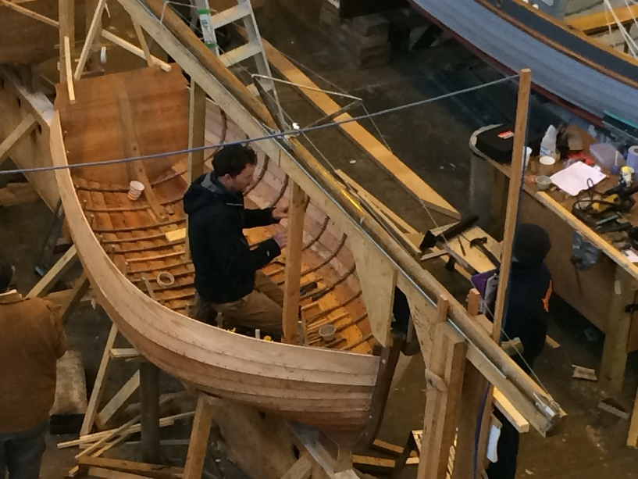
Boathouse 4
Clinker built craft being taught

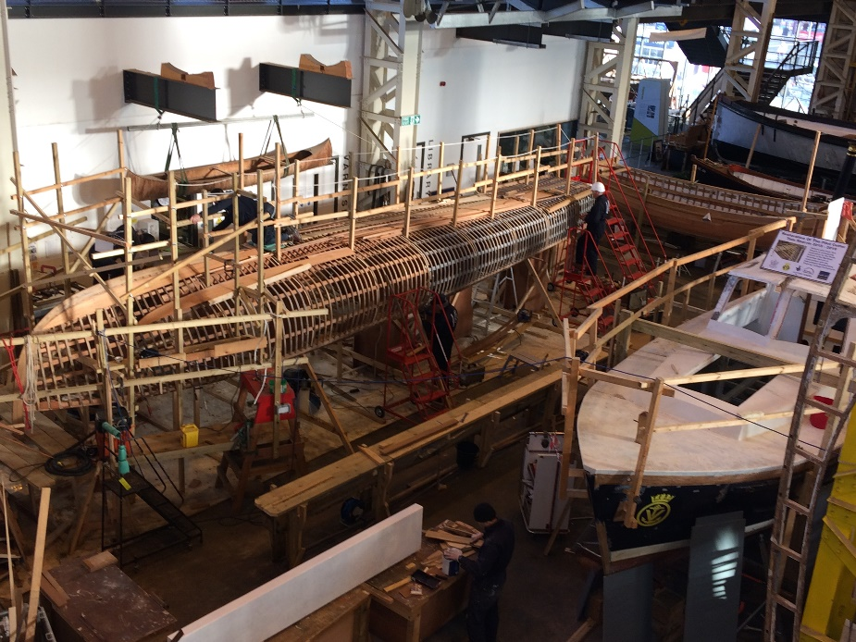
Although not directly under NMRN Boathouse 4 partners for restoration work and displays some of the NMRN exhibits. It is open to the public to see the work that is currently being undertaken.
Gosport
Explosion Museum
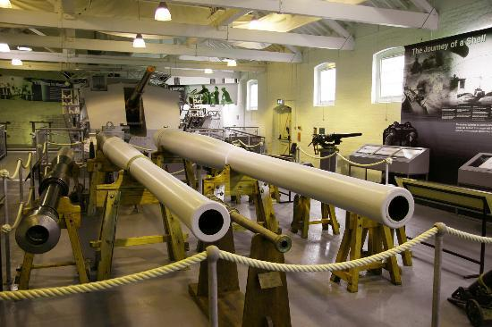
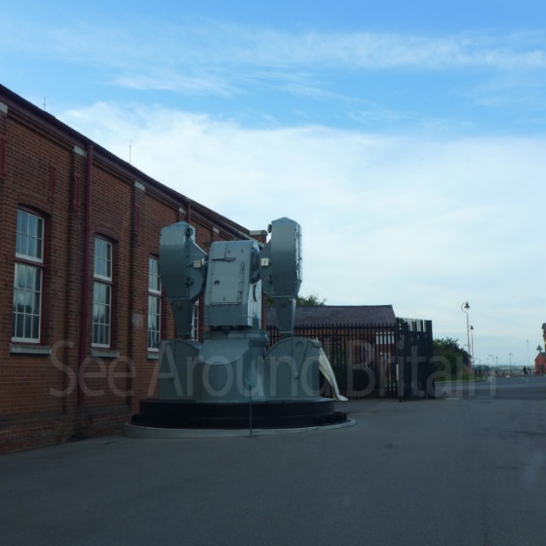
The Explosion Museum displays the Power of Naval Weaponry throughout the ages. It is also now displaying an Exhibition called Night Hunters. This is a very poignant account of the value, bravery and skill of the sailors of the Royal Navy in Coastal Forces during WW2. This includes the High Speed Launches used and graphic accounts of the raids that were undertaken. 4 Victoria Crosses were awarded.
HMS Alliance
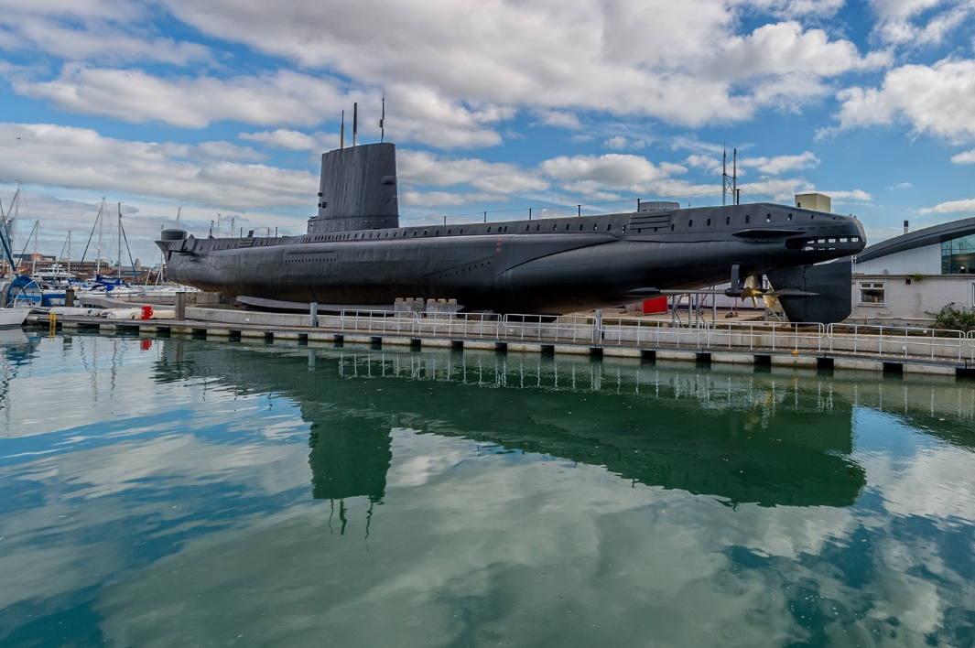
HMS Alliance was laid down at the end of WW2 and launched in 1947. She is an A Class Submarine and gives the visitor a unique experience of life at sea in a Submarine. Some of the Volunteer Guides on board served on her and have some very colourful stories of some of her trips.
RNAS Yeovilton Ilchester
Fleet Air Arm Museum
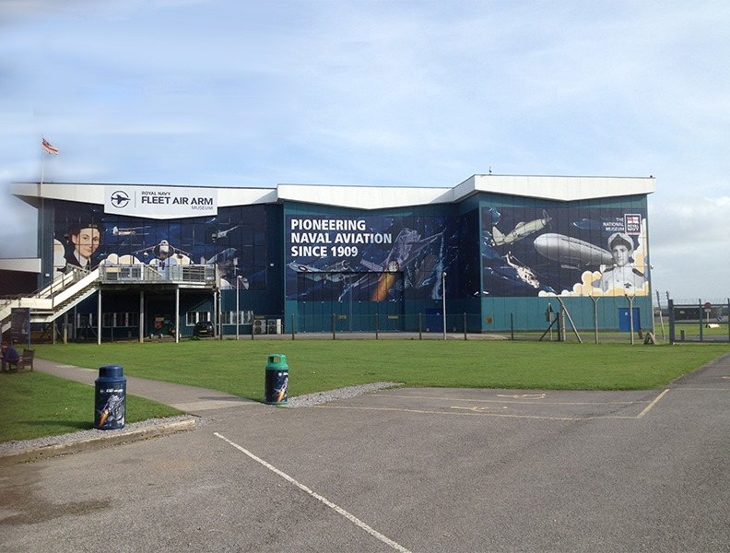
The Fleet Air Arm Museum has 90 Aircraft, 30 thousand artifacts and over 2 million documents being displayed in 4 Exhibition Halls. All relate to Naval Aviation and one of the original Concorde aircraft. One of the main attractions is entitled The Carrier Experience which gives a great insight into life and operation on board a Royal Navy Aircraft Carrier past and present.
NMRN Hartlepool
HMS Trincomalee
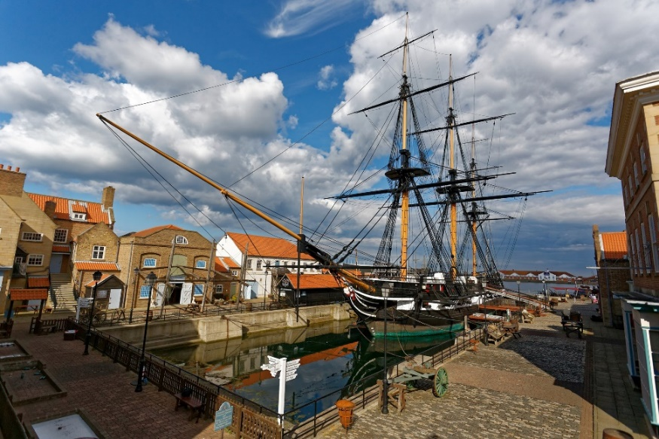
HMS Trincomalee is the last remaining Royal Navy ship that was built in India. She is still the oldest floating British Warship and the last of Admiral Horatio Nelson’s frigates that fought at Trafalgar. This magnificent restoration was completed by the same team that restored HMS Warrior between 1979 and 1987. The skills required to undertake these two projects were passed on to young Trainees and Apprentices to enable further vessels from other countries to be restored. This brought much needed employment and training opportunities to the area.
Belfast Northern Ireland
HMS Caroline
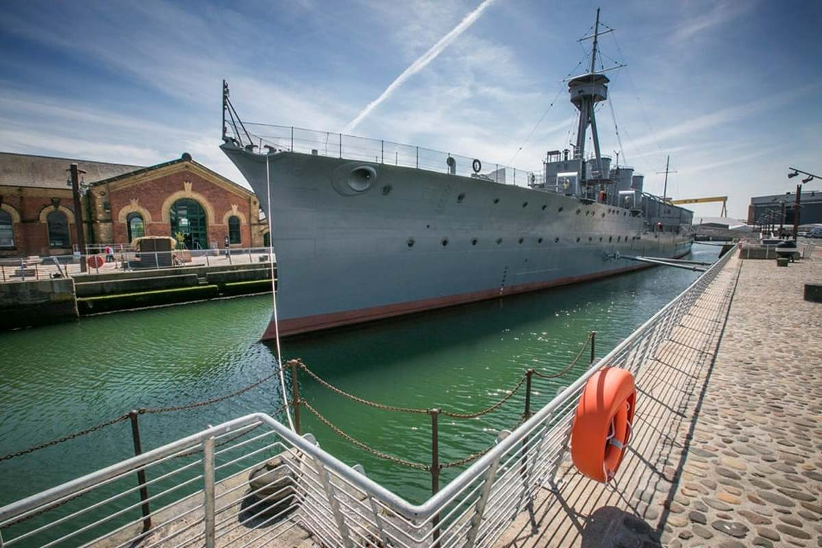

HMS Caroline is a WW1 Light Cruiser which saw service at The Battle of Jutland and gives a fine example of life on board at that time. A graphic film gives a real time experience of the battle. Shoreside there are exhibits which show the importance of early communication systems and Gun Direction techniques.
The National Museum Royal Navy is fulfilling a fundamental role in Preservation and Conservation in maintaining our Naval History. Long may this continue? To find out more detail please log in to www.nmrn.org.uk
FORTHCOMING MEETINGS AND EVENTS
Poole Maritime Trust
Meetings are held, jointly, with the Royal Motor Yacht club at their HQ and commence promptly at 20.00. Parking is free (subject to availability)
2023
2nd March : The Tyser Legacy, the foundations of the Port Line (in service 1937-1982)
26th April : AGM 11.00 for 11.30 (not the usual evening event) – Details to be circulated.
20th May : Solent Explorer Coach & Cruise – Refer to website for booking form or e-mail UKCCA@AOL.com
World Ship Society - Dorset Branch
Meets at The Centre - Ferndown, Barnes Road, BH22 8XH … our hybrid events are simultaneously available via Zoom … contact info@shipsdorset.org
~~~ ~~~ ~~~
February 11th 2023
~ Firth of Forth Shipping ~ with Iain McGeachy ~
A whistle-stop tour of the Firth’s harbours and the wide variety of shipping visiting in recent years.
~~~ ~~~ ~~~
March 11th 2023
~ Broadening my Horizons ~ with Ann Haynes ~
Travel memories and ships spotted on Ann’s 2012 OLS cruise departing from Marseilles in the south of France.
~~~ ~~~ ~~~
April 8th 2023
~ Doctor at Sea ~ with William Cremin ~
Stories of the ships and medical challenges encountered whilst serving as the medical practitioner onboard.
~~~ ~~~ ~~~
May 13th 2023
~ Visions of the Nineties ~ with Steve Pink ~
A class of six RCCL cruise ships delivered 1995-98 … if 1988 saw their first “megaship” – what came next?

BROWNSEA ISLAND 1920

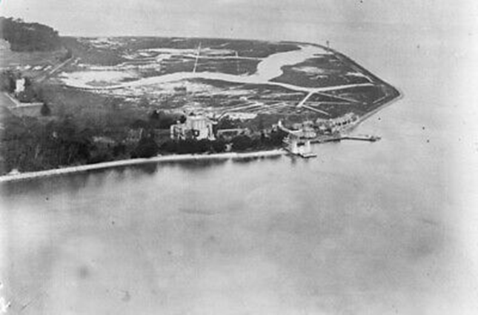

COASTAL CRUISING ASSOCIATION
SOUTH COAST SPRING WEEKEND FROM POOLE AND CHRISTCHURCH
SATURDAY 11 AND SUNDAY 12 MARCH 2023
PROMOTED BY
THE COASTAL CRUISING ASSOCIATION
(“Actively supporting Britain’s Maritime Heritage”)
SATURDAY MARCH 11th
Cruise from Poole Quay (BH15 1GZ) by City Cruises M.V. “ISLAND SCENE” 10.30.- 15.15 Fare £25
A cruise across Poole Harbour and along the river Frome to the ancient town of Wareham. 1.5 hours (approx.) will be given ashore allowing passengers the opportunity to explore, have lunch or take advantage of Wareham Saturday Market that is held upon the Town Quay. Upon re-embarkation, the “ISLAND SCENE” will retrace the winding river Frome and return to Poole Quay with an extended harbour cruise taking us through the Dorset Lakes and onward to the harbour entrance at the Haven providing panoramic views of the Purbeck Hills. There will be a fully informed commentary.
NOTES
The “ISLAND SCENE” has limited covered accommodation. In the event of inclement weather an awning is drawn across the after deck providing ample cover. The boat has a cosy saloon with refreshment and toilet facilities. Passenger numbers will be limited.
Guests travelling to Poole by bus or rail: The Quay is a twenty minute stroll from, both, the railway & bus stations. The quay is served by a bus link from both. (Route ONE – Poole Quay Circular) that operates at thirty minute intervals.
SUNDAY MARCH 12th
Depart historic Christchurch Quay (BH23 1BY) 10.30 Return 12.00 Fare £20 Lunch (optional) Main £9 Dessert £4
A rare Christchurch Harbour, rivers and creeks cruise aboard one of the Mudeford Ferries. Lunch will be available in the adjacent Christchurch Sailing club. The club lounge provides fine views across Hengistbury Head and along the river Stour. The craft is more usually employed upon the ferry service linking Mudeford Quay and the popular beach at Mudeford Sandbank. As such, it is, basically, an open boat and appropriate clothing is advised. Numbers will be limited and early booking suggested.
NOTES
There is a large public car park five minutes from Christchurch Quay (The Priory Car Park) and the quay is well-signposted. By bus: Buses serving Christchurch High Street are a ten minutes walk from the Quay. .The ferry has no onboard bathroom facilities. Public conveniences are located 150 yards from the departure point on the ‘Quomps’ recreation ground and within the Sailing Club. The Sailing Club is located adjacent to Christchurch Quay. (There are no on-site parking facilities) For more information : e-mail : UKCCA@AOL.COM or call : 07718934425
NB. All travel information is correct at the time of publication. Passengers are advised to check there are no service…………………………………………………………………………………………………………………………………………………………………………………………………………………………………………………………
BOOKING FORM – PLEASE DETACH, COMPLETE AND SUBMIT WITH PAYMENT AND A STAMPED ADDRESSED ENVELOPE
Name_______________ ____________ Tel. No. _______________ E-mail_____________________________________
Postal Address : ________________________________________________________________________________________
SATURDAY MARCH 11th
“ISLAND SCENE” CRUISE – TO WAREHAM : Please send me……….tickets £@ £25 = £……………..
SUNDAY MARCH 12TH
Christchurch Cruise : Please send me …….. cruise tickets @ £20 = £…………. & ….. lunches @ £9 &…… Desserts @ £4 = £……
LUNCH AT CHRISTCHURCH SAILING CLUB SUNDAY MARCH 12th 2023.

Please tick appropriate boxes | NAME | NAME | NAME | NAME
LUNCH @ £9
Beef & Ale Pie Chips and Peas
Breaded Scampi Chips and Peas
Vegetarian Tart Salad Garnish & Chips
DESSERT @ £4
Apple Crumble and Custard

I enclose a cheque to the value of £……….. made payable to the COASTAL CRUISING ASSOCIATION and a S.A.E.
PLEASE SEND TO : CCA CRUISES, 11 UPLANDS ROAD, BOURNEMOUTH BH8 9SR
Courtesy of the MEMORIES OF THE JURASSIC COAST group

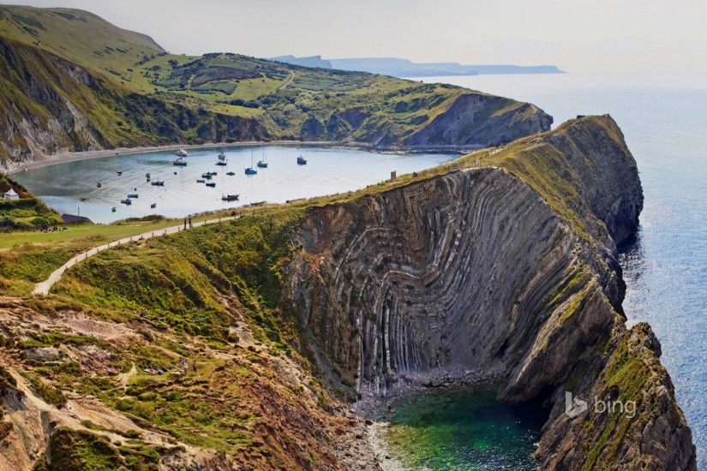

The continents of Africa and Europe were critical in shaping the Jurassic Coast during the Alpine Orogeny, which occurred approximately 6 million years ago, when mountain ranges including the Alps, Atlas and the Pyrenees were formed.
The uplift and folding of the rocks, which are evident along the Jurassic Coast, can be seen at Man o' War Bay and Durdle Door but the most dramatic example of folded, limestone strata is here, at the Stair Hole in Lulworth, Dorset. Photo: Ian West
The Trust has developed a vast collection of, mainly, nautical memorabilia and ephemera. We are always seeking new and historically valuable material. Donations are always welcome and, in the case of images, we can scan and retain copies in the cases of ‘loaned’ material. We have a small and dedicated team and we are always seeking fresh blood in the form of volunteers. If you are interested, please get in touch or just come along one Thursday morning (from 10.00) to our headquarters on the first floor of Canford Cliffs library. Call 07718934425 or e-mail to : poolemaritimetrust@aol.com.
I appeal to any reader who has a historical story or information relating to Maritime matters, to let the Trust know, and allow us to record the information before it is lost. If, ever, anything we print is inaccurate, or can be added to, please let us know ! Thanks to all of those who have given of their time and precious memories enabling the Trust to create a wonderful and unique archive. We seek to bring to light the most remarkable and, previously, unsung maritime related stories. The next edition of the newsletter will be published in, approximately, two months. I would like to thank all contributors; in particular, Kevin Mitchell for his regular and wonderful Port images, Jack Hawkins for his diligently researched historic articles and Jan Marsh for her continued support and regular contributions.

Whilst every effort is made to credit images, it is not always possible to trace the source. In the unlikely event we have infringed copyright we unreservedly apologise.

