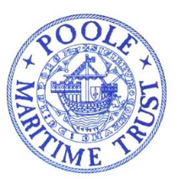 POOLE MARITIME TRUST 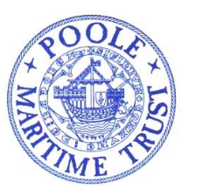
Spring Programme 2023
Poole Maritime Trust / Travellers Tales (RMYC)

2nd March 2023 Speaker: Jonathan Clark Engineer Officer (BI and P&O 1962-76)
The Tyser Legacy, the foundations of the Port Line Ltd (in service 1937 to 1982.
11th March 2023 South Coast Spring Weekend from Poole and Christchurch
Cruise from Poole Quay (BH15 1GZ) by City Cruises M V ISLAND SCENE 10.30-15.15 Fare £25 (Booking form on website)
12th March 2023 A rare Christchurch Harbour, rivers and creeks cruise aboard one of the Mudeford ferries. Depart historic Christchurch Quay (BH23 1EY). 10.30 Return 12.00 Fare £20 Lunch (Optional). (Booking form on website)
26th April 2023 AGM at RMYC 11am for 11.30am followed by lunch at 12.30pm (Menu choices form on website). Presentation by Kira Bennett, winner of PMT Turland Award follows lunch
20th May 2023 Solent Explorer Cruises – full details and booking form on website

www.poolemaritimetrust.org/programme

The Society for Poole programme of talks can be found at:
http://societyforpoole.org

