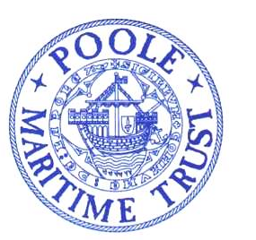
POOLE MARITIME TRUST 50th ANNIVERSARY
PHOTOGRAPHIC COMPETITION 2022
RULES
- The competition is open to all and free to enter. The subject is Poole Harbour: Old and New. Any picture outside the competition theme will not be used and will be destroyed.
- There are 3 categories for entries – Children under 16; Adult – Heritage; Adult – Environment.
- Entries must be your own work.
- Closing Date for entries is 31st January 2023. Judging will take place in February 2023.
- All photographs entered in this competition will be available to be used by the PMT for any purpose on any media in the future free of charge but they will not be the exclusive copyright of the PMT. “Do not send any pictures if you have concerns about their future”.
- PMT will have no control of submitted pictures possibly used by other sources.
- PMT will decide which pictures will be on its own website and other media.
- Winners will be announced on the Poole Maritime Trust website and prizes awarded at the PMT AGM in April 2023
- The judges will be made up of a panel of AUB staff and PMT Members. The judges decision will be final.
- There will be a maximum of 2 entries per photographer. Images will only be accepted as JPEGs
- The site location, direction, description and date taken must be recorded on entry form and submitted with entries.
- No children under the age of 16 may appear in the images and all persons featured must give their permission for their image to appear in the competition and on the website.
- No-one involved in the competition may enter.
- All entries to be submitted by email entitled “Competition entry” to [poolemaritimetrust@aol.com] by midnight on 31st December 2022. Entries received after this date will not be accepted.
- Cash prizes of £100 will be awarded in each category.
- In the event of insufficient entries the judges reserve the right not to award prizes.

Please download an entry form from www.poolemaritimetrust.org.uk and submit it with your entry.

