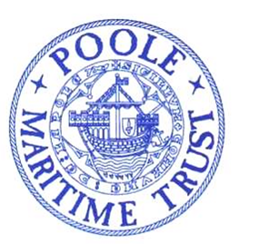
POOLE MARITIME TRUST
NEWSLETTER JULY 2022
Committed to recording and preserving the history of Poole Harbour, It’s people, surrounding environs, trading links, industries and everything maritime related.
Welcome to the July 2022 edition of the Poole Maritime Trust Newsletter.
Many thanks to those who contribute to the newsletter We are always seeking features AND INFORMATION RELATING TO Poole Harbour and it’s environs. This edition features, in particular, three historic ships that, either, have already visited or are scheduled to call at Poole.
It will be good to see the famous “WAVERLEY” paying a visit after a break of a few years. “WAVERLEY” is the World’s last seagoing paddle steamer and she is scheduled to undertake three cruises from the port. In order to ‘set the stage’ for the arrival of “WAVERLEY”, Tom Lee has very kindly permitted us to publish an article by his late father about a day trip in 1934 aboard the mighty river Thames based paddle steamer “GOLDEN EAGLE”. Cherished memories from a by-gone era. Please refer Tom’s excellent web-site for further delights (www.webarchive.org.uk/wayback/archive/20130302114730).
Paddle steamers at Poole will be remembered by older readers. They were an integral part of the British seaside holiday scene. The last such vessel to be based at Poole each summer was the “EMBASSY”, here seen in Weymouth Bay, that survived until 1967.
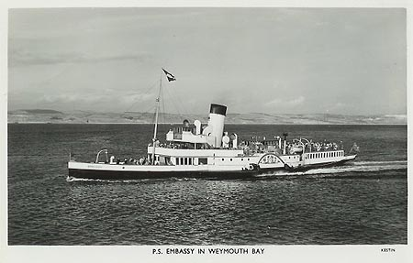
Another welcome visitor is the preserved cargo vessel “SHIELDHALL” that, again, will be offering cruises to the Bournemouth Airshow and a sailing to Southampton. Both ships are unique and worthy of support. In Addition, the port was blessed by the beautifully restored Dunkirk ‘little ship’, “ESTRALLITA” over the period of the Queen’s jubilee celebrations. Once owned by the entertainer Hughie Green, the ship has a remarkable history and was also owned by the Bonham-Christie family. A photo is featured in Kevin Mitchell’s article.
CHAIRMAN’S QUARTERLY REPORT
Visitors to the Poole Maritime Trust website may have noticed that for some time there has been no report from the Trust Chairman in respect of current activity. This has, in part, been due to the absence of a useable and managed website but also, for reasons many will understand, the need to limit events over the past two years due to the pandemic. Clearly things in this area have improved of late such that this year members events in the form of lectures have taken place as has the Trust AGM.
Although, due to the pandemic, the Trust has not put on an exhibit in the local area for the past two years, things have returned nearer to normal and on 30th April and 1st May, the Trust had a stand at the Bournemouth Maritime Festival. This was held at Hurn near to Bournemouth Airport and brought together a large number of organisations which are involved with local maritime business and maritime affairs. Our stand did attract quite a lot of interest although the weather and the location did limit footfall to some extent. The Trust committee will examine where such events might take place in the future.
On a different issue, the Trust has recently come to a provisional arrangement with the Society for Poole whereby members of both organisations can attend each other’s events. The Trust and the Society hold similar interests in relation to Poole, the Harbour and the local environs. The relationship may be developed further in the future.
Looking to the future a number of projects are under consideration. Work using our remotely operated underwater vehicle (ROV) and other up to date technical equipment, including a drone, will continue over the summer. As far as the archive is concerned, the Trust has been generously gifted a number of new items which assist in the development of our understanding of the history of the harbour and local area. The Trust committee is examining examine ways in which this material can be better exhibited as our current location is limited in terms of space.
Details of future events will be published on this website and updates will be published on a regular basis.
Commodore G H Edwardes OBE, Chairman

POOLE MARITIME TRUST WEBSITE
The Poole Maritime Trust’s website has been redeveloped and updated: www.poolemaritimetrust.org.uk
It is a work in progress, but we now have a website which we hope in time will give you information about the Trust’s activities including the work with the remotely operated underwater vehicle (ROV) which enhances our ability to study and explore the busy sea floor in and around Poole Harbour. Events over the past two years have been limited due to the pandemic but as we put together a comprehensive programme of talks and events in the future, all details will appear on the website. It will also include details of the awards we present with the winner’s names.
Information on the material held in the archive at the Library will appear with galleries of photographs, indexes of the material held in the collection, the library catalogue and details of the many donations we receive.

ARCHIVE, LIBRARY & COLLECTION REPORT

The team are always kept busy thanks to the regular flow of donated material. Recently we have been indebted to, amongst others, Bognor Regis Local History Society, Lisa Kyprianou, Peter Burt and Dave & Helen Robson who donated some wonderful maritime material including a signed limited edition print of the Cunard liner “QE2” on the Mersey.

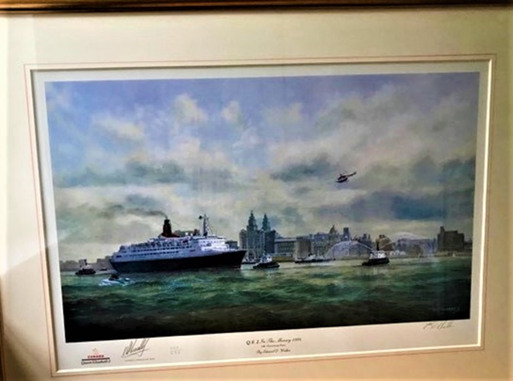

CANNON BALL DISCOVERY
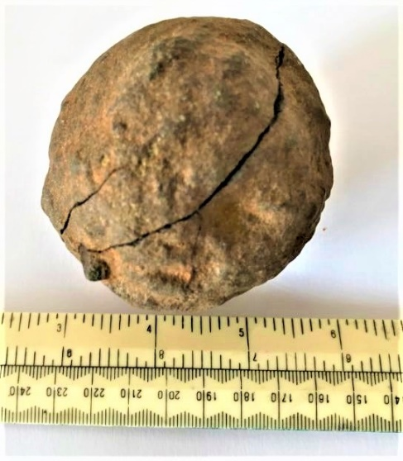
The Trust have been donated this cannon ball, a valuable and interesting addition to our collection of local history. The donor, sharp-eyed Lisa Kyprianou, was visiting Lulworth Cove and whilst paddling spotted it washed upon the beach. Robert Heaton comments : “A great little find just rolling around the seabed. Quite how it’s density stopped it from dropping through the stones we will never know. Perhaps it was embedded in a cliff and got eroded out. When these dry out they can fall to pieces, but it seems to have survived.”. Natalie Georgina has provided the following that may provide clues to the history : “It’s the summer of 1643 and in the fields beyond Dorset’s Lulworth Castle, a small group of women and children are enjoying the afternoon sunshine. Though you would never know it from the idyllic scene, the county is rife with tension as the violent clashes of the English Civil War begin to wreak havoc. Suddenly, a single musket shot rings out and a child falls, mortally wounded. As his mother wails in anguish, word is passed to Sir Humphrey Weld, owner of the castle. Within minutes this former Sheriff and Lord Mayor of London, devoted Royalist and defender of the Crown, is mustering the waiting troops of his friend, Sir Thomas Tyldesley. Meanwhile, Oliver Cromwell’s Parliamentarian forces are gathering in an attempt to take Lulworth. Within the hour a bloody battle is raging as the Royalists push forward, determined to repel the advances of the Roundheads. In a blaze of musket and cannon fire the two sides become locked in brutal hand-to-hand combat. They drive hard into each other, a forest of pikestaffs clashing, their muskets – useless at such close range – gripped by the barrel and used to club the enemy to the ground” From : Great British Life – Living History at Lulworth Cove.

We are always seeking historic images of Poole Harbour and it’s environs and any interesting maritime related artifacts, material, books and ephemera. Old movie films can be restored and digitally enhanced. Please be sure to make contact if you have anything you consider would be of interest. Contact details may be found on our web-site.

Poole Maritime Trust Newsletter July 2022
Port Update by Kevin Mitchell

Recently a small craft has been spotted making occasional trips between Brownsea Island and the South Quay at the Port of Poole. I am not sure if it has a name, but it has a raised wheelhouse resembling a Portakabin although it appears to be propelled by another, yellow vessel. I believe there has been tree-felling on the island and it is used to transport the logs over to the port.
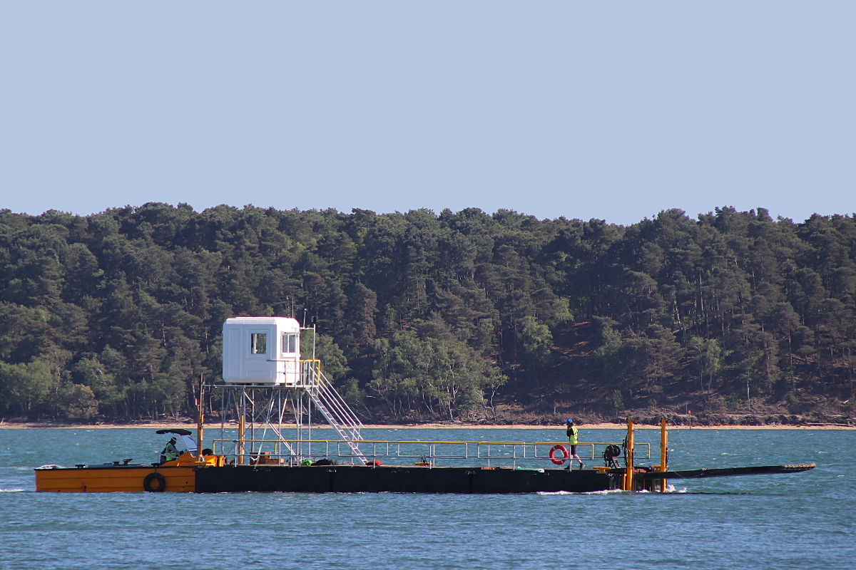
During May the MN Pelican had to divert to the French port of Brest whilst on a journey from Bilbao up to Poole, due to a leak in its scrubber exhaust-cleaning system. The Pelican resumed its voyage but had to return to Brest later for dry-docking. On 27th May a new high-speed service started using Condor Liberation operating on behalf of Brittany Ferries. At peak times the Liberation will sail Portsmouth to Cherbourg then back to Poole before making an afternoon crossing to Guernsey. The photo shows the Liberation arriving in Poole that afternoon from Cherbourg. Brittany Ferries’ own fast craft Normandie Express now sails for Condor Ferries as Condor Voyager.
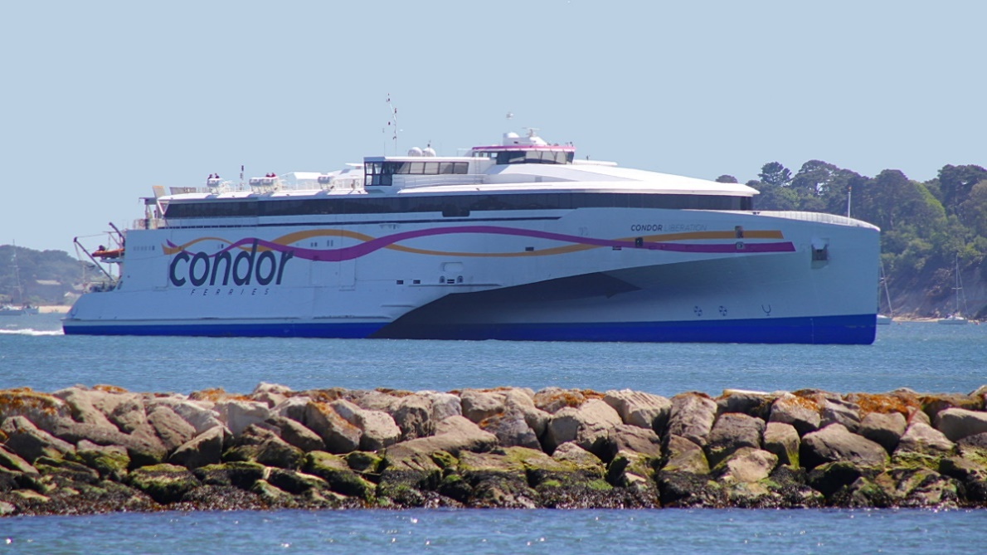
Poole has seen an uptake in super yacht visitors recently. At the end of May the Rahal arrived at the Poole Quay Boat Haven from Gibraltar. The 46.5m vessel is used on the charter market, and sailed on 3rd June for the Isle of Man. It is believed that she was being used by the King of Bahrain’s son for visiting the TT Races on the island. Rahal returned to Poole on 14th June. Another luxury motor yacht Phoenix left the Boat Haven on 5th June. She is 41m long and built by Benetti of Italy in 2021, one of a series of 18 Oasis models. The distinctive twin-hulled motor yacht Nebula arrived at the Port of Poole Marina on 12th June. She is 67m long and was completed in Spain earlier this year by Astilleros Armón, This photo of Nebula was taken by Kevin Walters.
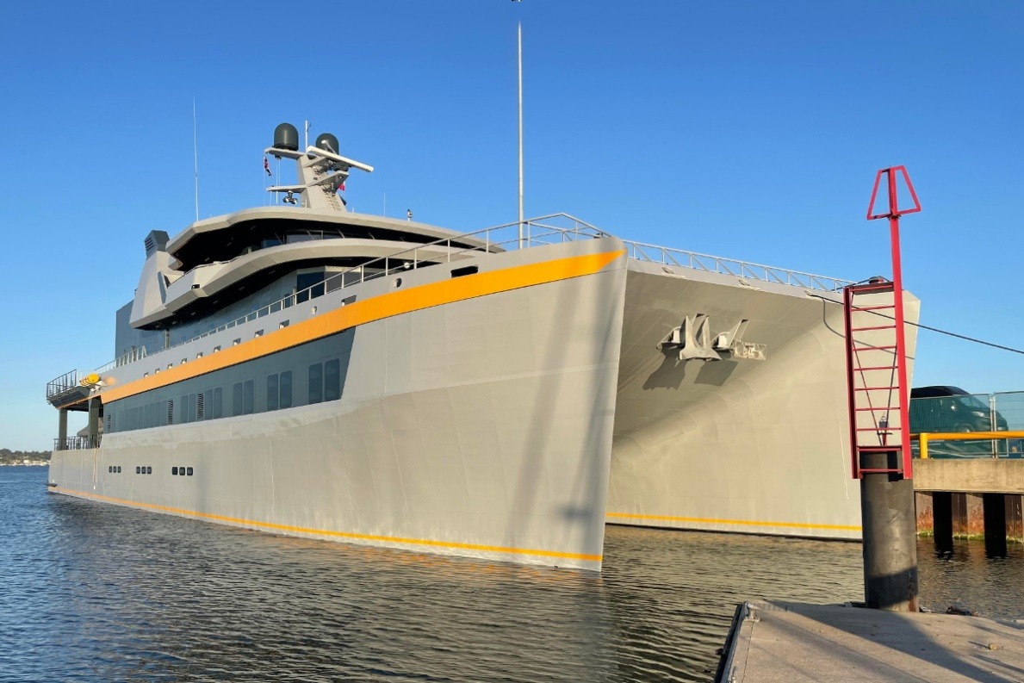
On 27th May the cargo ship Celtic Crusader was photographed arriving at the port from Cardiff to load Purbeck ball clay for export to Spain. This high-quality clay is used in the manufacture of ceramics, and is a regular trade from Poole.
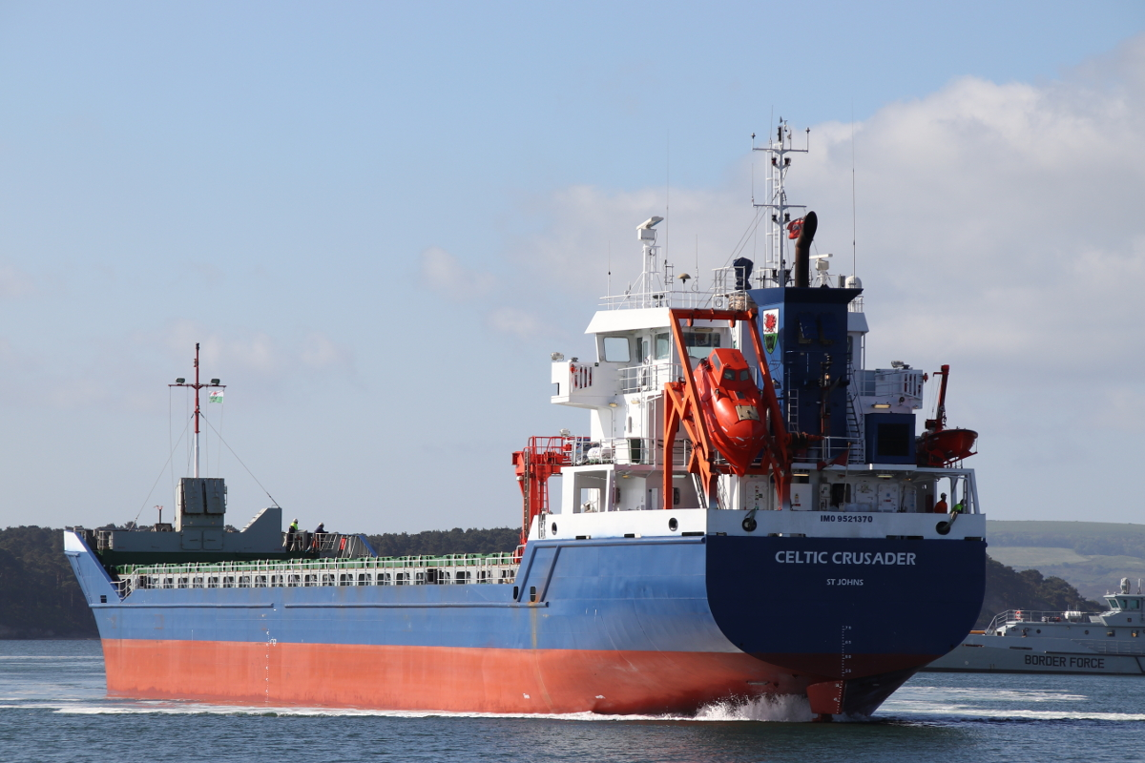
It was good to see many of the local pleasure boat fleet dressed up for the Platinum Jubilee celebrations. On Saturday 4th June all boats in the harbour were invited to sound their horns at midday as a salute to Her Majesty. An interesting arrival at the Boat Haven over the Jubilee weekend was the Estrallita which came down from Lowestoft, and was her first time back in Poole since 1946. The 1934-built Estrallita is one of the UK’s national historic ships. She last sailed from Poole on 28th May 1940 to assist in the Dunkirk evacuation, returning on 3rd August that year to serve as a harbour patrol boat for the duration of the war. This photo was posted to the PMT Facebook group by Iain McAllister.
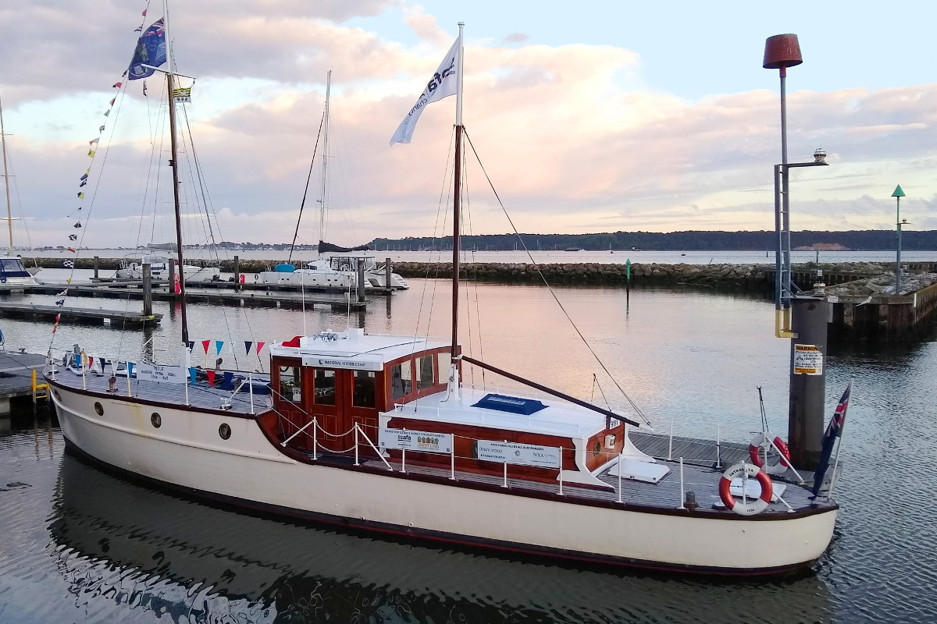
The cruise ship Amadea arrived from Falmouth on the gloomy morning of 7th June as part of a round Britain itinerary. This German-owned ship is operated by the same company as the Deutschand, which came to Poole earlier in the year. At 192m long she is the second largest ship to have visited Poole, after the former Fred. Olsen cruise ship Boudicca in 2019.
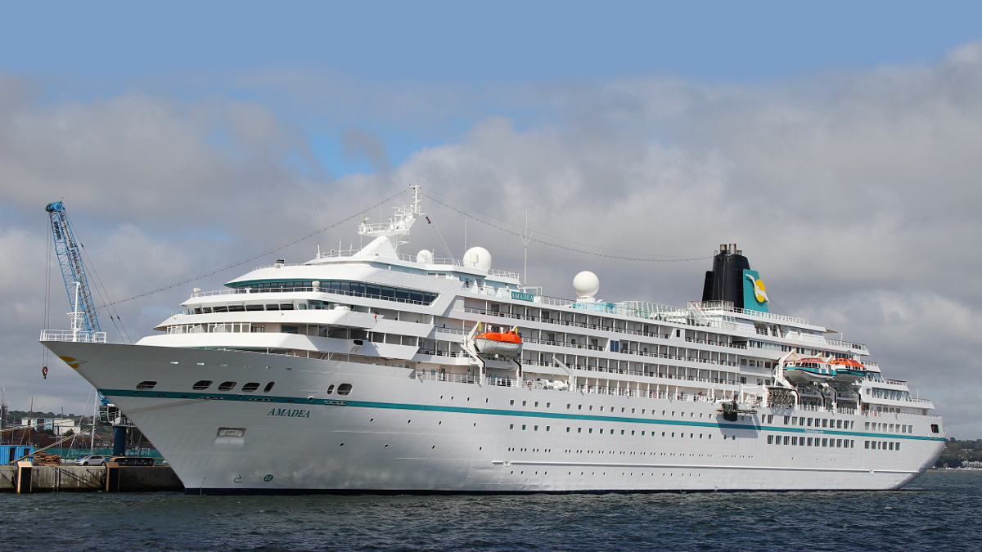
On 12 June the UK Offshore Powerboat Racing Association held its Poole Bay Classic event. The craft were unloaded from lorries at the port over the two days previously, and made for interesting and noisy viewing from Poole Quay.
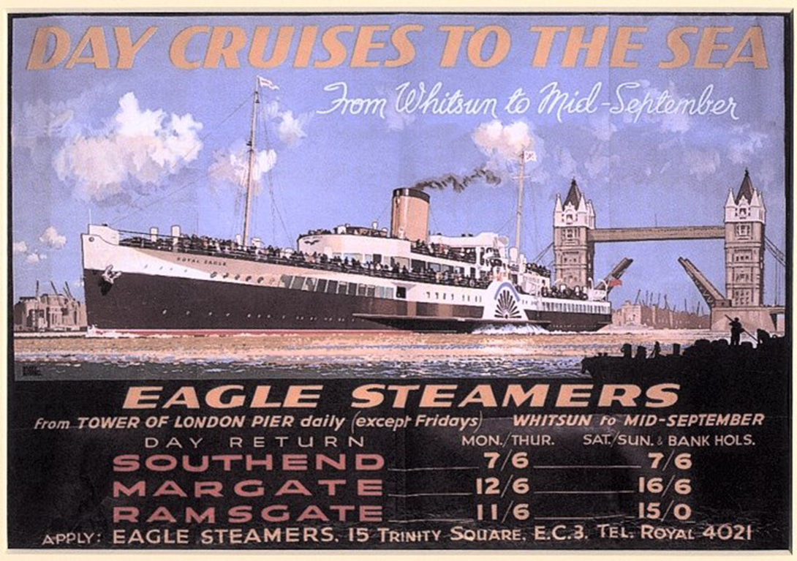

A trip on the Royal Eagle (Circa 1934) – courtesy Tom Lee
This record was composed by my father, Gordon Burnham Lee, 1920- 2004. His father, Henry James Burnham Lee, was employed by the General Steam Navigation Company.
It is early on a warm summer Sunday morning, and Dad and I are in the garden. Sunday is the only whole day in the week he has off. "What about a trip on the Royal Eagle, Dad?" "You don't seem to realise that, by the time I've taken you and your Mother on the bus to Southend and back, a train up and down the pier, lunch on board (my father did get staff prices for lunch) for the three of us, and tea and biscuits in the afternoon, I don't see much change from a pound." I point out how much good the trip would do us and what a lovely day it is for it. Finally he agrees to ask Mother, who says that we ought to go to church. I say that missing one Sunday now and then is all right. Anyway somehow I get my way, and we leave home suitably dressed for a Sunday.

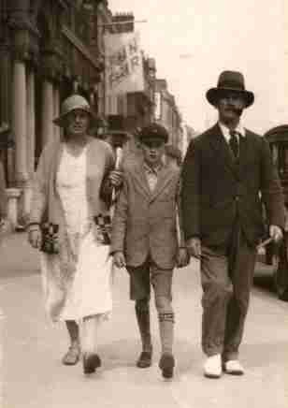
We catch an open-top bus, which takes us the three miles to the pier entrance. We travel mostly along the sea front, but unfortunately on the way we pass the church which we usually attend. Faces are averted until we are safely past. Dad's pass for the Eagle Steamers also gives us admission to the pier, but not the pier trains. These are the 'toast-rack' variety, open except for one enclosed carriage. As this is a fine day, we ride in the open. Many people are walking up the pier, others are fishing as the tide is in. As soon as we get off the train, we hear the representatives from the various shipping companies (Eagle and Belle steamers, Palace and Medway steamers) handing out leaflets and trying to out-shout each other, extolling the benefits of travelling by their steamers.
Mr. Thomas, the G.S.N.C. agent, takes us the front of the pier, instead of having to join the queue, one of several where passengers await the arrival of their particular steamer. Deck chairs are provided, from which we watch the "Royal Eagle" approach through the summer haze. At a signal from the ship's bridge, the ship's name pennant on the foremast and the Company's flag on the main, are unfurled, simultaneously. The Company's flag also has a point, as Captain Branthwaite is Commodore of the G.S.N.C. fleet. The paddle wheels go astern, lines are thrown and caught and the mooring ropes pulled in and secured, while the capstans are turning to finish the settling of the boat against the pier. Gangways are rolled out from the pier and, bidding goodbye to Mr. Thomas, we are the first on board after the passengers for Southend have disembarked.
Dad's pass gives us admission the Sun Deck (2/6d. extra for ordinary passengers) and deck chairs are secured. As soon as all the passengers are on board the bow rope is let go while the capstan tightens the stern rope, thus turning the bow away from the pier. The stern rope is let go, the telegraph rings, the paddles start to turn, and we are on our way.
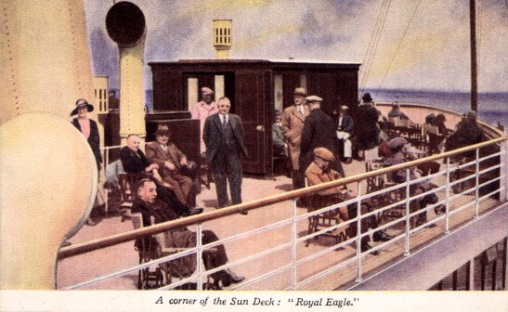

Sun Deck on the Royal Eagle (2/6d extra for ordinary passengers!)
Not being a great one for sitting still, I make an 'inspection' of the ship, pausing for several minutes to watch the mighty engines. Mum and Dad stay put until, after a chat with Captain Branthwaite in his cabin, as we pass Herne Bay, we go down to lunch. The chef wears a tall white hat and carves from a long table in the centre of the saloon. From the saloon windows (port holes only at the bow end of the saloon) we can watch the Kent coast passing in the distance.
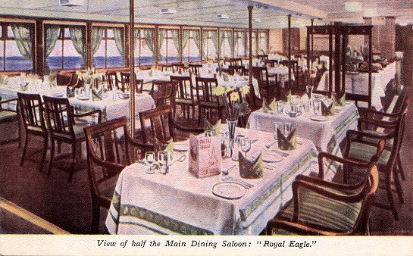

The Dining Saloon on board Royal Eagle could seat 322 diners at one sitting
On returning to the Sun Deck, we can see the white cliffs of Birchington and soon we are tying up at Margate Jetty. Alongside the jetty is the "Golden Eagle" which has come down earlier, and is awaiting the time for taking her passengers for a sea trip to the Goodwin Lightship. On many earlier occasions we have travelled on her. We do not land at Margate, but stay on for the end of the trip, which is Ramsgate. We round the North Foreland, with its white lighthouse on the cliff, and turn south to Ramsgate harbour, where on arrival a black ball is hoisted on the quay to show that a steamer is alongside, and will soon be leaving the harbour again.
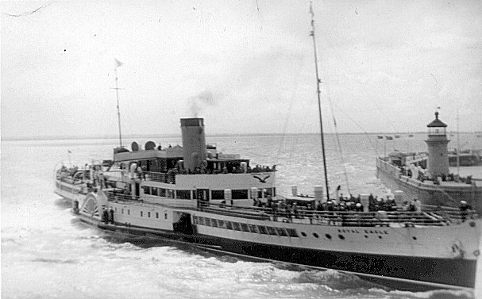

Royal Eagle backing out of Ramsgate Harbour
As soon as the disembarking and embarking of passengers is completed, with three blasts of the whistle, we cast off and proceed astern through the harbour entrance. We now start our journey in reverse; it never seems to me quite so exciting as being outward bound. We are soon at Margate Jetty again, picking up the passengers we dropped earlier, before leaving on our return journey to Southend. Nearing the Essex Coast, we see in the distance the "Crested Eagle" returning to Southend from Clacton. A race to the pier begins, which, as usual, the "Crested" wins, having the extra knot from her superb engines.

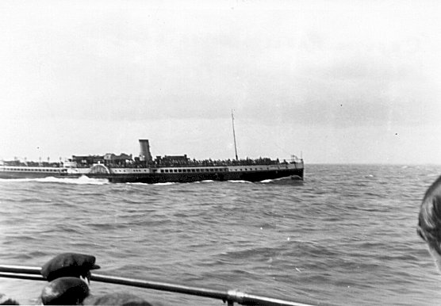

Crested Eagle passing by in 1934

Having landed on the pier, I want to wait to watch the ships departing for London, but am hustled to the train station to catch the train ashore. Once again we travel home on the sea front bus, and all too soon we are home once more, my face burning from the sun and wind. After an evening meal it's off to bed which seems to rock me gently to sleep. G Burnham Lee
THE TWILIGHT OF OCEAN TRAVEL. 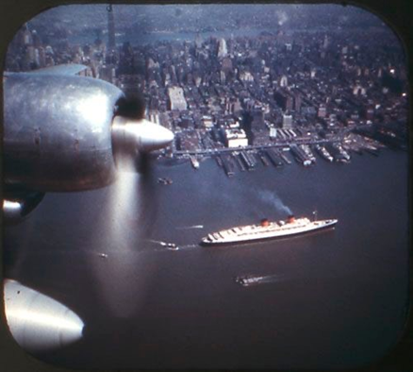
The Mighty “QUEEN ELIZABETH” steams majestically out of New York. This image taken from a turbo prop passenger aircraft, the successors of which would spell doom to the fleets of Ocean Liners
POOLE MARITIME TRUST
FORTHCOMING EVENTS
(Other dates will be added in due course)

Prize Photographic competition – (Full details will be circulated shortly)

Visit Swanage
It is hoped to arrange an outing to Swanage where members can enjoy a tour of the pier facilities, look behind the scenes, and have a brief lecture of the history of the pier, it’s role in World War ll, and the dramatic revival and re-uincarnation this remarkable and historic structure has undergone in the past two decades and the plans for the future. Optional lunch will be available at the new and delightful 1859 Pier Café & Bistro. From Poole Quay and return aboard ‘City Cruises’ scheduled sailing. Full details will be published on the web-site and in the forthcoming newsletter.

Visit Portsmouth – Wednesday 21st September.
Grand day visit by coach from the Poole & Bournemouth environs to visit the Historic Dockyard.
Full details and booking form attached.

Autumn Supper
29 September Autumn Supper at Royal Motor Yacht Club (details to be announced)

Visit Brownsea Castle – Afternoon Tea Thursday 20th October
Details to follow.

New Year Supper at the Royal Motor Yacht Club Thursday January 5th 2023.
Details to follow

Society for Poole meetings
All are welcome

19 July "When the Germans invaded Dorset" by Brian Bates
12 September Poole Guildhall Open Day for Dorset Architectural Heritage Week 10-12
20 September "Mapping the Manors" by Mary Sparks
18 October "Alleyways of Old Poole" by Don Nutt
15 November "Wildlife of the Jurassic Coast" by Brian Petit

All meetings held at British Legion Hall, North Road, Poole
at 7.30pm Guests £4

Canberra A Celebration
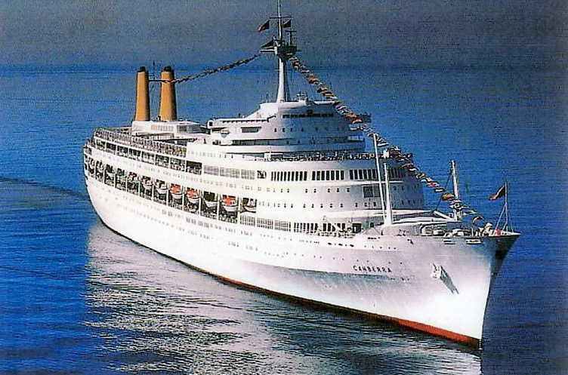
A Must for All Those Who Sailed in And Loved This Special Ship
www.ocean-liner-society.com
Saturday 30 July, The Masonic Hall, Albion Place, Southampton, SO14 2DD.
Doors Open: 09:30 Talks Start: 10:00. Event Closes: 17:30.
Access: There is parking close to the hall. The venue is a short walk from Southampton Central Station.
The Ocean Liner Society planned to hold a special event to celebrate the sixtieth anniversary of this much-loved ship’s entry in to service in 1961, but sadly we were thwarted by the Covid pandemic. Instead, we are presenting a whole day event in Southampton on Saturday 30 July 2022.
This all-day conference will cover Canberra’s story from inception to “finished with engines” and will include lectures and lunch, morning coffee and afternoon tea within the ticket price. The ticket price is £60.00 for Ocean Liner Society Members and £65.00 for others. To purchase the member price tickets for this event please email: ols.events41@gmail.com giving your membership number and stating how many tickets you require. Those who are not members of the OLS can purchase tickets through TicketSource. This can be done by visiting the OLS Website and clicking on the button displayed on the section describing this event. Anyone with an interest in ocean liners and cruise ships, or who sailed in Canberra, as a crew member or passenger would thoroughly enjoy this event. Come and join us!

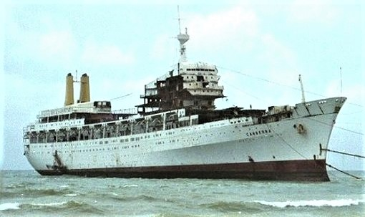

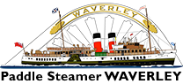
Paddle Steamer Cruises from Poole Aboard
“WAVERLEY”
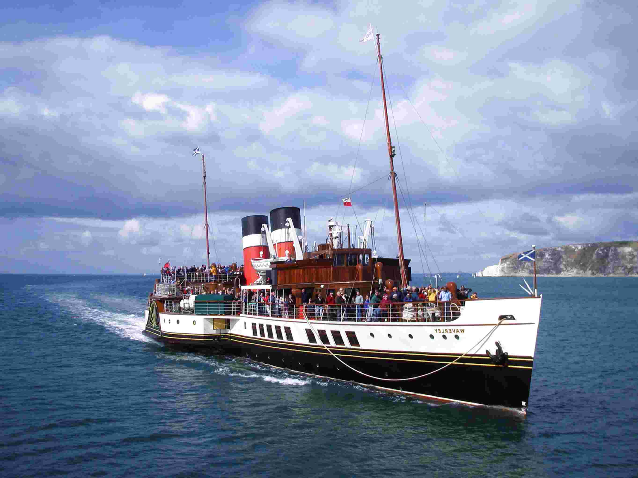
The last seagoing paddle steamer in the World
TUESDAY
September 13
Poole 1000
Yarmouth 1230
Steam Round Isle of Wight
Yarmouth 1700
Poole 1915
WEDNESDAYS
September 7 & 14
Poole 1030
Swanage 1150
Yarmouth 1340
Cruise Cowes & Solent
Yarmouth 1600
Swanage 1745 T/F to Coach
Poole Coach Arrive 1845

FOR FULL DETAILS AND TICKETS
VISIT
https://waverleyexcursions.co.uk
Subject to availability, tickets may be purchased aboard on sailing day.

STEAM-SHIP “SHIELDHALL”
SAILS FROM POOLE QUAY
Steamship Shieldhall is the largest working steamship in Britain. A member of the National Historic Fleet she serves as a sea going tribute to Britain’s maritime heritage. Operated by a team of dedicated volunteers. As part of your Shieldhall experience, see the impressive engine room with its original steam engines at work and the bridge, with its traditional instruments and gleaming brasswork; admire the ship’s steam assisted steering gear (similar to that used on Titanic); talk to the Captain and our crew and listen to the commentary as we pass the sights.
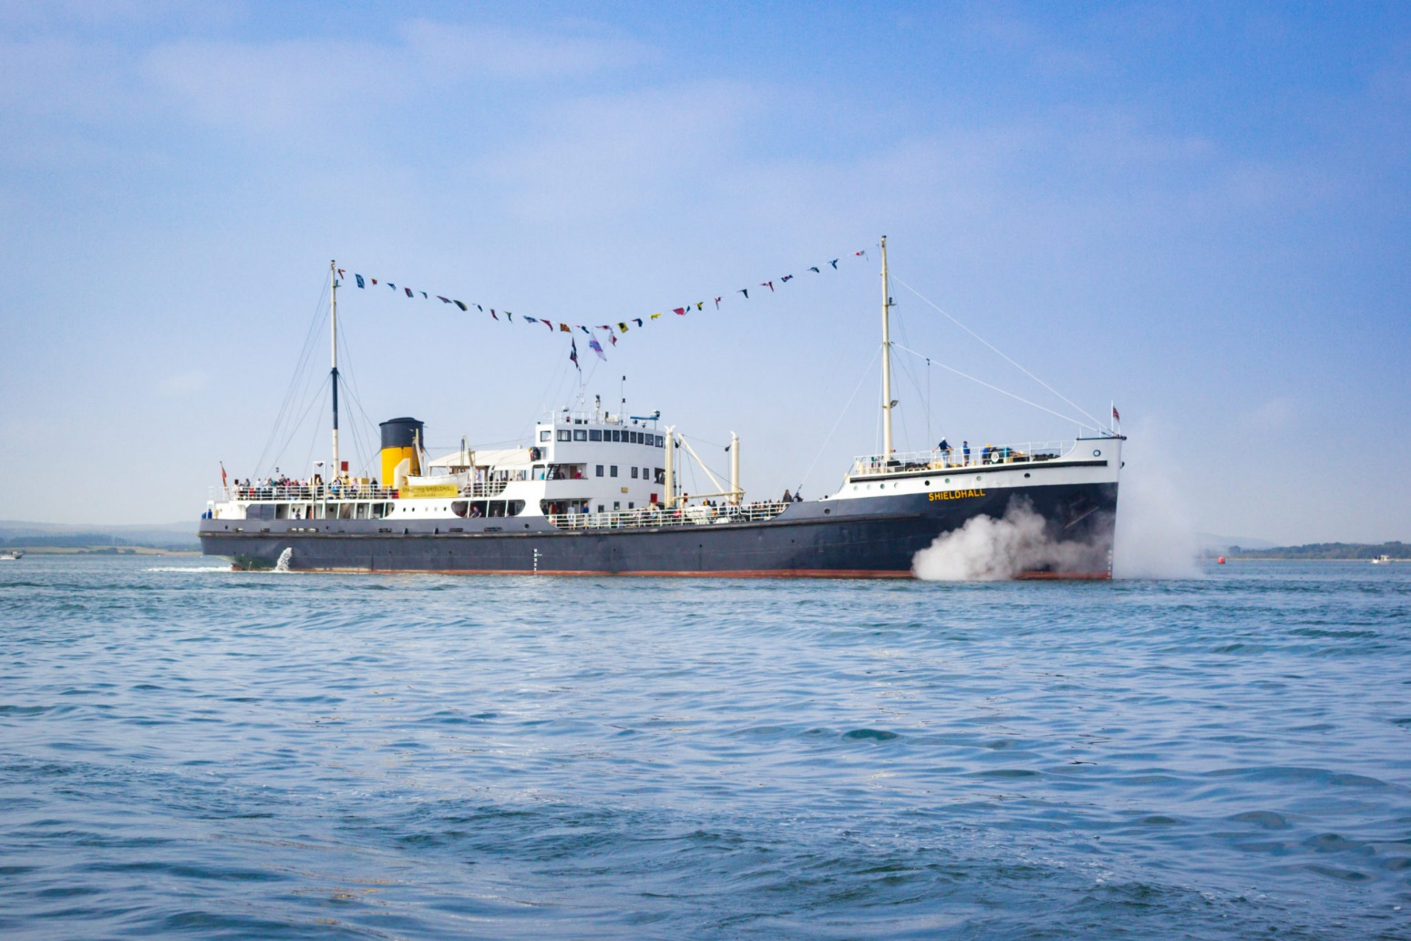

Bournemouth Air Festival
Shieldhall

Friday 2nd September, 10:00 - 19:00
Sailing from Poole Quay
Adults £51.00, Children £22.00, Family £124.00

Saturday 3rd September, 10:00 - 19:00
Sailing from Poole Quay
Adults £56.00, Children £22,00 Family £134.00

Sunday 4th September, 10:00 - 19:00
Including an onboard Merchant Navy Day Service
Sailing from Poole Quay
Adults £56.00, Child £22.00, Family £134.00

Monday 5th September, 10:00 - 16:00
One way trip from Poole to Southampton
Sailing from Poole Quay
Adults £47.00, Children £17.00, Family £111.00

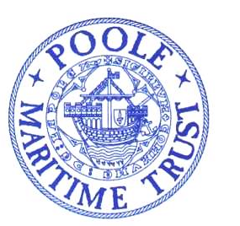

POOLE MARITIME TRUST
ANNIVERSARY COACH OUTING
TO
PORTSMOUTH HISTORIC DOCKYARD
WEDNESDAY SEPTEMBER 21st
COACH DEPARTS
SELSDOWN LANE, POOLE (OPP, BUS STATION) 08.45
CANFORD CLIFFS LIBRARY 08.55
WESTBOURNE BINGO HALL 09.05
RETURN
DEPART PORTSMOUTH 16.00 ARRIVE BACK (APPROX) 17.30 – 18.00
INCLUSIVE FARE £30.00.
Ticket entry to the dockyard will entitle guests to enjoy three of the following onsite attractions
HMS Victory
The Mary Rose
HMS Warrior 1860
National Museum of the Royal Navy
Action Stations
HMS M.33
Boathouse 4
Laser Quest Portsmouth
Dockyard Apprentice
Victory Gallery

PLEASE TAKE THE TIME TO READ ATTACHED NOTES THAT ARE INTENDED TO ENSURE YOU HAVE AN ENJOYABLE AND SAFE VISIT.
ACCESS
We welcome all visitors to the Dockyard and we have tried to make it as safe as possible. However, some of our attractions are historic buildings and ships, and we know that there can be challenges for some visitors. We have included information below to help you understand a bit more about the site, to help you plan in advance and to decide if you think that your visit will be impaired at all.

MOVING AROUND OUR SHIPS
Our ships may have been seaworthy for sailors, but they can be tricky to navigate for some. HMS Victory contains step stairs, rope bannisters, low ceilings, narrow and low doorways, low light levels and uneven floors. It can also be slippy on the upper decks when wet. There is wheelchair access to Lower Gun Deck where a DVD tour runs, subject to availability and audio guides are available. HMS Warrior is accessed via a ramp. Because she is still afloat the gradient can change with the tides and we would recommend entering at low tide if that is a concern, tide times can be accessed here. These photos indicate the gradient of the ramp at high and low tide.Like HMS Victory, HMS Warrior does have steep stairs with rope bannisters, trip hazards, low ceilings, poor lighting and can be slippy on a wet day. There is however and an accessible route marked on the deck plan and includes a fixed bannister staircase at the rear of the ship and a stairlift between the upper deck and the main gun deck (suitable for visitors who are able to transfer themselves to the stairlift). Wheelchairs must be left on the upper deck and a manual wheelchair is available for visitors to use on the main gun deck. Staff are on hand to help throughout the ship.
HMS M.33 is more accessible than some of her older counterparts. Wheelchair access to the lower deck is available via a lift and upper deck stairs are more generously spaced. There are some steep stairs in place and our Audio Visual Experience does not have subtitles and can be dark and upsetting for some.
HMS Alliance, based at the Submarine Museum in Gosport, is not accessible for wheelchairs and like the submariners who served on her, visitors will experience dark, cramped spaces, with low ceiling heights and trip hazards.
*Please note the M.33 lift is currently not in use
ACCESSING OUR MUSEUMS AND ATTRACTIONS
We have tried to make our museums and buildings as easy to move around as possible. However, there is always more we can do and they do still have some limitations as they are often based in historic buildings. This means floors can be uneven but are negotiable for wheelchairs and buggies.Galleries have a mixture of handling exhibits, film and audio displays and most have hearing loops. Audio transcripts or large print text is also available, just ask our staff. Mary Rose Museum also offers sensory resources, including tactile plans and painting of the ship, although there are low light levels in the building which some may struggle with. Unfortunately the Waterbus service to Explosion Museum of Naval Firepower and the Submarine Museum is not accessible for wheelchairs. Depending on the demand for spaces on board the vessel, it may be possible to take a folded manual wheelchair onto the vessel. There are a couple of large steps onto and off of the Waterbus. However, you can access those sites by car.
PLEASE NOTE THAT THE WATERBUS IS WEATHER AND SEASONAL DEPENDENT
ACCESSIBLE TOILETS AND FACILITIES
Accessible toilets are available in the National Museum of the Royal Navy, Boathouse No.7, Action Stations and the Mary Rose. Adult changing facilities are available in the Mary Rose disabled toilets.
Portsmouth Shopmobility scheme hires powered scooters to members of the public with limited mobility and these are available at our Visitor Centre at the entrance to the Dockyard. These are sometimes unavailable in adverse weather conditions. Booking is recommended and this can be done via email portsmouthdutymanagers@nmrn.org.uk or phone 02392 839 766 Ext:2083. The Mary Rose also operates a buggy service.We have a number of shops and cafes available on site offering hot and cold food and drink. The National Museum of the Royal Navy Shop, The Mary Rose Shop and Nauticalia are all accessible to wheelchair and pushchair users. The Boathouse No.7 Restaurant, Costa Coffee and The Mary Rose Café are all accessible to wheelchairs and pushchairs users.
SUPPORTING YOU ONSITE
Our staff are there to help make sure that every one of our visitors has a great day out so please do ask them if you require additional support. Whilst the military base does not allow animals on site generally, an exception is made for assistance animals and guide-dogs who are permitted in all areas.
We also offer carer tickets free of charge if you would feel more comfortable bringing someone to support you in your visit and particularly recommend this for visually impaired visitors to help them negotiate some of the uneven flooring and difficult spaces.

TICKETS ARE LIMITED AND MUST BE PURCHASED IN ADVANCE
(Bookings will close on September 10th)
------------------------------------------------------------------------------------------------------------------------
BOOKING FORM

Name :________________________ Address : _______________________________

___________________________________________________Post-Code__________

Tel : ________________________e-mail:____________________________________

Please supply_______tickets @ £30 for the coach trip to Portsmouth Dockyard.

I enclose a cheque to the value of £______made payable to POOLE MARITIME TRUST

I will board the coach at : _______________ and I enclose a stemped addressed envelope.

Please send ticket application, cheque and SAE to : Poole Maritime Trust, First Floor,
Canford Cliffs Library, 6 Western Road, Canford Cliffs, Poole BH13 7BN

