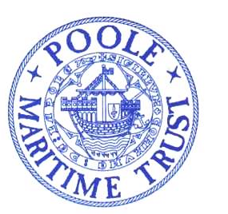

POOLE MARITIME TRUST
NEWSLETTER
DECEMBER 2021.
CHAIRMAN’S CHRISTMAS MESSAGE
In the past, members of the Poole Maritime Trust received a quarterly report from the Chairman. Due to a number of circumstances, this has not been achieved for the past three years. The advent of a new web site has provided the opportunity for the Chairman to publish a quarterly report once again, not just for the membership but for all those who take an interest in what the Trust is undertaking now and for the future.

As many will be aware, much of the Trust’s usual event activity has had to be largely curtailed for the past eighteen months due to the pandemic. Hopefully this situation will now improve and a full list of evening lectures and other events, to take place starting early in 2022, is being circulated by Bob Reid, the Programme Secretary of the Trust committee. Members will wish to note that our New Year supper will be held at the Royal Motor Yacht Club on 6 January 2022. Details are in the October 2021 newsletter which is circulated to members.

While pandemic restrictions have impacted on events, the other work of the Trust has continued apace. The archive has increased substantially, largely due to generous donations by members but also through donations from local people who have an interest in maintaining a maritime history of Poole and its environs. Peter Lamb, Vice Chairman and Archivist, assisted by Pat Woodruff, has been indexing the material and storing it in box files. Our Secretary, Jan Marsh, has also been at work indexing our paintings and helping set up a new Titanic display. Another volunteer, Jack Hawkins, has been carrying out research on Dunkirk and the little ships that went to the beaches from Poole in June 1940.

Two years ago, the Trust procured an underwater remotely operated vehicle (ROV) which has allowed a considerable amount of research into the harbour seabed to be undertaken. This has been largely undertaken by Robert Heaton who, in addition, operates his privately owned drone, which will permit the Trust to provide some interesting material for the new website.

As ever, the Trust welcomes those who are interested in the nature and the maritime history of Poole harbour to become members, who are given access to both the archive and the many lectures and visits which take place throughout the year. Applications can be made to the above address and applicants will be welcomed by our Membership Secretary, Margaret Morris.

It will not surprise those who follow the Trust activities to learn that with the increase in archive material, much of which requires to be saved through digital means, the Trust committee is giving consideration to finding new premises from which the Trust can operate. Nothing has been established to date but a number of options are under review. Information will, of course, be updated as things develop.

I hope you have a Happy Christmas and an excellent New Year.

Best Wishes,

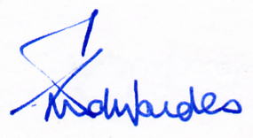

Geoffrey Edwardes. Chairman, Poole Maritime Trust.

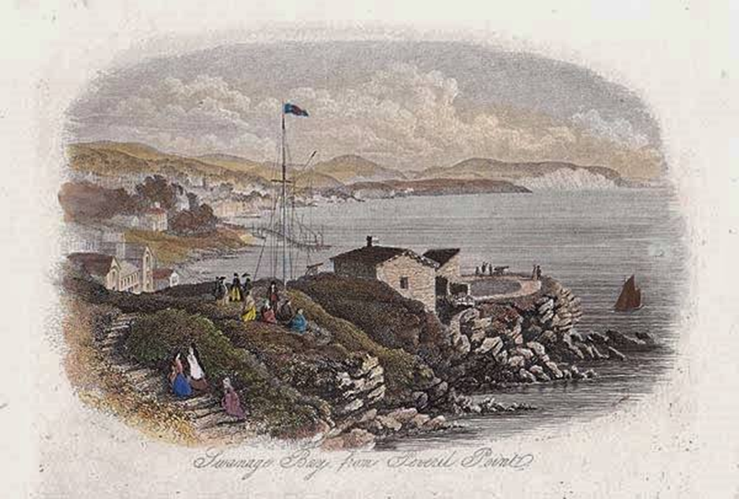

Davis’s Boats 1924
Mr. Davis, of Sandbanks, is having an Ailsa Craig Kid 10-14 h.p. four-cylinder marine motor fitted in his passenger boat ‘Gertom’, which will be run under Board of Trade regulations. The work of installation is being carried out by Messrs. Wilkins and Wilkins, of Poole.

UNDATED
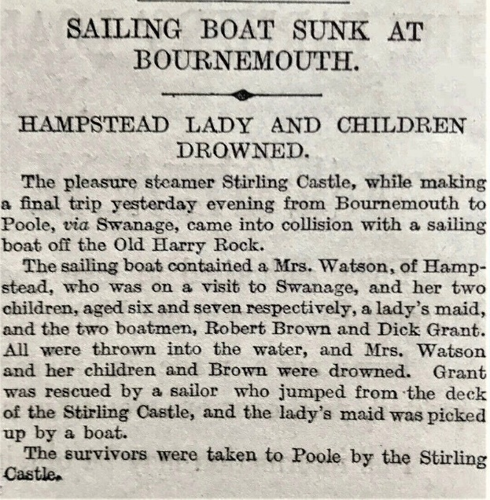

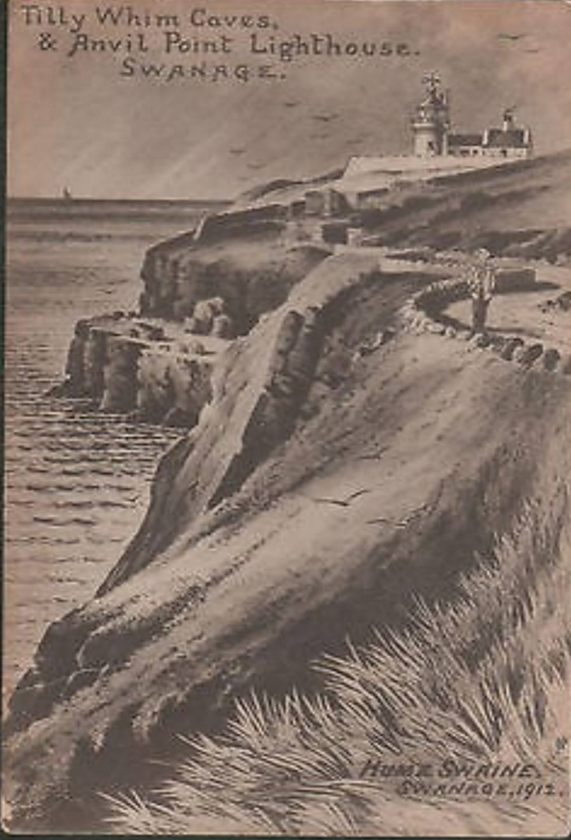

[Taken from Bournemouth’s founders and famous visitors by Andrew Norman 2020]
MARCONI
In a letter to the Bournemouth Daily Echo Percy Newlyn declared:
These experiments were then, more or less secret, and were conducted between here [Bournemouth] and the Needles [Isle of Wight], but the point which gives Bournemouth the claim to priority in regard to them is that it was between these two points that he achieved the first fulfillment of his dreams, i.e. a 2-way communication.
I well remember the day on which the 2-way communication was achieved, as the man who held the purse strings [believed to be Scottish physicist and mathematician Lord Kelvin] was residing in the Royal Exeter Hotel, and a private luncheon to celebrate the occasion was held by those intimately concerned.
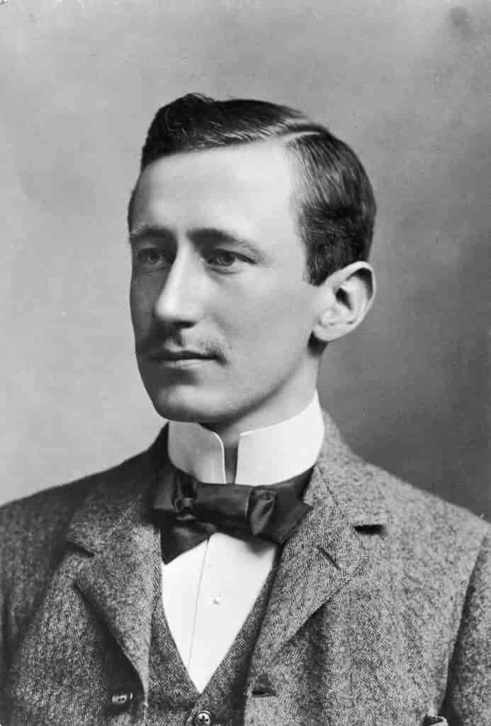
In another letter to the Bournemouth Daily Echo dated 4 May 1940, F A Olding of Moordown wrote that he too could:
…well remember the day on which the 2-way communication was made, since I was privileged to see something of the delight with which the inventor declared his triumph on that occasion. On a warm sunny afternoon, early in the season I think, I walked up the Bournemouth Pier with a message from my mother to her cousin, Capt Cox of Cosens & Co’s paddle steamer Victoria, just as that vessel was berthing.
I was startled to see a slight, dark man in a blue suit, dash excitedly across the gangway, waving his right hand to the pier-master on the upper deck and shouting ‘I’ve done it – I’ve done it’. With a small black box tucked under his left arm he continued a run down the pier shouting ‘I’ve done it’, as he went.
Going on board, I soon enquired from the captain the reason for the excitement, and was told that the man was an Italian named Marconi, and that he had told the captain that the ‘box’ he had under his arm had enabled him that day to send, as well as receive signals by ‘wireless’, and that it was the first time that it had been done in that way. Previously, he had been able to receive only on the island [of Wight], and not send.
It was on 3 June 1898, that ‘Sandhills’ had the honour of receiving the world’s first, paid ’radiogram’ – transmitted from the isle of Wight by Marconi on behalf of Lord Kelvin (who insisted on paying a shilling for each message of greeting he sent to his friends, who had assembled on Marconi’s cliff-top station in Bournemouth),

PADDLE STEAMER “VICTORIA” – Pictured in Weymouth Bay.
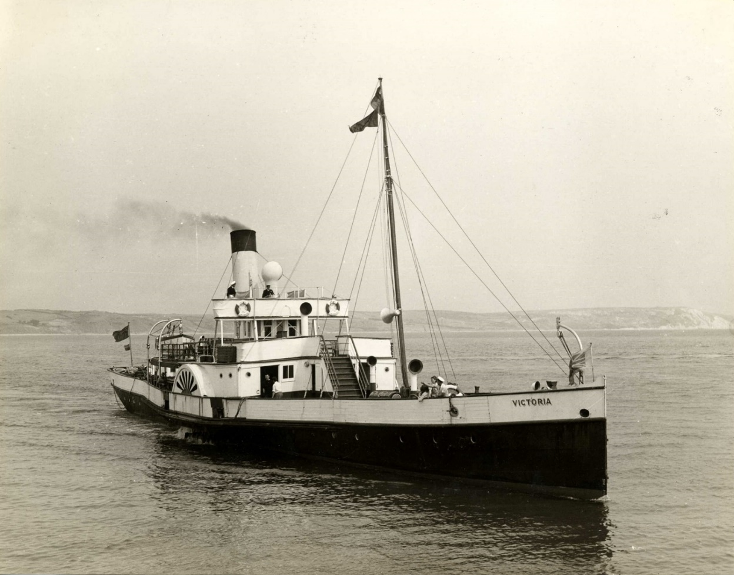

THE POOLE CURIO SHOP 1924
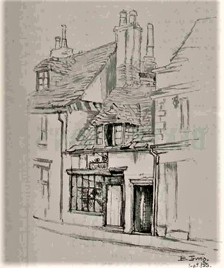

WE ARE INDEBTED TO DR. CHRISTINE COUSINS FOR HER VALUED DONATION COMPRISING A REMARKABLE COLLECTION OF IMAGES OF HISTORIC GALSSWARE AND POTTERY RECOVERED FROM THE HARBOUR FLOOR OVER A PERIOD FROM 2005 – 2007.
CAN ANYONE IDENTIFY THE SHIPPING COMPANY FROM WHOM THE FRAGMENT, BELOW, ORIGINATED ?

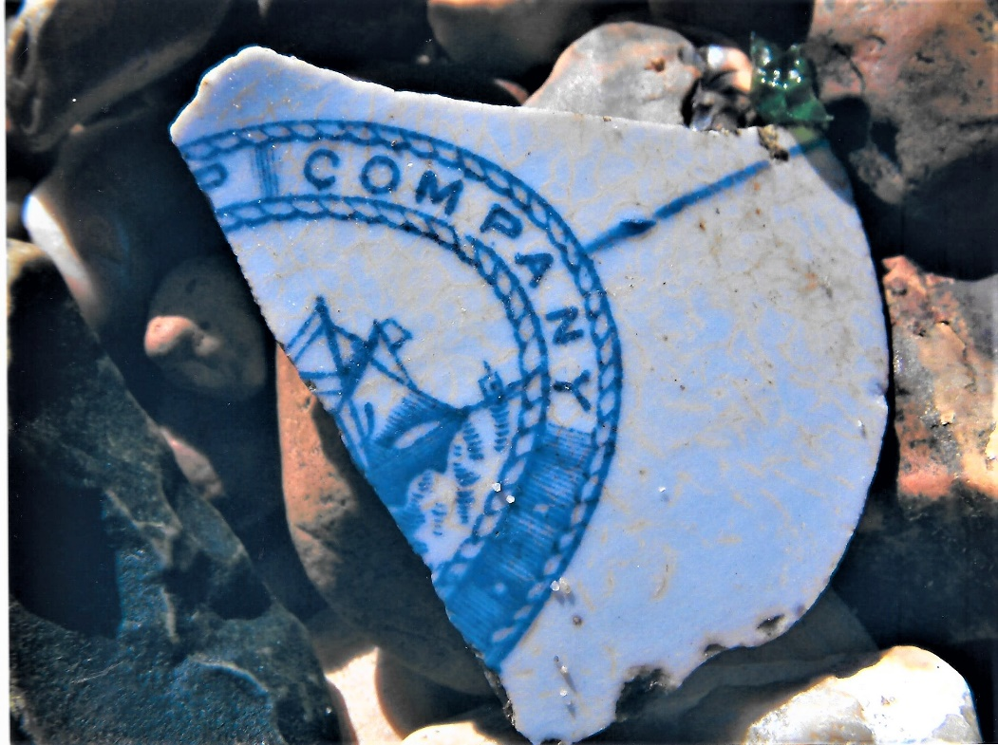

WITH THANKS TO ANDREW HAWKES FOR THE FOLLOWING SUBMISSION

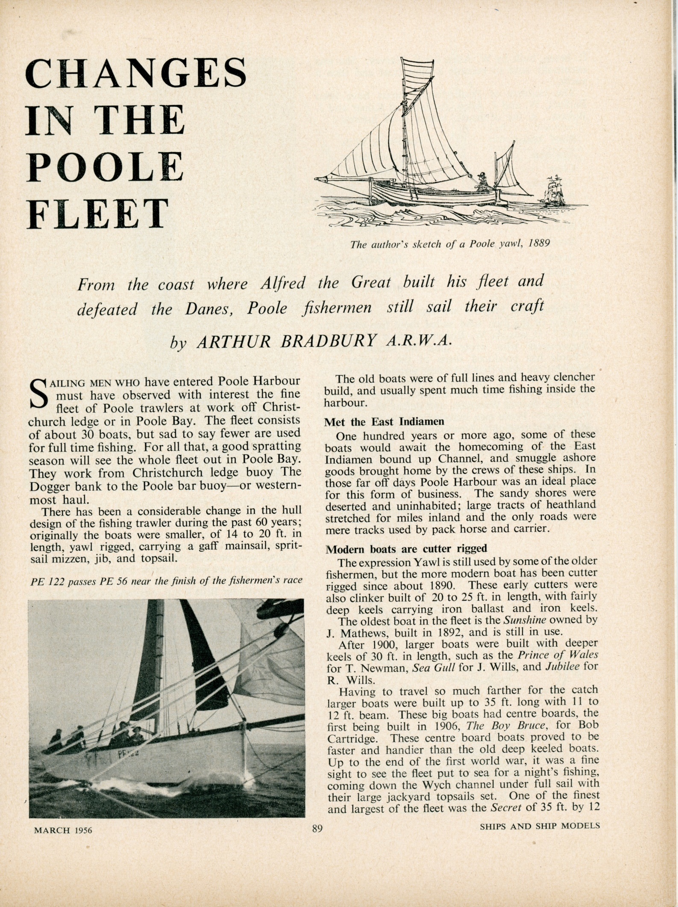

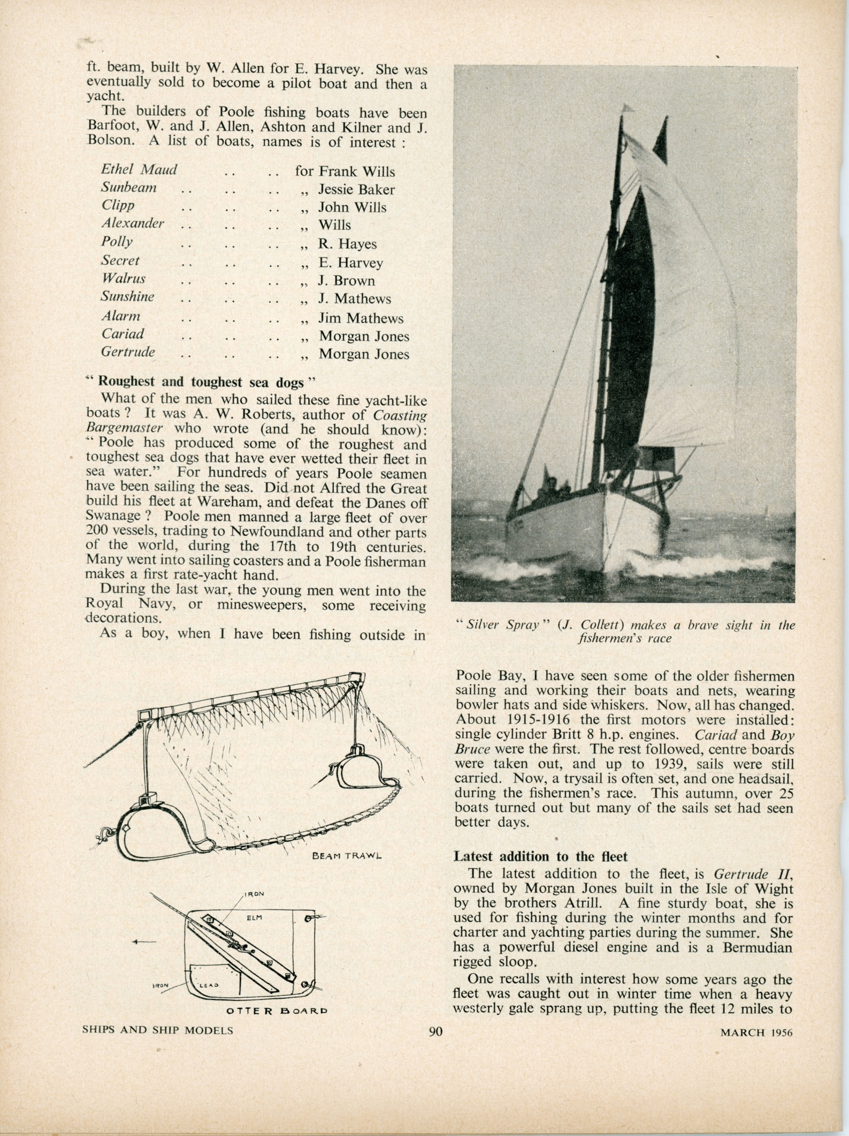

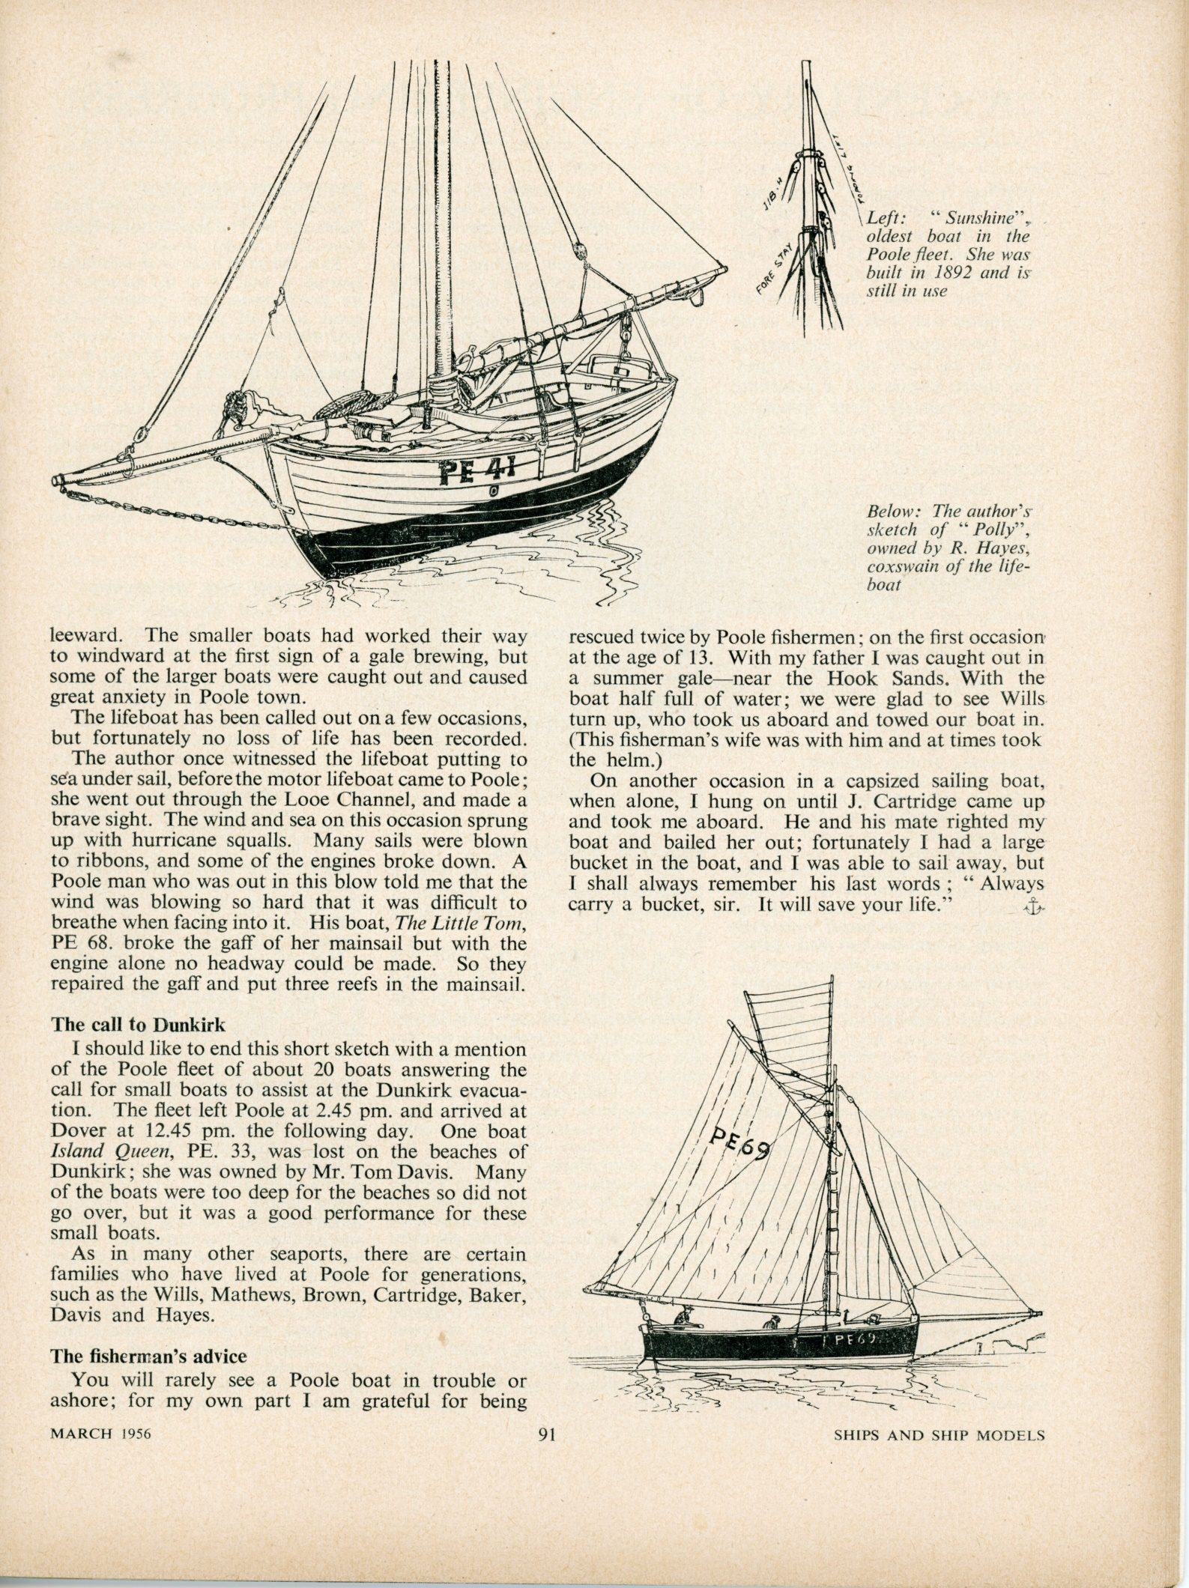
THE LOSS OF THE ‘TITANIC’, 15th April 1912.
Titanic Exhibit. December 2021.

John and Hester Cribb have been members of the Poole Maritime Trust for many years.
Before John died earlier this year, they agreed that they would donate a piece of important family history to the Trust. We are delighted that Hester has now given the PMT a wonderful family heirloom that gives us a direct link between John’s family living in Parkstone, and the sinking of the Titanic.
We have a charming picture of John’s Grandfather, John Hatfield Cribb, in a most unusual frame, along with a copy of a handwritten graphic description by his daughter Laura, of the few hours in which the Titanic hit the iceberg and sank and how Laura was rescued and taken to New York.
Thank you Hester, for this generous and important donation. We have created a small, temporary display which can be seen at our library HQ, above the Public Library in Canford Cliffs.
At the moment, we are open every Thursday morning 10:00 – 12:30 or at other times by request.
Peter Burt.
The Poole Maritime Trust thanks the late John Cribb, (grandson of the man who lost his life on the Titanic) and his wife Hester Cribb for donating the material displayed here, from their family archive.

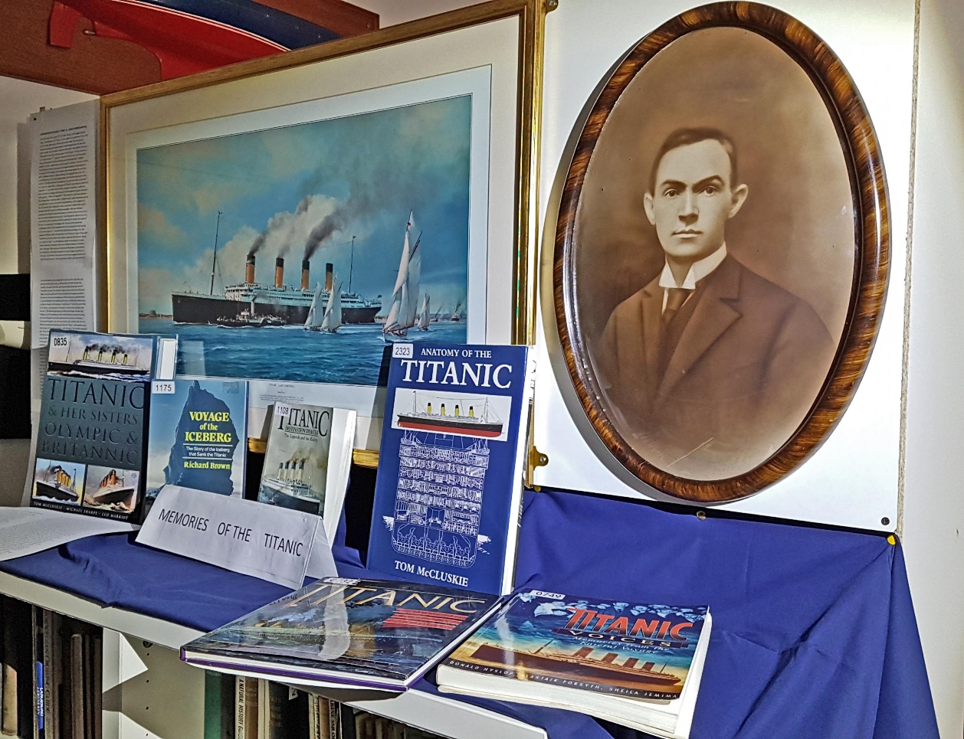

MY EXPERIENCES ON THE R.M.S. TITANIC by LAURA M CRIBB (SURVIVOR)
Set sail for New York on April 10th 1912 with Father, on the largest steamer afloat, the White Star Line “Titanic” on her maiden trip, which was the first and last, for, when within about 40 hrs; journey from New York, she struck a monstrous ice-berg, the upper portion of which crashed onto the deck, the lower crashed into the bows of the boat, which split in the middle in less than three quarters of an hour after we were in the life-boats. The ship struck at 11-15 on Sunday April 15th; I was not in bed till 10-50, but was soon fast asleep. I have a very powerful instinct and very clearly remember that I suddenly awoke, and, with a slight shiver sat bolt upright in my bunk. I am sure I sat thus for quite three minutes, hearing only the deep breathing of my companions who were still fast asleep, and the splash of the waves against the port-hole, when suddenly the ship trembled violently, then stopped with a jerk, and a second after one of my companions awoke, and fervently clasping her hands, cried out “Oh! My God what has happened” then she turned to me and said “I can’t leave my two children, will you go and find out if any serious accident has happened”. So I got down from my bunk, dressed as quickly as I could and went out into the passage, which was soon full of people all eagerly asking the same question, “What has happened?” I had only been in the main passage a few minutes when I heard my father calling my name, and I answered as loudly as possible above the din, and soon he was beside me, and he asked me if I was fully dressed, and I replied that I was, so we went a little further up the passage to talk with some of our fellow passengers. After we had been laughing and chatting for about five minutes, my father turned to me and said that we should probably have to go out in the life-boats for half an hour or so, as we had met with an accident and they would want to lessen the weight of the ship, to try and repair the damage. But I am sure Father knew that something very serious had happened and that once away from the ship we should never return to it. Just as Father had finished speaking to me, the Captain and Officers came hurrying along, and shouting as loudly as they could “Gentlemen, assist the women and children to get their life-belts on, then go up on deck all of you”. So I immediately pushed my way back to my cabin, where I found my companion and her two children dressed, so I told them what I had heard, then I got up on my bunk and took down all the life-belts that were there, I then took one down for myself and gave the others to my friend and I told her that if she came out in the main passage some-one would assist her to put them on. I then rushed back to Father, who took the life-belt from me and told me to hurry along with him at once to the upper deck, and we were the first there, so we ran swiftly across to the little iron stair-way leading to the second-class deck, which we ascended and easily got over the little gate at the top. Then we went through the saloon and up to the first class (deck) state-rooms and out on to the deck where the life-boats were ready to be lowered. As soon as we appeared, an Officer came up to us and told Father to put the life-belt on me, which he did at once, and then Father told me to go and get as close to the life-boats as I possibly could. I then left him, and neither of us spoke as we expected to meet again in a short while. I was able to get into the 3rd life-boat being lowered, but when we had been let down about halfway, one of the pulleys got stuck, whilst the other one was still working, and we all thought we should be overturned into the sea, but however, it started working again just in time to prevent such a calamity. We had a very difficult time indeed in getting away from the ”Titanic” as the sucktion was so very strong, but however the sailors, with the help of four females managed to get it away from the gradually sinking ship. I must say here, that there was very little panic indeed, as the truth of what had happened was not known by a great number of people until we were away from the ship, then we could see for ourselves what had happened, as a huge portion of the ice-berg had crashed crashed on to the deck near the wireless operating room. We had only been out about half an hour, when suddenly the lights of the doomed ship went out, and immediately after there was a terrific thunderous explosion, followed by the most terrible shrieks and groans of the helpless and doomed people that were left on the wreck of the great ship, the explosion having caused the ship to split in half, and then it sank very rapidly indeed. Since leaving Father I had not uttered a sound, but as soon as the ship exploded and split I gave one awful shriek and fell unconscious. When I became conscious again it was dawn, and a more beautiful scene you could not have wished to see and there was no sign of the “Titanic”. I asked how long I had been unconscious, and was told “Nearly six hours”. I was pretty well frozen through and my limbs ached dreadfully but gradually the sun came out stronger and brighter, and I very very slowly got a little warmth into me. After a while the Quartermaster (who was with us) lifted me up a little and pointed to the “Carpathia” to which we were rowing as quickly as possible, but it seemed as if we should never reach it, every minute seemed an hour. But in about an hour and a half we reached it. I was so stiff with the intense cold, that I could not climb the rope ladder which had been let down over the side of the “Carpathia”, so I had to have the belt and rope adjusted under my arms and round my waist. As soon as I reached the top two blankets were thrown around and over me, and I was carried to the saloon which served very well as a hospital that morning. After I had rested about 10 mins; a nurse came and rubbed me and gave me a cup of black coffee, boiling hot, and without sugar or milk, this she made me drink almost at once, then she wrapped me up again and went to attend some-one else. After I had become warmed up a little, I was helped to a cabin, where a nurse was waiting to put me to bed. I had to sleep on the top bunk, and as my nerves were very much strained I became excited in my sleep, and only woke up just in time to prevent myself from falling out. After breakfast next morning I was able to go out of my cabin, and as I went through the saloon I found everyone looking at the notice board for news of their loved ones. It was not till then, that I fully realized what had happened and what it would mean to me in the future, and yet I could not give up my hopes entirely of seeing my Dear Beloved Father again. It was very foggy next day. A dense yellow fog hung about us, so that we made very little progress, and the fog-horn was going the whole time. The third day was glorious, and we had a very dazzling view of an immense field of ice. The first two days we were on the “Carpathia” the Bandsmen were not allowed to play their instruments at all, and were told to assist the ladies as much as possible on deck, but on the third day the played Hymns and some beautiful soothing selections of music. At last we arrived in New York under cover of darkness about 9-30pm, on April 18th. We were taken to a room and given a little food and money, (and clothing to those who needed it, as a number of people were very scantily clad). Then after answering a few questions, we were whirled away to various hospitals in ambulance cars. I was taken to St Vincents Hospital and was soon in bed, but friends managed to locate me very quickly and came to fetch me about 10 mins after I was in bed, so I had to get up again, and home where we arrived about 12-30pm that night. At noon next day I was taken to the city of my birth, Newark, New Jersey, where I had relatives and friends anxiously waiting for my arrival.
Laura M Cribb
Survivor of the
“S.S. Titanic”
ITCHEN FERRY – GAFF CUTTER
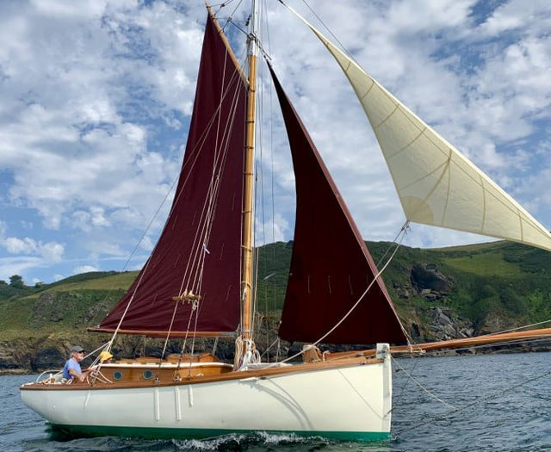

This beautiful old gaffer, sold recently by Wooden Ships yacht brokers, was built in 1898 by Hayles on the Isle of Wight on lines of the classic Itchen Ferry boats.
Itchen Ferry gaff cutters were first built on the River Itchen during the 19th and 20th centuries. They were originally used for fishing in the Solent and surrounding waters.
This beautiful example was discovered as a derelict wreck in the late 1980s. A complete professional rebuild commenced that eventually saw the boat re-launched in 2003.

Skylark 9 Restoration Project

A small boat with a big history
The Skylark IX Recovery Trust cares for a ‘Dunkirk Little Ship’ that saved lives during Operation Dynamo in 1940 and was herself later saved from a watery grave at Loch Lomond in 2012. Today, as a symbol of recovery and resilience, Skylark sits at the heart of our projects inspiring people to make positive changes to their lives and communities.
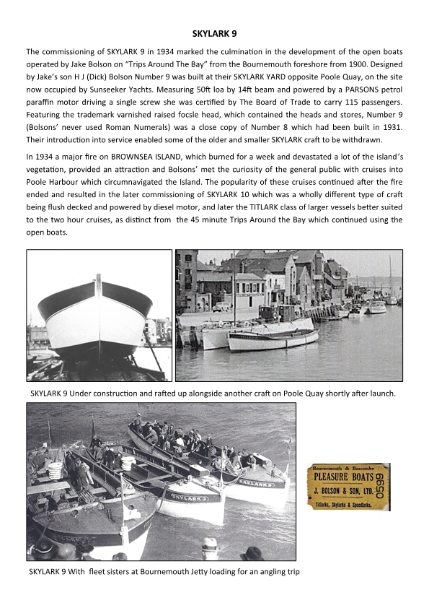
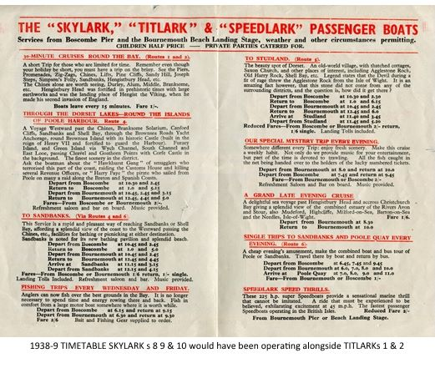
With thanks to Chris Wood for the history of the “SKYLARK 9”
On 25th November the Trust were delighted to host Fergus Sutherland from the Skylark 9 restoration project. He is continuing to research her history including her involvement as part of the Flotilla of Little Ships that left Poole on 28th May 1940 to take part in Operation Dynamo, the Evacuation of the BEF from the beaches of Dunkirk.
Chris Wood and Jack Hawkins assisted Fergus who now wishes to maintain the links with PMT and further research in our extensive archive of Bolson’s Shipyard and Poole Naval Base 1939 to 1945. He found Chris's book, “ANYMORE FOR THE SKYLARK” a rich source of the vessel’s history and had his copy signed by Chris. Jack advised with the references held in the Trust library as a result of the research undertaken regarding the Motor Yacht Estrallita.
“SKYLARK 9” and the restoration project are continuing to help others. She is proving a focal point for people within the community of Glasgow community who need to gain confidence and skills in order to improve their lives. The vessel’s history itself is a lesson of overcoming tragedy and adversity.

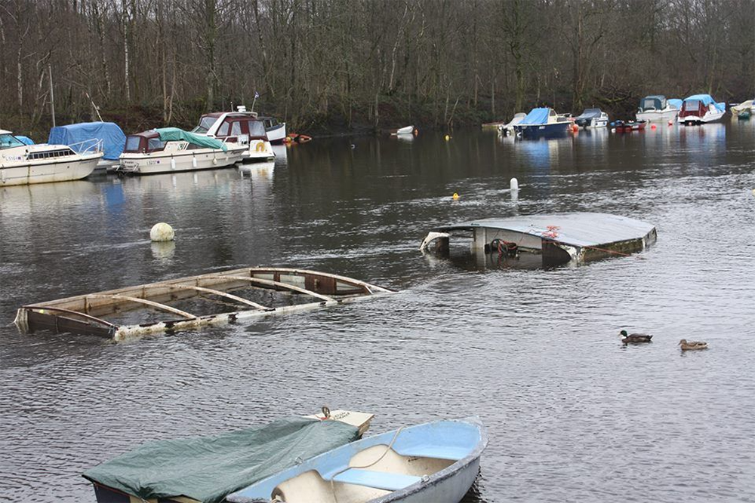
Two days after the 70th Anniversary of Dunkirk Skylark 1X sinks at her moorings and remains there for two years.
.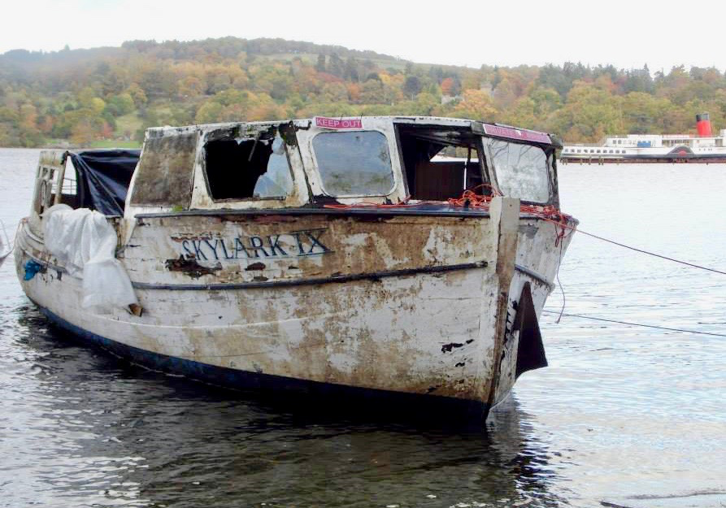
In 2012 she was discovered and although in a sorry state was recovered.
From this Little Ships inspiration, the Trust has set up courses for Skiff building, Boat building and Coastal Rowing to encourage young men and women to engage and reach their full potential. We wish them all the very best and look forward to working with Fergus again soon. You can find out more on the link below. https://skylarkix.co.uk/recovery-project/restoration/
JACK HAWKINS & FERGUS SUTHERLAND taking a break

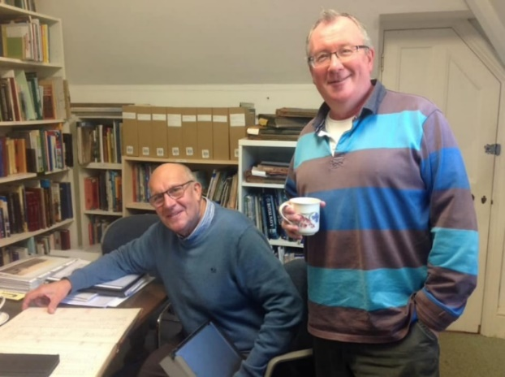
FURTHER REVELATIONS CONCERNING THE ROLE OF POOLE BOATMEN

IN THE EVACUATION OF DUNKIRK.
(With many thanks to Jack Hawkins for his tireless efforts in researching this important historic event)

“We have submitted our documentation to Association of Dunkirk Little Ships which has been reviewed and revised by a Naval Historian who is an academic with his field being Naval Intelligence. This was our first indication that Private yachts left Poole on 28th May 1940 to deploy to Dunkirk.”

“Lend Your Boats To Bring Troops!”
Fishermen Said “Yes”
When an appeal was made to Poole fishermen and yachtsmen to lend their boats to help in the transport of troops from Dunkirk a ready response was made by the fishermen.
Volunteers were asked to make up crews. The regular seamen were not able to go, so many of the crews consisted of tailors, fishmongers, and men who had never been to sea in their lives before.
About 20 small boats were eventually got together, and left Poole Harbour late on Wednesday night for a south-east port.
The boats including smacks from the Poole fishing fleet, Skylarks, and motor launches belonging to Councillor Tom Davis and Harvey’s.
Captain H. Bennett, age 75, took charge of the Skylarks. The Poole lifeboat was also in the procession.
Captain H. Quick, who was in charge of the small fleet, told a “Herald” reporter that at daybreak he found one of the boats anchored about 10 miles out to sea with engine trouble.
Later on they found a tug which had lost its bearings. Mr Quick explained where they were going and the captain of the tug joined in the procession.
THEY ALL GOT THERE
The journey which was about 200 miles took most of the boats 28 hours of continuous sailing.
In spite of numerous breakdowns and other troubles, all the boats arrived safely.
“It’s really amazing how they got there at all” said Mr Quick.
Yesterday the crews left Poole by train for the same port in order to sail their boats back again.
Poole and Dorset Herald
June 1940

Poole Maritime Trust Newsletter December 2021
Port Update courtesy Kevin Mitchell

Over the weekend of 16th / 17th October the large 145m long cargo ship Haren was in port to unload two large helicopters which it is believed are destined for the Royal Naval Air Station at Yeovilton in Somerset. This photo of Haren alongside South Quay was taken by Darryl Morrell.
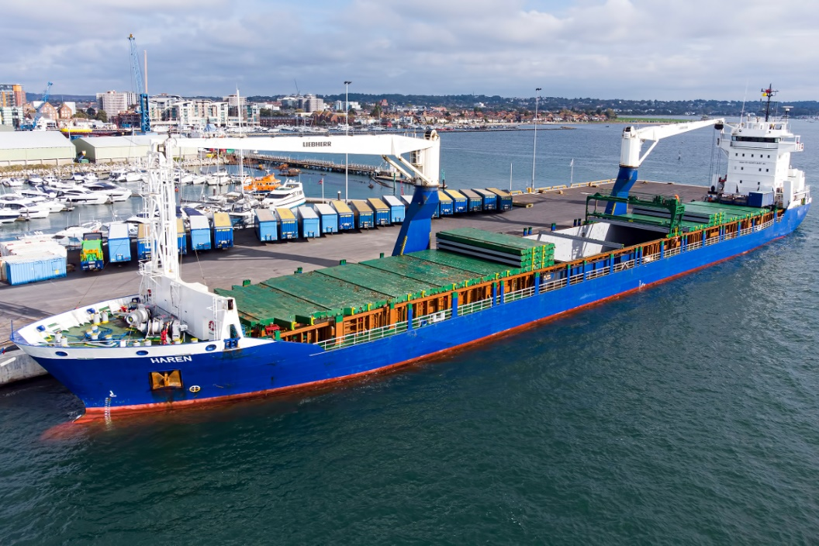
The PHC tug Herbert Ballam returned from prolonged maintenance work in Southampton on 3rd December, and went straight to work assisting the St Helena to berth at South Quay.
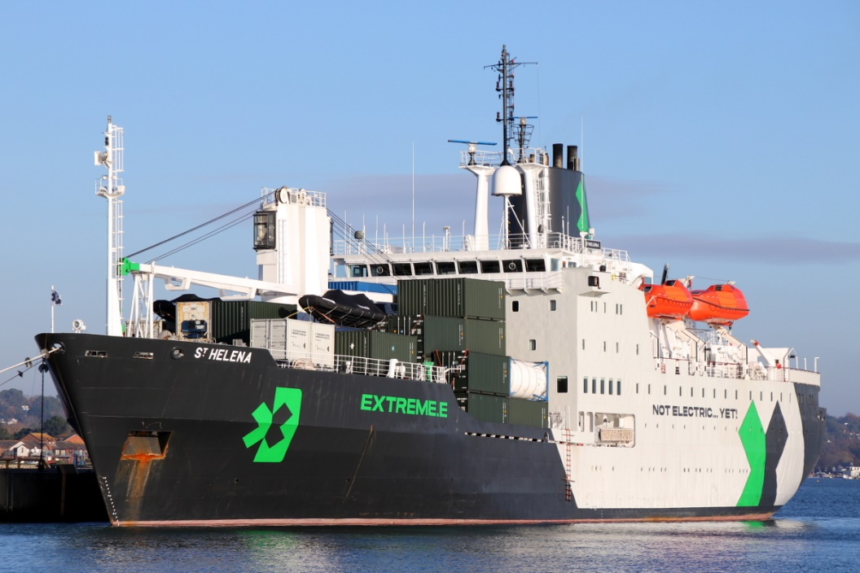
Due to Herbert Ballam’s absence and a lack of other tugs, the Afon Las belonging to Holyhead Towing was brought to Poole during October and moored at the Jenkins Marine pontoon and was in use on the evening of 19th October to berth the freight ferry MN Pelican in strong winds.
Brownsea Island closed for this year on 31st October, Greenslade’s Pleasure Boats running just their Purbeck Pride that weekend. The Poole fleet of harbour ferries generally get overhauled and repainted over the winter, although City Cruises continue to operate harbour trips throughout the winter. Their Harbour Scene was dry-docked at Gosport during October and Island Scene at Lake Yard, Hamworthy. The City Cruises fleet are all being repainted with blue hulls ready for next summer. Brownsea Island Ferries’ Maid of the Islands and Maid of the Lakelands were noted alongside Poole Town Quay at the beginning of December with freshly repainted yellow hulls.
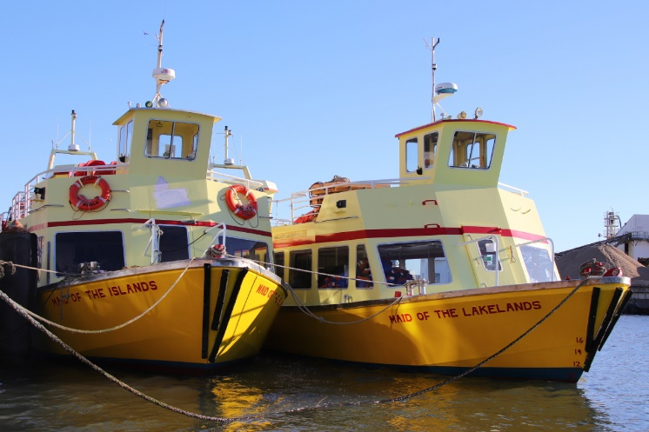
Condor Ferries had a busy summer with both Condor Liberation and Condor Voyager sailing from Poole to the Channel Islands, but as from November a reduced winter timetable is in operation. Each will take it in turn to be dry-docked at Falmouth this winter. Brittany Ferries were not able to offer any passenger sailings from Poole this year, with the popular Barfleur remaining laid-up in the French city of Caen until early 2022 (see photo taken on 5th November).
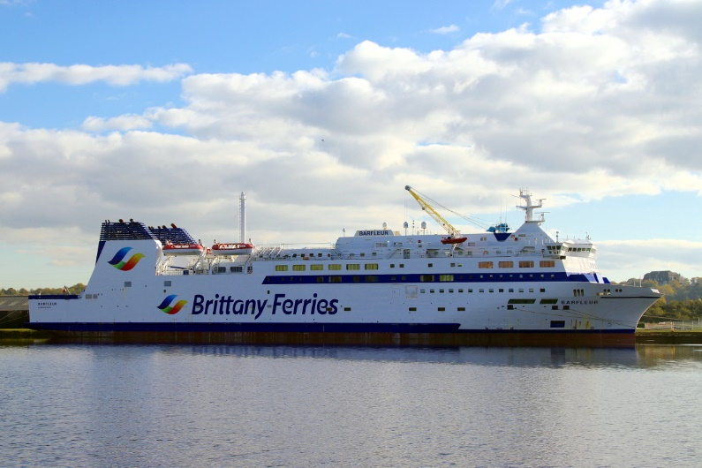
A new seasonal high-speed service has been announced for 2022, with the Condor Liberation operating Portsmouth-Cherbourg-Poole on Fridays, Saturdays and Sundays on behalf of Brittany Ferries, before making an afternoon sailing to the Channel Islands for Condor Ferries.
On 23rd November the former Royal Mail Ship St Helena arrived at South Quay for the first time. Having spent most of her career carrying passengers and cargo to the remote island of St Helena in the South Atlantic from Cape Town, she now transports cars and equipment around the world for the Extreme E motor sports series. The latest event was at Bovington during December. Having unloaded around 80 containers, St Helena proceeded to Falmouth for a brief period of maintenance before returning to layover in Poole on 3rd December. Also in port on 23rd November were the general cargo ships Wilson Rotterdam discharging steel beams, and Ventura loading barley. Due to the national lorry drivers’ shortage, some goods are instead being transported around the UK coast by ship, and Poole has benefitted from this extra trade.
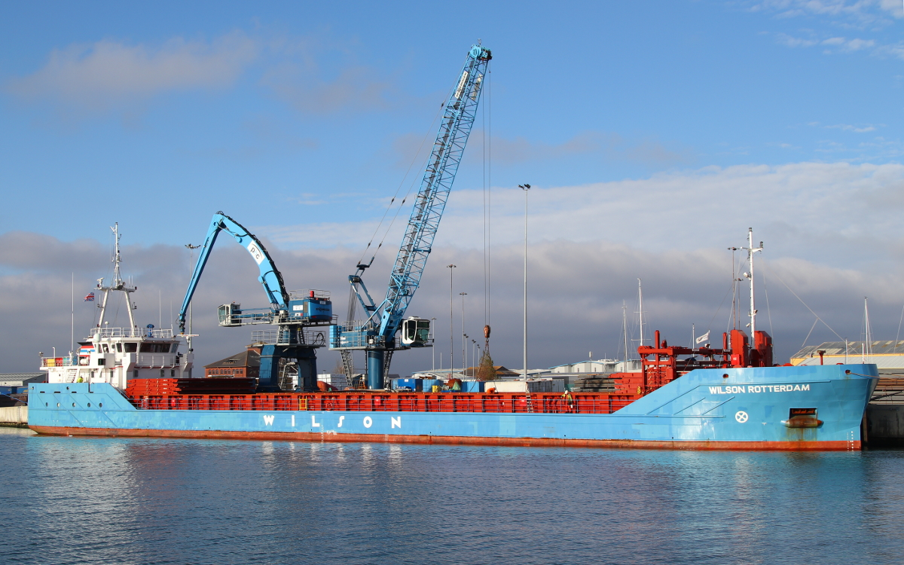
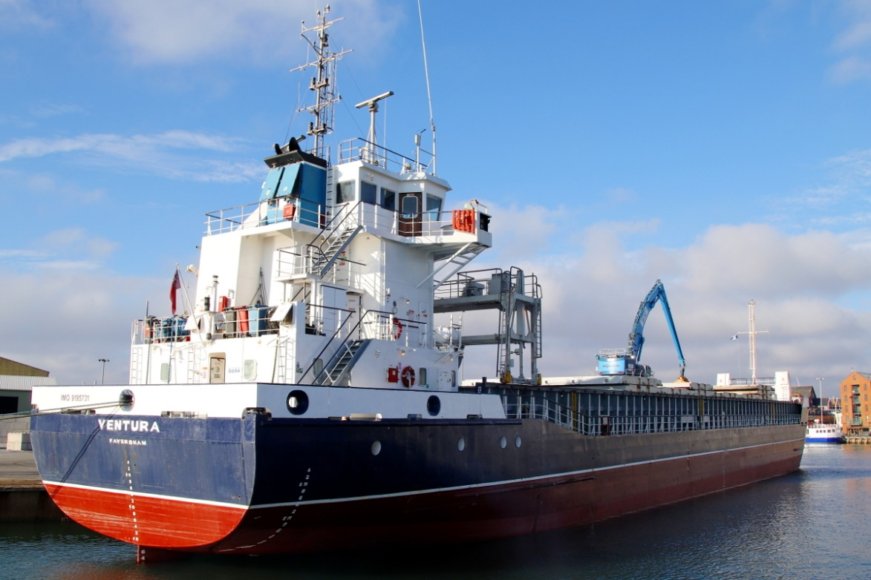
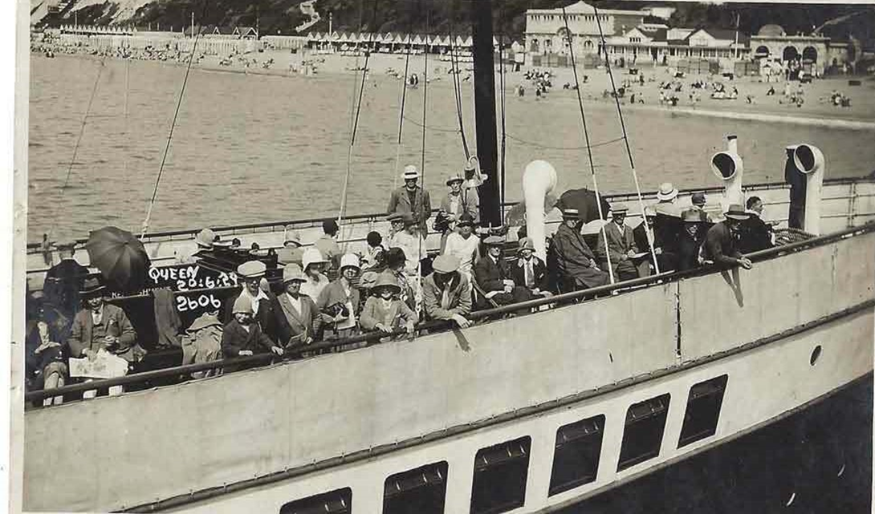
BOURNEMOUTH QUEEN
Alongside Bournemouth Pier 20th June 1929. BOURNEMOUTH QUEEN was owned and operated by Red Funnel Steamers, of Southampton. Each summer, for many years, she would be based at Poole operating a variety of, mainly, long distance excursions from Bournemouth, Poole and Swanage.
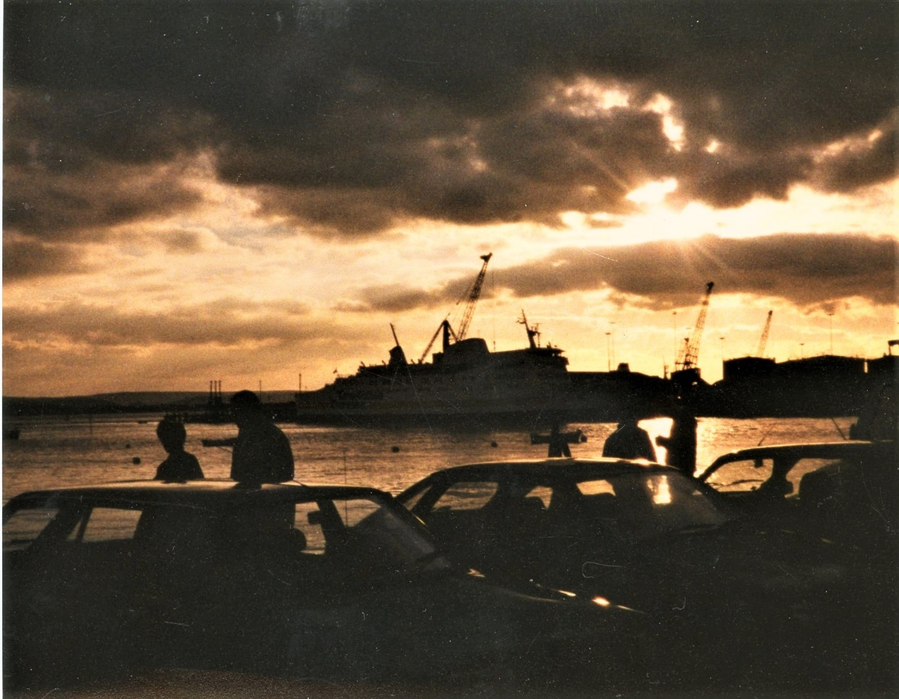
A POOLE SUNSET 1990
FORTHCOMING MEETINGS AND EVENTS
POOLE MARITIME TRUST
January Talk  20th January | The work and resources of the Poole Maritime Trust | Poole Maritime Trust Members
February Talk  17th February | “Cunard History and Glamorous Stars” | Steve  Herra
March Talk  17th March | “Crossing The Severn” | Brian Margetson
AGM  April | To Be Confirmed | TBC
All events and talks will be at 8pm. in The Mountbatten and Edinburgh Rooms on the first floor of the Royal Motor Yacht Club, Entrance from Old Coastguards Road, 54 Panorama Rd, Sandbanks, Poole BH13 7RE

PADDLE STEAMER PRESERVATION SOCIETY
SATURDAY MARCH 5th 2022
SUNCLIFF HOTEL – EAST OVERCLIFF BOURNEMOUTH BH1 3AG
AT 2pm – an illustrated talk
“FROM THE NEEDLES TO THE NAB”
Peter Lamb recalls the halcyon days of the 1950’s & 1960’s
Revisiting the
Ports, Harbours and Resorts and looking back at Ships and other craft that serviced them
Entrance is FREE and all are welcome
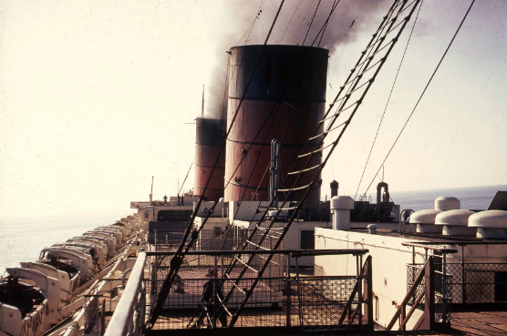
NEWSLETTER
The newsletter is published every 2 – 3 months. Submissions are invited for consideration in the form of articles, stories and images. If you have anything you consider would be of interest relating to the Harbour, it’s history, or other maritime related subjects, please e-mail it to : UKCCA@AOL.COM

LIBRARY AND ARCHIVE COLLECTION NEWS.
WE ARE ALWAYS SEEKING THE FOLLOWING TO BOOST OUR EXTENSIVE COLLECTION
We will be happy to collect.
- Photographs, slides and negatives – Anything maritime or harbour related.
- Films
- Ephemera – Posters/Leaflets/Tickets/Letters/Documents etc.
- Artifacts of any kind however loosely linked to the harbour or the maritime trade world-wide.
- Family history relating to Poole and it’s environs
- Books
- Magazines & Periodicals
- Paintings
- Discarded lap-tops and surplus office equipment and supplies
We are very fortunate in receiving regular donations covering all aspects of Poole, it’s fabulous harbour and shipping interests around the world.
Volunteers are always welcomed – Each Thursday morning from 10.00
First Floor, Canford Cliffs Library (Entrance at the rear of the building)
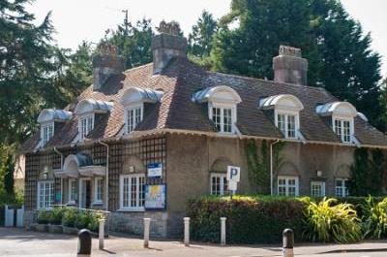
WITH MANY THANKS TO THOSE WHO HAVE CONTRIBUTED MAKING THE PUBLICATION OF THIS NEWSLETTER POSSIBLE AND WISHING EVERYONE A VERY HAPPY NEW YEAR.
THE NEXT EDITION IS ON THE STOCKS AND PUBLICATION IS AIMED FOR THE END OF FEBRUARY.

