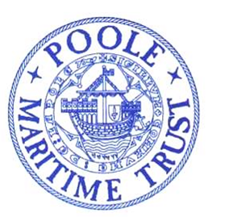
POOLE MARITIME TRUST
NEWSLETTER FEBRUARY 2022
Committed to recording and preserving the history of Poole Harbour, It’s people, surrounding environs, trading links, industries and everything maritime related.
Welcome to the Poole Maritime Trust Newsletter. Contributions are invited for future editions.
Please send any material to be considered for inclusion by
e-mail : secretary@poolemaritimetrust.org or Tel: 01202-706673

FROM OUR CHAIRMAN.
It seems appropriate to mention in this newsletter, that the Poole Maritime Trust celebrates its 50th anniversary this year. Much has happened since the Trust was founded by three notable gentlemen, Alasdair Ferguson, Teddy Neville-Jones and Sir Frederick Coates. Although the original objectives of promoting and encouraging of the study of Maritime History in this area remain the same, much work has been accomplished over this period of years. The Trust has not only maintained but largely increased the archive which covers the activities surrounding Poole Harbour and its environs, but also moved with the times in terms of technology. The use of a sub-surface profiler, a remotely operated underwater vehicle (basically a mini submarine) and a privately owned drone, has enabled the Trust to gather considerable information regarding the nature and history of the harbour. In addition, the Trust has close liaison with other groups involved in the history of this area, notably the Poole Harbour Heritage Project and, more recently, the Society for Poole. Our activities can be seen on Facebook and on our website which is currently in the process of a major update. A number of events are planned to celebrate this important anniversary, details of which are contained within this newsletter.

Commodore G H Edwardes OBE, Chairman

TILLY WHIM CAVES from old lantern slide that appeared on FACEBOOK
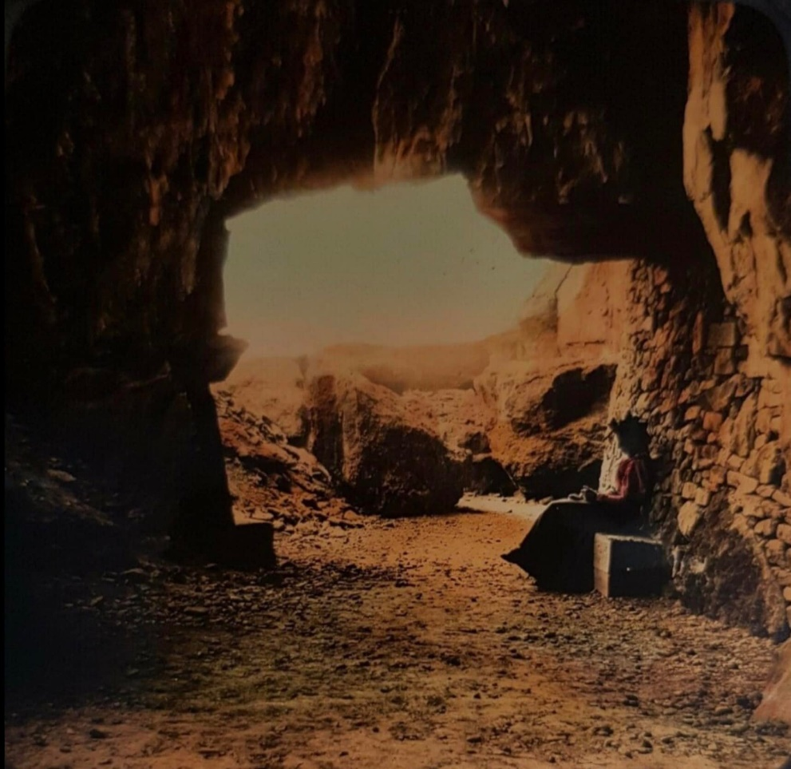

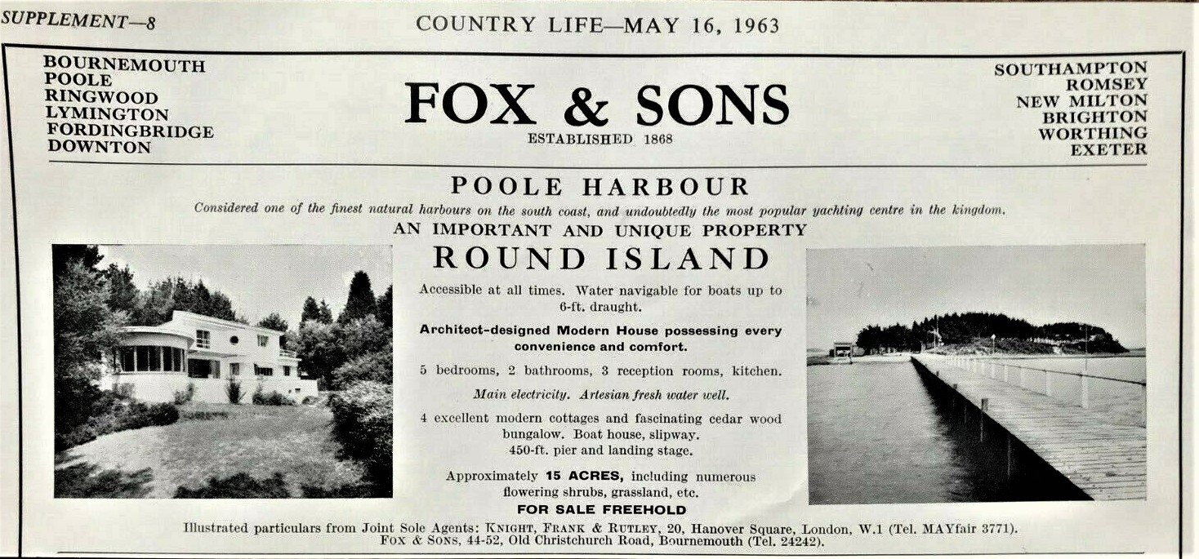

POOLE BAY WATERSPOUT.
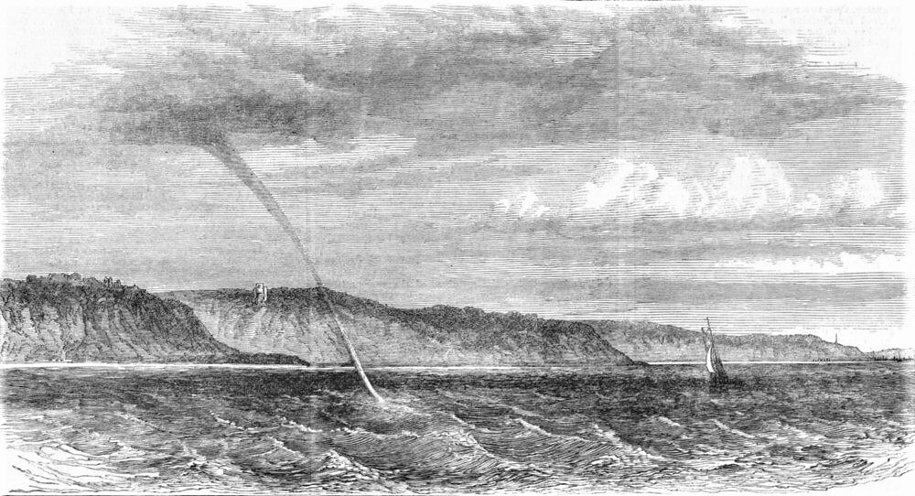

THE RYE LIFEBOAT DISASTER OF
1928
Note. This article was submitted by a member. I understand the images and text were sourced from internet research. In the unlikely event any copyright infringement has occurred we would unreservedly apologise.
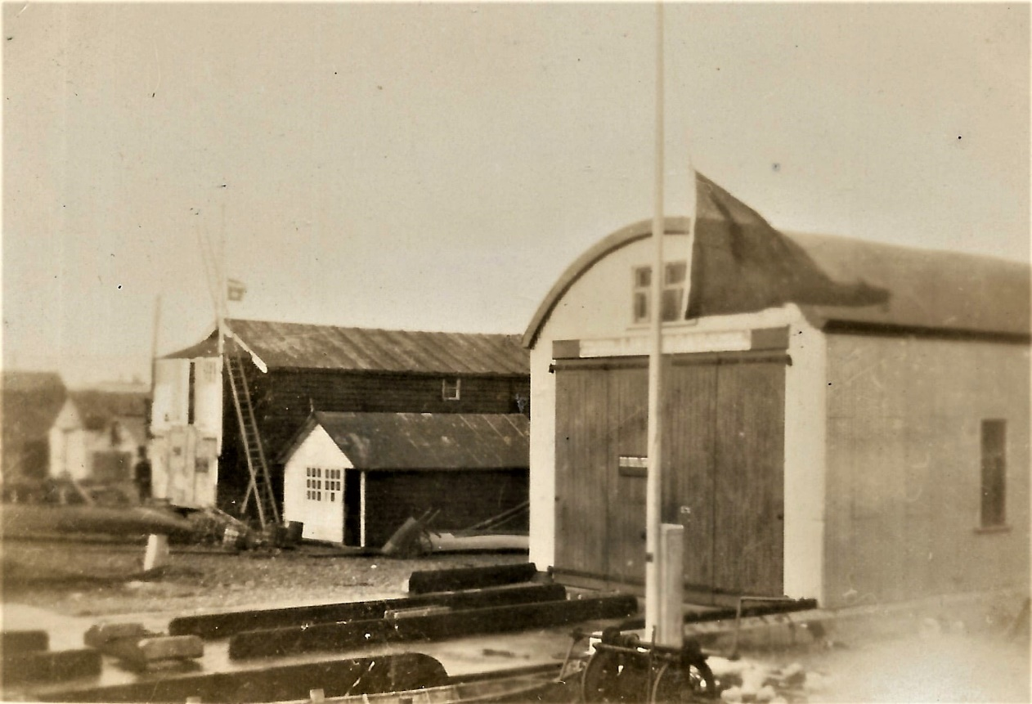

1928: The Mary Stanford Disaster. The entire crew of the Lifeboat 'Mary Stanford' of Rye were drowned whilst attempting a rescue in heavy seas. The attached photograph of a black flag at half-mast may be seen flying from the Eastbourne Lifeboat Station.

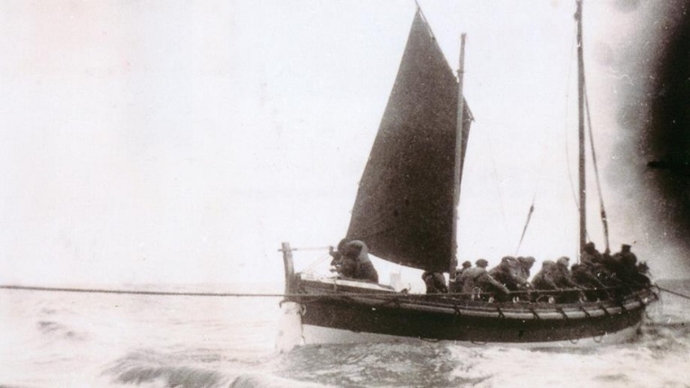
Early in the morning, on 15 November 1928, the Rye Harbour lifeboat Mary Stanford was launched to assist the Alice, a small Latvian vessel in difficulty off Dungeness. The weather conditions were among the worst in living memory.Frank Saunders was a launcher on that fateful day and recalled that it was a dark and wild morning, blowing a full gale from the south-south-east. The maroon was fired at 5am. One crew member observed that you couldn’t see across the marsh because of what looked like fog, but was in fact the spray from the shallow breaking waters.It was low water and the volunteers had great difficulty in launching the boat. There was a stretch of sand to pull the boat across and it took three attempts before she was afloat. The crew had to get out of the craft, so they were drenched through before they even set off. Mary Stanford had only been afloat a matter of seconds when a message came through recalling her, as her services were no longer required. The signalman, Mr Mills, fired his recall signal and Frank Saunders ran across the sands into the water to try to attract the attention of the crew. The weather was atrocious and they were busy getting the sails set. Mary Stanford was a pulling-and-sailing type lifeboat. She had no engines or radio; none of the devices that today we regard as commonplace. With oars in their hands and sails to set in a gale, it is little wonder that they did not see the recall signal. What happened between setting sail and her capsize we will never know as all 17 hands onboard lost their lives.
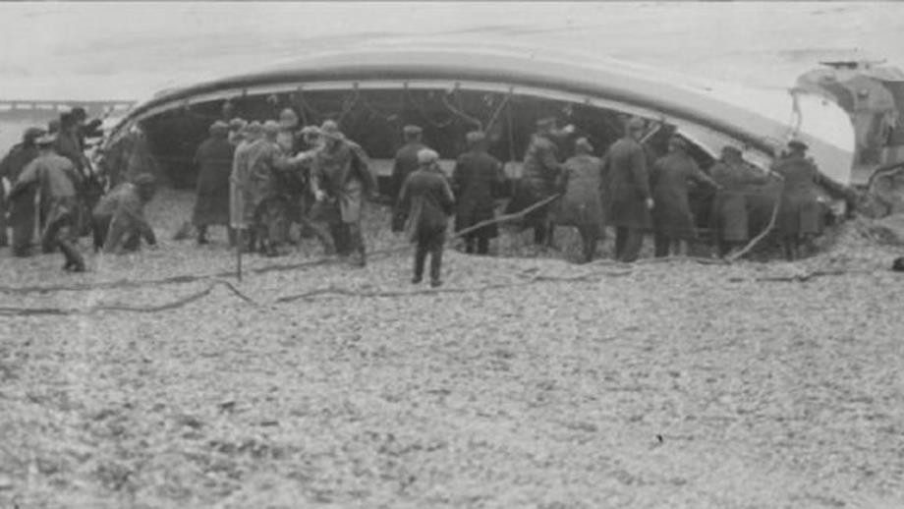

Villagers at the time recall the devastating sight of the vicar, Reverend Harry Newton, kneeling on the beach with the women of the village praying. Eventually the bodies were all brought back to the harbour and put in the Fisherman’s Room. All the coffins lay side-by-side with just the words ‘Dies Gallantly’ placed on each one. The Mayor of Rye launched an appeal for money for the families, which went worldwide.
The day of the funeral arrived and it was the biggest known in these parts. There were over 1,000 wreaths laid.

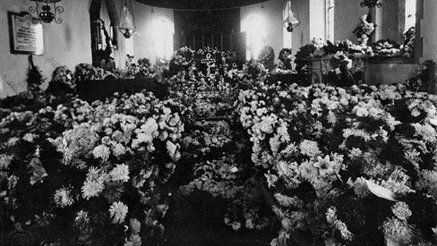
The crew of the lifeboat had worked together, laughed together, saved lives together and died together – and now they were buried together. The village was in mourning for a very long time, having lost so many of their men.
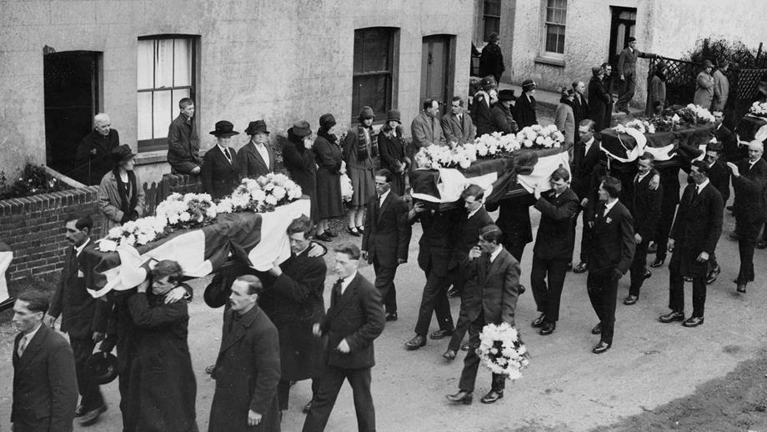

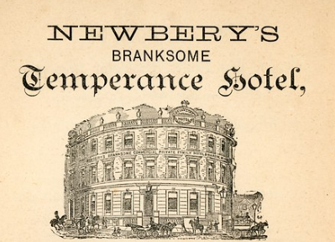

POOLE HARBOUR HERITAGE PROJECT.
REPORT BY ROBERT HEATON OUTLINGING SOME OF THE REMARKABLE RESEARCH BEING UNDERTAKEN BY THE PHHP.
FOR FURTHER INFORMATION ON THE WORK OF THIS GROUP
PLEASE E-MAIL : robert.heaton555@btinternet.com

Winter Archaeological Activities

In the midst of a wild winter, the subject of water based activities is not so appealing. However Poole Maritime Trust also has roots in land based archaeology and that means that there is always something exciting going on.

This week has been a journey in stone. Two summer seasons at the site of a demolished medieval church has led to a wide range of carved stone sections being recovered. Such excavation work in the summer leads to extensive post excavation analysis and writing up for the rest of the year.

I went along with a trailer to recover the heavy blocks and prepare them for examination. What you need for most objects is an expert and in this country with all its Universities and rich cultural heritage are some amazing individuals. These specialists in narrow diverse subjects are able to tell us amazing things, although they can sometimes be expensive or completely overloaded with work.

Fortunately in Dorset we still have some immensely experienced quarrymen and stone masons that really understand the many complex geological layers and how they can be best used. It’s a big subject and we do have a wonderfully wide range of colourful stones in Dorset. To make things even more complicated is that wealthy French barons often brought their own limestone blocks from across the channel just to keep the experts on their toes.

So the trailer of architectural stone has had most of the pieces identified. Then you have the tooling marks and fossils to study and traces of mortar. The complex shapes are often challenging and the erosion from being up on upper parts of the roof or tower is extreme. There are some broken limestone grave tops known as cross slabs and the styles can be dated to fairly precise limits.

Our next task is to draw up the blocks for the report, so I will pass them on to our artist. Eventually the best stones will go on display and the rest will return to the site. But we will begin to understand the church in increasing detail thanks to experts.

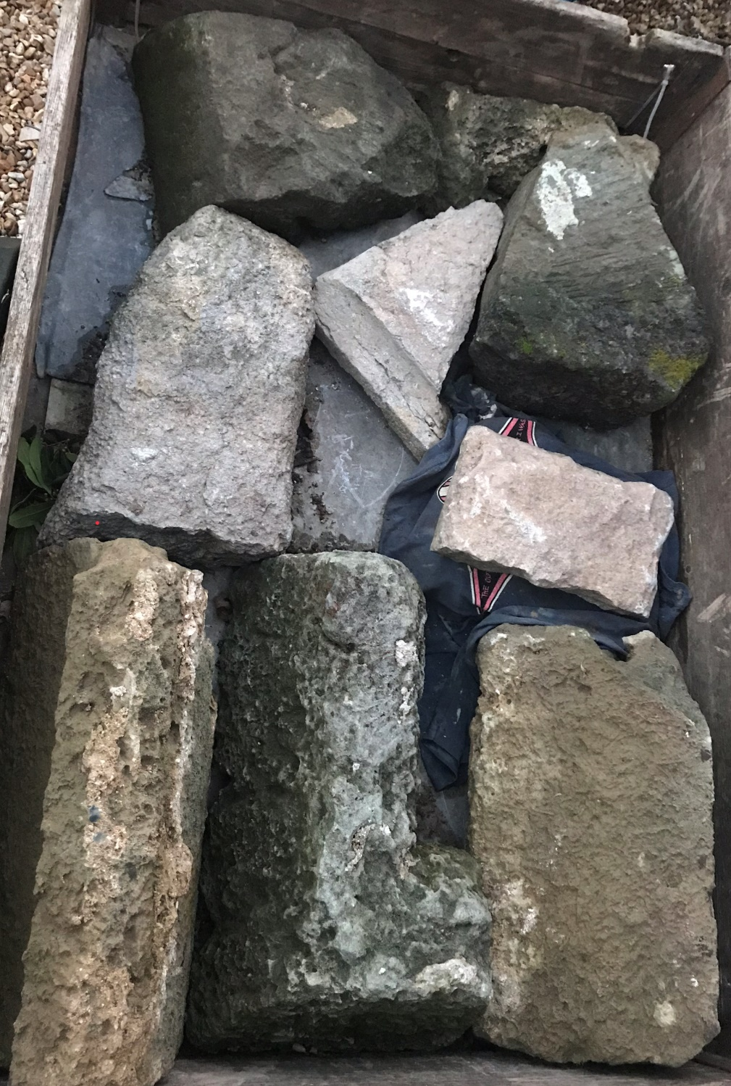

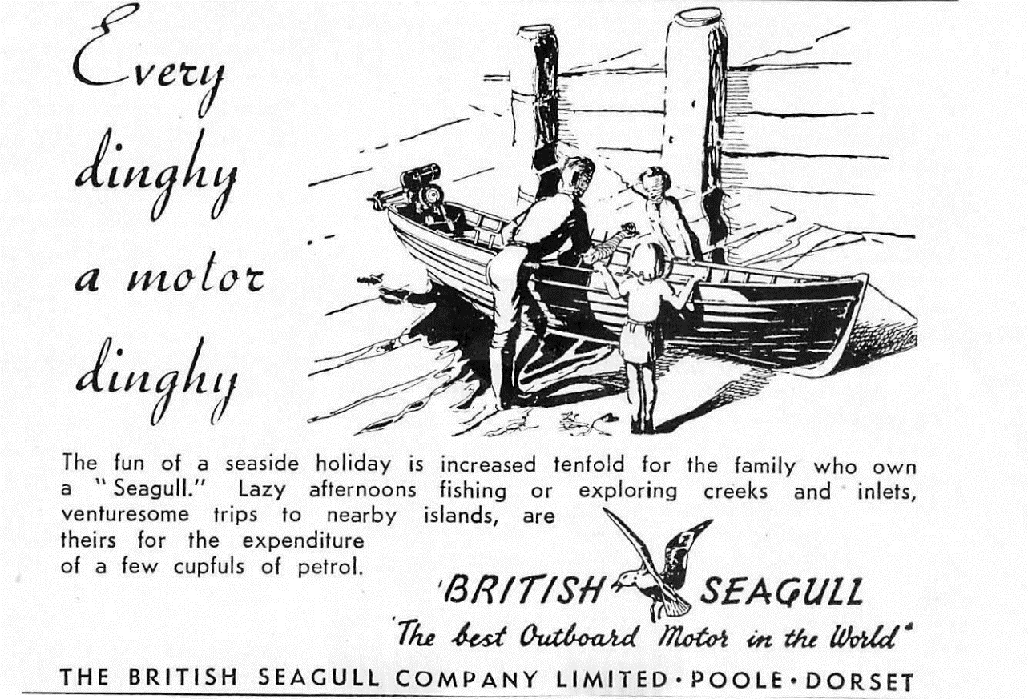
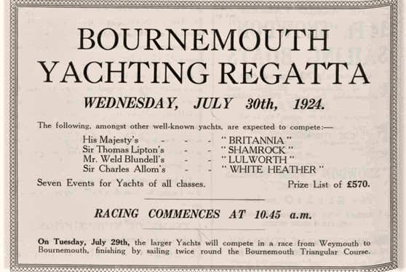

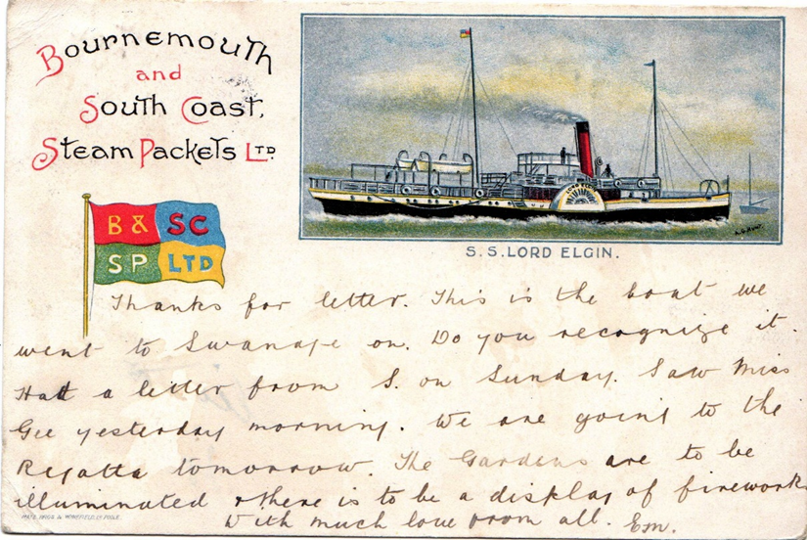
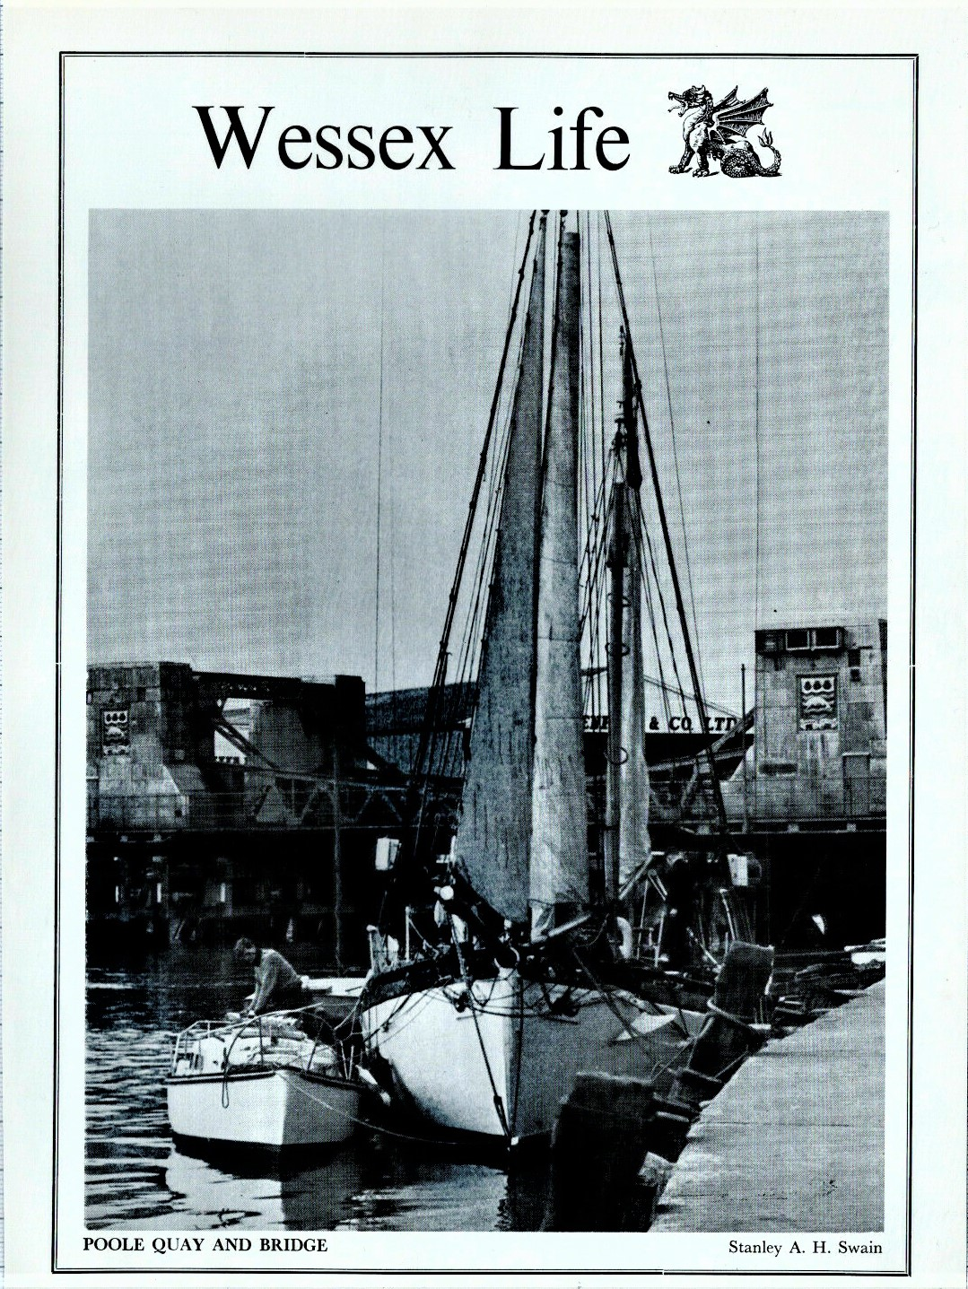

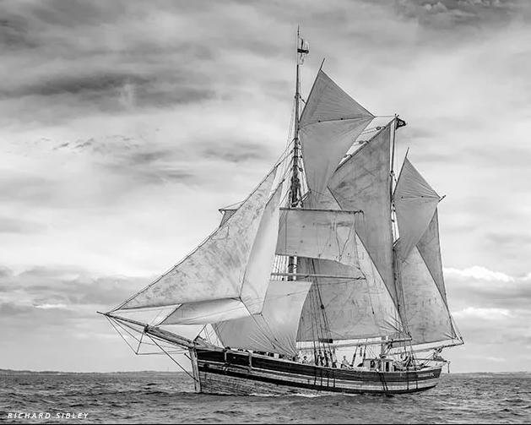
Illustrated, here, is the Norwegian Galeas, Svanhild. Built in the year 1896 to ferry salt fish from north Norway to Bergen. Everything aboard has been kept to the original, from manila and sisal rigging to paraffin navigation lights.

A JOURNEY TO NEWFOUNDLAND IN THE DAYS OF SAIL
(Norah O’Sullivan – Poole Maritime Trust member (1990))
A small sailing ship, 150 tons or less registered weight bound from Poole to Newfoundland, had to face many hazards, both natural and man-made. To begin with, the route from the British Isles, unlike that from Portugal or Spain to the West Indies, is against the main westerly air stream, and ships had to be handled with great skill and courage against the prevailing winds. Ships endeavoured to follow a Northern route followed later by ocean liners bound for New England or New York. The earliest explorers to sail west discovered new lands by setting out from known places on their charts and proceeding by comparatively short stages via the islands off the coasts of Scandinavia and the British Isles to Iceland and so on to Greenland, Baffin Island, Labrador and Newfoundland. Fishing ships, however, had a great stretch of open ocean (nearly 3,000 miles) to cross after leaving Ireland behind them. These ships normally sailed in early Spring but, even so, storms and gales were often encountered, and as they approached Newfoundland the waters could be freezing cold, ice-bergs were common and there was often thick fog. So, fogs, gales, ice-bergs, rocky coasts were some of the natural hazards – but enemy action and the appearance of press-gangs, privateers and pirates were man-made perils which captains and their crews had to face and which owners had to pay for when equipment, cargoes and even ships were taken. England and France were often at war with each other during the period when the cod trade was most important to Poole, and France sided with the colonists in the American War of Independence. Not all ships suffered from such alarming experiences and we are fortunate to have access to the diaries of some members of the Lester family of Poole in which they describe journeys to and from Newfoundland. The original diaries are in the Dorset Record Office [now the Dorset History Centre]. Here are some extracts from those of Benjamin Lester for 1767.
April 25th Went on board the brig ‘Betsey Jo’ laying at Brownsea, bound for
(Saturday) Newfoundland . Wind S.S.E. couldn’t get out. Bought a calf’s brain (keg of brandy) for 36p at North Haven.

April 26th Foggy but weighed anchor at nine – got outside the boom then S.E. gale.
April 27th Off Portland, wind from east.
April 28th Off Lizard 6 p.m.
April 29th Fair weather, sea smooth.
April 30th All hands sail making. Reference to scudding sails. 391 miles to date.
May 2nd Spoke to French boat 36 days from Domingo to Nantes.
(Saturday)
May 3rd Still fine weather. Saw several vessels including a large Dutch ship which was supposedly from East Indies.
May 4th Winds still from S.E. Few drops of rain. Crew sail making.
May 5th Strong winds S.S.E>
May 6th Brisk wind. Rain. Closed reef and topsails and got down top gallant yards.
May 7th Calm again.
May 8th Fresh gale. Wind N.N.W. Rain
May 9th Sea like Portland Race ‘We were afraid it would break through cabin windows’. Put up deadlights. Recorded seeing birds. 1620 miles to date.
May 10th ‘Number of Noddye and other birds’. Fresh gales, wind N.N.E. Cold with much cloud

May 11th Thick fog. Saw large ‘Isle of Ice’. Sounding 40 fathoms. More ice. Tried for fish. Caught some cod but hauled up weeds like branches of trees. Strong swell. Strong swell, little headway.
May 12th Calm, ice. Kept a line out all night but caught no fish.
May 13th ‘No more ice – hope coast is clear’. Saw several islands. Strong wind. 6 a.m. Cape St Francis 16 leagues N.W. Saw a brig coming down Carbonas Bay. Saw it was from Weymouth. Arrived Trinity 7.00 p.m. Found a number of other ships in harbour including the Two Brothers – master Captain Winters.
May 14th Unloading the brig. Couldn’t go into Green Pond because of the ice. Salt off – loaded into the smaller boats.
May 15th Unloading Betsey and loaded again for Silly Cove but couldn’t get her out because of strong breeze.
The diary then describes the day to day life of a merchant in Newfoundland. Some extracts of interest are:
May 21st Boat sent to collect a load of hoops from Lawleys but returned because of a ‘great sea’. Boat lost at Admiral’s Island – afraid to risk others.
May 22nd Boat arrived from Tillingate Harbour with load of oyle skins.
May 27th Brig Amy sailed for Lisbon. Very little fish about. Boats couldn’t get into St John’s because of strong winds.
Benjamin Lester returned to Poole in November. He set sail on November 16th and arrived in Plymouth on December 4th. There are no details in the diary.

On a subsequent trip in 1770 the entry is as follows:
November 26th Had a job raising anchor because of previous gales.
(Newfoundland) 11.00 a.m. clear of shore winds but ‘terrible sea, greatest I’ve ever seen. Our vessel thank God, very tight, everything stowed away, cables coiled, hatches battened down. The ship had such motion that all our cabin messmates were sick sand were obliged to go to their cabins’.
The whole voyage was stormy and the ship reached the Scilly Isles on December 20th.
December 21st Portland Bill 12 noon. Anchored in Studland Bay 6 o’clock. ‘A pilot boat came from Studland, got into boat and went up to Poole, got on shore at 9. Thank God found all well!’

Poole Maritime Trust - Port Update by Kevin Mitchell

There was a bit of goodwill at the port over the festive season in the shape of Condor Ferries’ ro-ro freight ferry Commodore Goodwill which usually sails between Portsmouth and the Channel Islands. The Goodwill separately spent both the Christmas and New Year periods laid up alongside ro-ro berth 3, seen here departing on 2nd January.
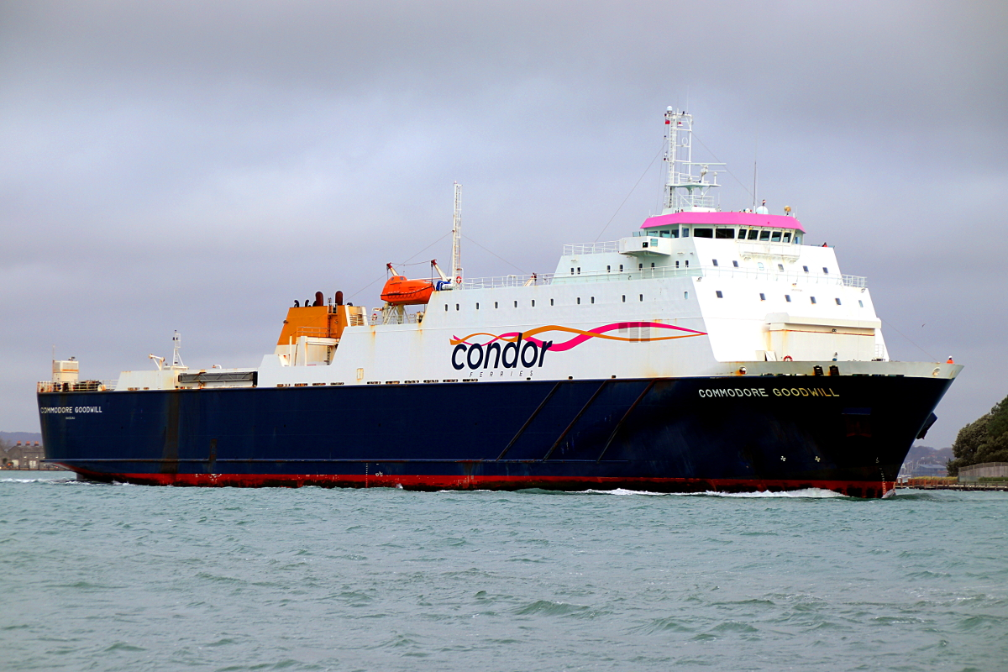
Another freight ferry Arrow arrived on 12th January for a three-day visit, she is operated by the Isle of Man Steam Packet but is regularly used by Condor Ferries as a relief vessel. Both ships came to Poole due to work being carried out on one of the ferry berths at Portsmouth.
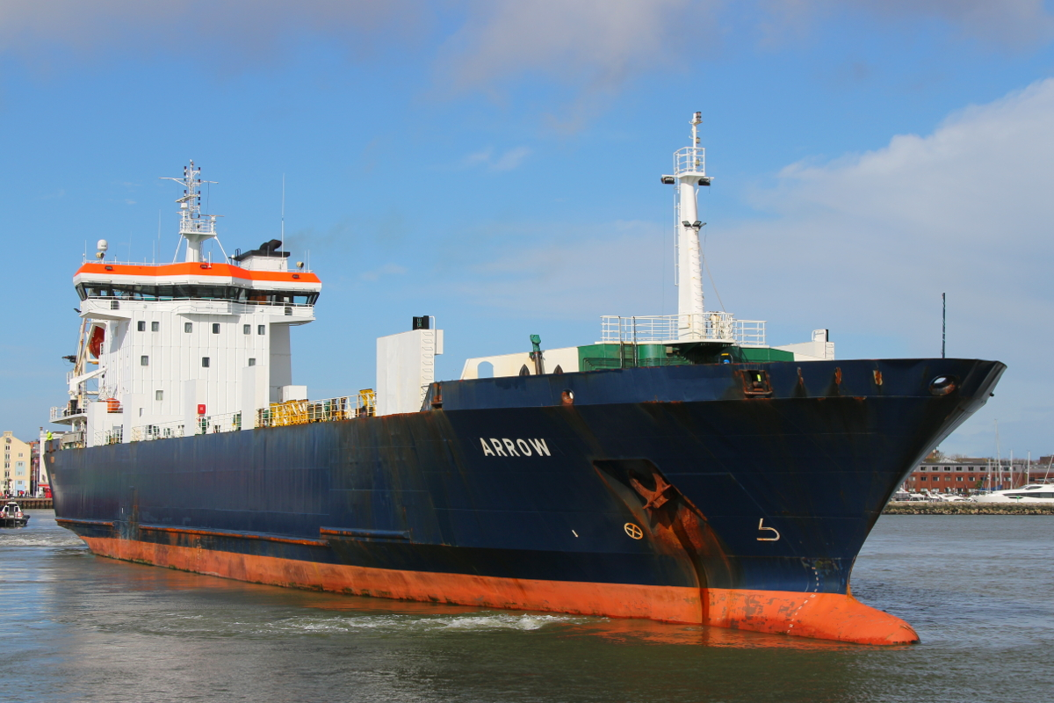
The St Helena left us on 16th January heading for Port Said in Egypt after a seven-week visit for the Extreme E racing event at Bovington.
News of our old friend the Barfleur, which has been laid-up for almost two years now due to Covid. She left the Calix Basin in the French city of Caen on 30th January. The Barfleur is 23m wide, the Colombelle bridge (the narrowest of the two bridges she had to transit) is 30m wide but the sea lock is only 28m wide! She sailed to Cherbourg to be readied for service then took up the Portsmouth-Caen route freight-only from 14th February (photo at Portsmouth thanks to Darren Holdaway).
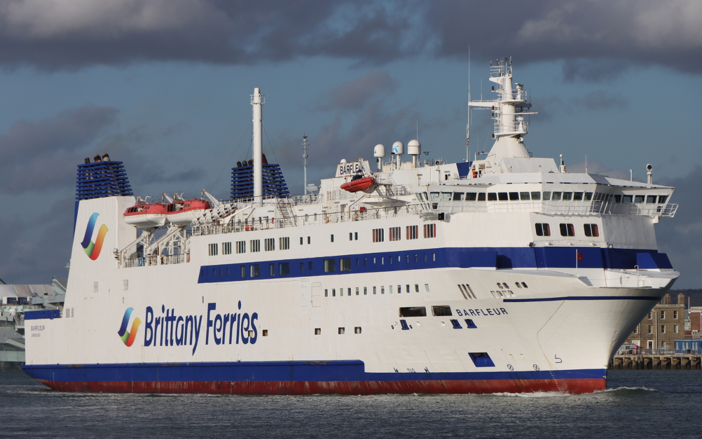
She is due back at Poole on the evening of 28th March to resume the daily passenger and freight service to Cherbourg. Before the Barfleur entered service in 1992, the Truckline passenger service was in the hands of the Corbière (1970) and Trégastel (1971). It was reported previously that the Corbière has recently gone for scrap after a remarkably long career, and now she has been followed by the Trégastel.
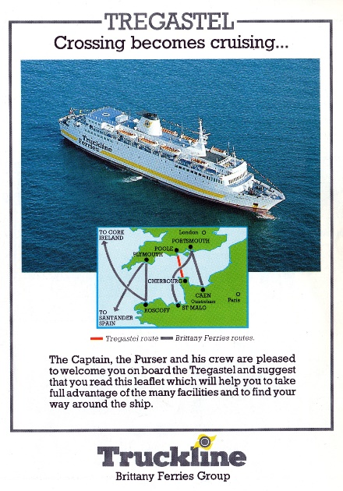
The French naval vessel P677 Cormoran arrived on the morning of 11th February and tied up at the New Quay Extension. She is a Flamant class patrol boat, one of a series of three built in and based at Cherbourg.
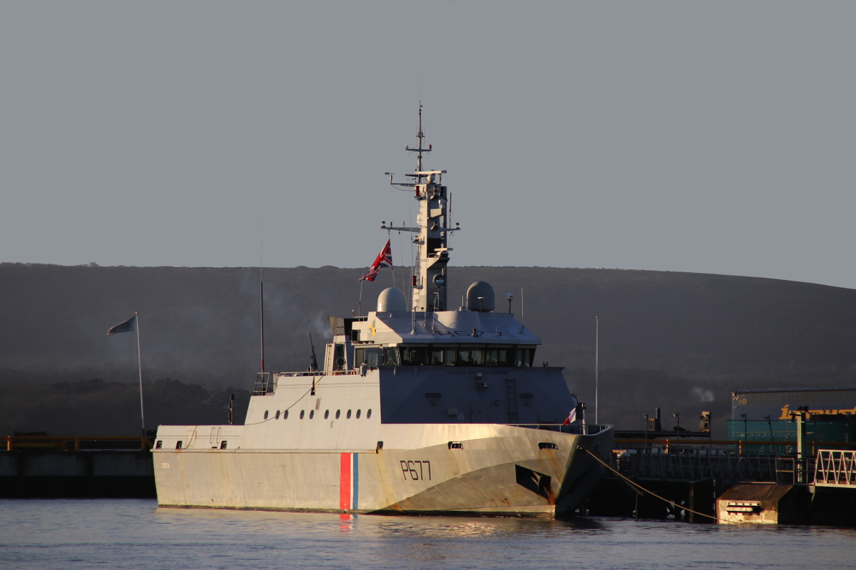
Storm Eunice brought very strong winds and rough seas to much of the UK on 18th February. Channel Seaways’ Trinity was photographed in port that morning – and look at the height of the water compared to the quayside, thanks to the high spring tides and tidal surge! The Poole lifeboat was called out on service at the height of the bad weather to look for a reported person in trouble in the vicinity of the Poole Quay Boat Haven. Thankfully, nothing untoward was found and the crew safely returned to station by 12.30.
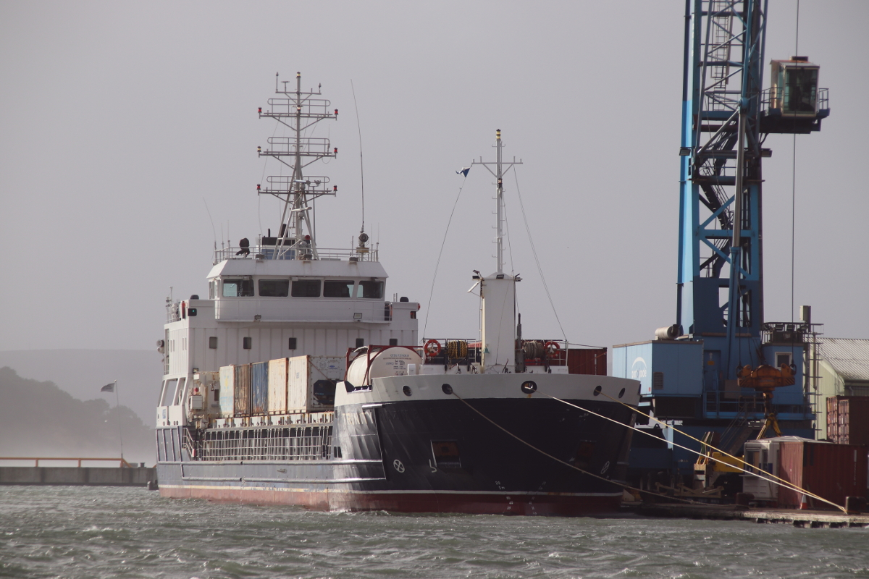

FORTHCOMING MEETINGS AND EVENTS
POOLE MARITIME TRUST
SATURDAY APRIL 9th – SOLENT EXPLORER CRUISE WITH COACH CONNECTION FROM THE POOLE & BOURNEMOUTH CONNURBATION.
SEE ATTACHED LEAFLET/BOOKING FORM.
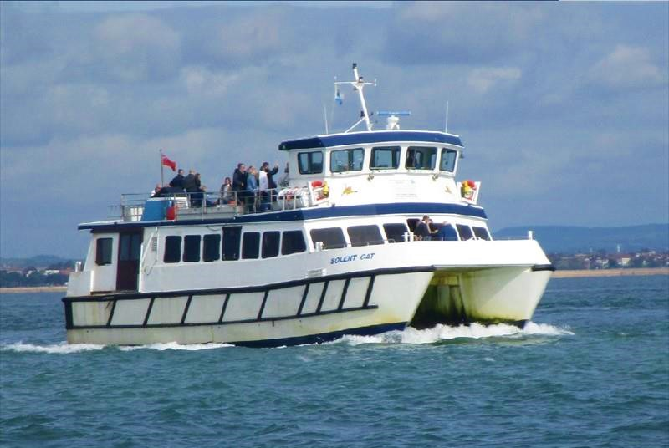

SATURDAY 30 APRIL & SUNDAY 1 MAY
BOURNEMOUTH MARITIME FESTIVAL
PLEASE REFER POSTER (ENCLOSED) AND WE-SITE FOR FULL DETAILS
THE TRUST WILL BE IN ATTENDANCE

SATURDAY JUNE 11TH
POOLE MARITIME TRUST OPEN DAY
Full details of this and other events planned for the summer programme will appear in the next newsletter.

PADDLE STEAMER PRESERVATION SOCIETY - WESSEX & DART BRANCH

SATURDAY MARCH 5TH - CUMBERLAND HOTEL, EAST CLIFF AT 2pm
(This event was previous advertised as being held at the neighbouring Suncliff Hotel)

THE HALCYON DAYS OF THE SOLENT - PETER LAMB
Return to the 1950's and 1960's with the use of archive images and films and revisit memories of the ships, boats and harbours now consigned to history.

FREE ENTRY - ALL ARE WELCOME

WORLD SHIP SOCIETY

WSS – Dorset Branch – Spring 2022 Programme

The Dorset Branch of the World Ship Society provides “hybrid” events combining face to face meetings with Zoom transmission allowing members and remote supporters to enjoy our monthly speakers simultaneously. Our current programme can be found below and at www.shipsdorset.org/events … for venue details or a Zoom Invitation Link please contact Branch Secretary, Steve Pink via steve@telecommerce.co.uk
March 12th 2022 ~ Clyde built ships – Cardiff Class bulk carriers ~ with Paul Strathdee
A series of 30 ships built in the 1970s each with deadweight tonnage over 26,000 launched on the Clyde.

April 9th 2022 ~ Shipping of Portland Harbour and Anchorages ~ with Paul Dallaway
An archive of 20 years. Boat-master Paul gets up close to Cruise Ships, RFAs, Tankers and Specialist Ships.

May 14th 2022 ~ 154 Days aboard 4 Post-War Liners ~ with Steve Pink
Nevasa, Edinburgh Castle, Pendennis Castle & Reina del Mar … ship facts, brochure graphics, images & stories.

SOCIETY FOR POOLE - Entry is Free and all are welcome.

Meetings are held at : Ex-Serviceman's Club, 66 North Road, Poole BH14 0LY at 7pm for 7.30pm start

MAR 15 …….PURBECK CASTLES…………DAVID WARHURST

MAY 17……..’D DAY’ EXPERIENCES………EDDIE GAINES

JUN 21……..A VERY DORSET DISASTER……ROD HUGHES

JUL 19……..WHEN THE GERMANS INVADED DORSET……..BRIAN BATES

NEWSLETTER
The newsletter is published every 2 – 3 months. Submissions are invited for consideration in the form of articles, stories and images. If you have anything you consider would be of interest relating to the Harbour, it’s history, or other maritime related subjects, please e-mail it to : UKCCA@AOL.COM

LIBRARY AND ARCHIVE COLLECTION NEWS.
THE TRUST ARCHIVE TEAM ARE ALWAYS SEEKING THE FOLLOWING TO BOOST OUR EXTENSIVE COLLECTION
We will be happy to collect.
- Photographs, slides and negatives – Anything maritime or harbour related.
- Films
- Ephemera – Posters/Leaflets/Tickets/Letters/Documents etc.
- Artifacts of any kind however loosely linked to the harbour or the maritime trade world-wide.
- Family history relating to Poole and it’s environs
- Books
- Magazines & Periodicals
- Paintings
- Discarded lap-tops and surplus office equipment and supplies
We are very fortunate in receiving regular donations covering all aspects of Poole, it’s fabulous harbour and shipping interests around the world.
Volunteers are always welcomed – Each Thursday morning from 10.00
If you afford a couple of hours and have an interest in ships, shipping and the harbour
please come along.
First Floor, Canford Cliffs Library (Entrance at the rear of the building)
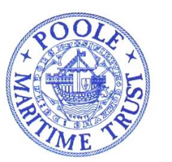
POOLE MARITIME TRUST
2022 - SOLENT EXPLORER CRUISE
(Replacing the cruise cancelled in 2021)
SATURDAY APRIL 9th - ABOARD A WIGHTLINE “CAT” CLASS VESSEL
FROM SOUTHAMPTON – WITH COACH LINK FROM BOURNEMOUTH & POOLE
Boat Departs, Southampton Town Quay (Hythe Ferry Terminal) 11.15 Returns 17.45
(Passengers wishing to join the vessel at Cowes at no additional charge for the light passage to Southampton
may do so but should call the cruise office in advance to confirm departure time 01983-564602).
A Direct Bus linking Southampton Station and the Town Quay (Red Funnel Terminal) operates from outside Platform 4.
Cruise Southampton Docks, Along Southampton Water and into the River Hamble so far as H.M.S. Mercury. Thence through the Western Solent and up the Beaulieu River so far as Bucklers Hard, returning along the island shore and sailing into the river Medina to the Folly Inn before re-crossing the Solent and around Portsmouth Harbour.
Cruise limits within the rivers owing to tidal restrictions and time. The boat has open decks and comfortable saloon. Teas, coffees, light refreshments & a bar aboard. There will be no meals available. Passengers may obtain sandwiches and other pre-packed food from the adjacent Red Funnel Terminal or one of the many outlets nearby.
SHIPPING MOVEMENTS IN THE PORT OF SOUTHAMPTON HAVE, YET, TO BE CONFIRMED.
FARE : BOAT ONLY (From Southampton or Cowes) £28
BOAT & COACH FROM BOURNEMOUTH/POOLE COMBINED £35
Coach Pick-Ups : 09.20 Poole (Seldown Lane – Opp Bus Stn), 09.35 Canford Cliffs Library,
09.45.Westbourne Bingo Hall
NOTES : Accommodation in Southampton should be booked SOONEST. Passengers travelling from afar may find it more economic and convenient to stay in Bournemouth and use the coach link. For advice and assistance with accommodation, please call 07718934425 (Left messages will be returned) or e-mail UKCCA@AOL.Com.
A regular bus service links Southampton Railway Station (Outside Platform 4) and the Town Quay Red Funnel Terminal
CRUISE OPERATED BY THE COASTAL CRUISING ASSOCIATION IN CO-OPERATION WITH SOLENT AND WIGHLINE CRUISES UNDER WHOSE CONDITIONS OF CARRIAGE PASSENGERS ARE CONVEYED.
PASSENGERS WHO BOOKED THE 2021 CRUISE AND ELECTED TO ROLL OVER TO 2022 NEED TAKE NO FURTHER ACTION.
…………………………………….…………………………………………..BOOKING FORM…………………………………………………………………………………
COASTAL CRUISING ASSOCIATION BOOKING FORM - SOLENT EXPLORER CRUISE SATURDAY APRIL 9TH 2021

NAME…………………………………………………………..ADDRESS…………………………………………………………………………………….………………………………………………………………………………………………………..POST-CODE…………………………..
E-MAIL …………………………………………………………….TEL (MOB. IF POSSIBLE)………………………………………………….
PLEASE SEND ME ……TICKETS @ £28 FOR THE CRUISE. I ENCLOSE A CHEQUE TO THE VALUE OF £………..
I WILL EMBARK AT SOUTHAMPTON/COWES (DELETE AS APPROPRIATE)
OR PLEASE SEND ME…..TICKETS @ £35 FOR THE COMBINED COACH & BOAT EXCURSION
I ENCLOSE A CHEQUE TO THE VALUE OF £………. I/WE WILL JOIN THE COACH AT :…………………………….
CHEQUES MADE PAYABLE TO : COASTAL CRUISING ASSOCIATION – BE SURE TO ENCLOSE A SAE TO : P. LAMB, POOLE MARITIME TRUST, CANFORD CLIFFS LIBRARY, 6 WESTERN ROAD, CANFORD CLIFFS, POOLE BH13 7BN. FINAL POSTAL BOOKINGS ACCEPTED SEVEN DAYS PRIOR TO THE SAILING. TICKETS AT THE GANGWAY WILL BE SUBJECT TO AVAILABILITY.

