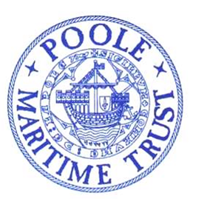
POOLE MARITIME TRUST
NEWSLETTER MAY 2022
Committed to recording and preserving the history of Poole Harbour, It’s people, surrounding environs, trading links, industries and everything maritime related.
Welcome to the Poole Maritime Trust Newsletter. Contributions are invited for future editions.
Please send any material to be considered for inclusion by
PLEASE NOTE NEW E-MAIL ADDRESS : poolemaritimetrust@aol.com or Tel: 01202-706673

HMS Warrior
A triumph of Naval Sea Power and Engineering of its time.
By Michael Hawkins.

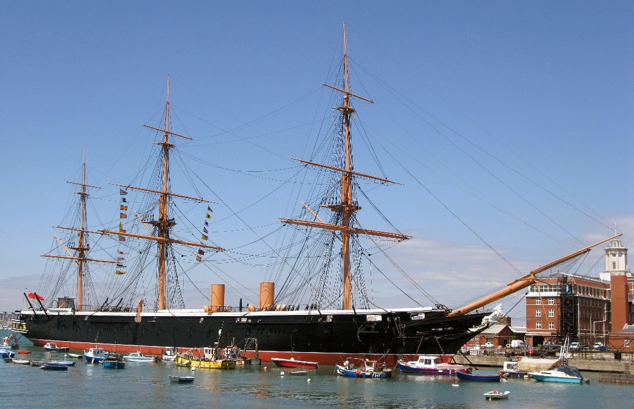
HMS Warrior alongside in Portsmouth
HMS Warrior is currently alongside the sea wall in Portsmouth proudly displaying itself as it would have been during its Around Britain Tour of 1863. The purpose of this tour was to show the British public and the world that the Royal Navy was prepared to defend the Nation and the Empire with the largest, fastest and most heavily armed warship in the world.
Warrior was built after a visit to France by the Prince Consort Prince Albert who perceiving a real threat by the French of invasion and their building of Iron Clad warships such as the Gloire launched in 1859 decided the Royal Navy needed something bigger and better as a deterrent. On his return he summoned the then Chief Constructor for the Navy Isaac Watts under Rear Admiral Sir Baldwin Walker to design and build a vessel using the most up to date technology of the time. The ship was to be built of iron and not iron clad as the French were building. This they did and Warrior was the outcome.

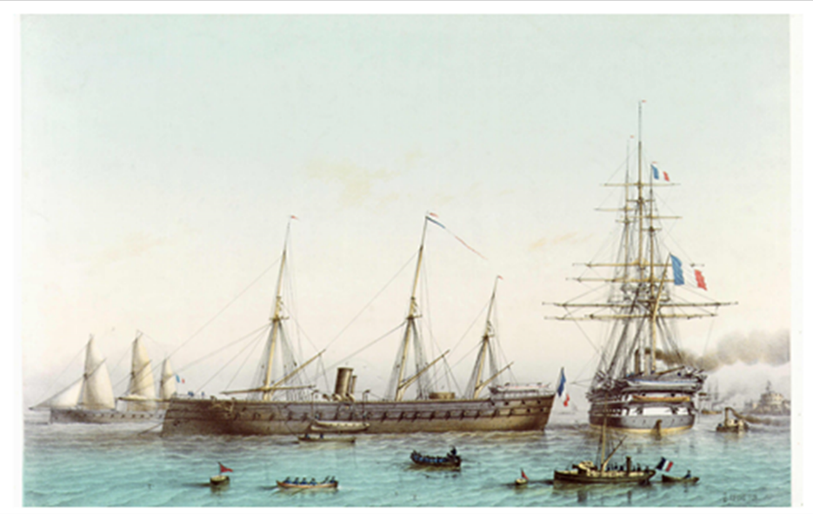
The French Ship Gloire
The ships contract was put out to tender as there was no precedence within the Royal Dockyards to build such a vessel and at an estimated cost of £282,284 The Thames Iron Works won the contract. Their reputation and quality of working with iron and the relationship for the care and welfare of their work force coupled with the skill sets required for this new concept allowed them to deliver the vessel in 27 Months. The keel was laid down in May 1859 and Warrior was launched on 28th December 1860 and Commissioned in August 1861 to join the Channel Fleet. The total cost brought in the concept of WOB (Well Over Budget) this is due mainly to the advances in technology and changes in design during build which is still ongoing in Warship building today. The final cost of the build being £377,292. The dimensions of the vessel were a length of 420ft which meant that Thames Iron Works had to slightly lengthen their Slipway. The overall beam was 58ft and she had a draught of 26ft. Her displacement was 9200 tons, and this led to some crossed fingers on launch day which was why it was 29th December 1860 as this was deemed to be a quiet period between Christmas and New Year. Getting her off the Slipway had its challenges as there was a harsh winter and the Tallow on the Slipway froze, and it took several fires and a tug to get her into the water and a sigh of relief when she floated. The hull is Clipper shaped and the Main Mast is 196ft above the waterline with the Fore mast and Mizzen being slightly less.
The structure of the hull is of Wrought Iron with Wrought Iron beams. The Upper and Lower decks are of Pitch Pine with the Main Deck being Oak. The design was innovative in the incorporation of an Armoured Citadel which runs from Fwd of the Officers Quarters at the stern to Aft of the Cable Deck Fwd. This is accessed by watertight doors and encased within the citadel are the crews living quarters on the Main Gun Deck. Below the main deck the magazines, gun powder rooms and the secondary and emergency steering positions. Below that came the engine room and boiler rooms. The construction of the citadel is an internal skin of 5/8” iron plate, outside of that 18” of Teak layered in two 9” layers laid horizontal and vertical at right angles. Then on the outside is 4.5” of Armoured plate slotted together in tongue and groove. This was where the skill of the ironworkers using Nasmith Steam Hammers was paramount. There are no rivet belts giving a sleek smooth hull on the outside. The hull was totally impenetrable from any weapon system at that time thus making Warrior a formidable warship. For propulsion HMS Warrior was a hybrid with the option of both sail and steam and a combination of both. When fully rigged for sail she had 48,000 square feet of sail which would give her an average speed of 13Knots. In order to achieve this the propeller weighing 36 tons was raised manually and locked off to cut down on the drag. This evolution took approximately 4 hours and 500 men to achieve. 250 men on each foil and a set of sheer legs rigged on the after deck. The steam plant was 10 rectangular Low-Pressure Boilers operating at 20psi. Each boiler has four furnaces, and one stoker would service each boiler shovelling approximately one ton of coal per hour for a four-hour watch. There would be six or seven boilers alight at any one time and one of those would be designated to make fresh water. The other boilers would be shut down for internal cleans and maintenance. The ship would carry 850 tons of coal in bunkers and this would last 4 to 5 days on steam alone. The temperatures in the boiler room would be up to 60 degrees Centigrade and the lack of ventilation meant that the atmosphere would be thick with coal dust and ash. The stokers were paid a little more than equivalent rates onboard, but life expectancy was 10% less.
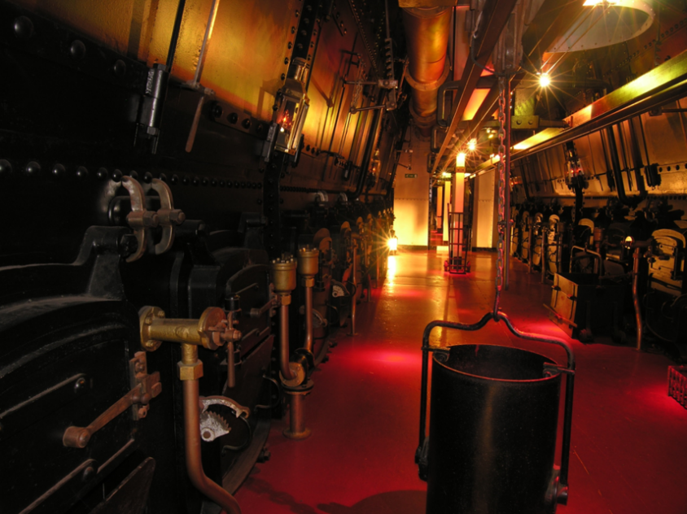
Aft Boiler Room
The Main Engine was manufactured by Pell engineering. It is a twin cylinder double acting horizontally opposed Trunk Engine which gave 577 HP and would rotate the shaft at 60 RPM to give her 15 to 16 knots. The condenser allowed a semi closed feed system to conserve water, but this was open saltwater cooling hence the regular internal boiler cleans. In order to use steam and sail together the funnels were telescopic and would be lowered by about 20ft to allow for the sails not to get damaged. The average speed of the wooden sailing ships at that time was 8 knots on a windy day, so Warrior was faster than anything afloat at that time. This also allowed more manoeuvrability particularly in tight situations. However, steerage came from the Sailing Navy with no mechanical assistance. It took 8 men to steer the ship and the ships log states that during particularly heavy seas it would take blocks and tackles rigged too the ships wheels to move the rudder. Also, with the propeller running at 60 RPM this would create extra pressure on the rudder again causing steerage difficulty. Warrior is a floating gun platform positioned on 2 decks the lowest gun ports being 9ft above the waterline. The main armament consisted of 10 x 110lb Breach Loader cannon with rifled barrels built by Armstrong. These were the first of there kind to go to sea. They were supported by 26 x 68lb standard muzzle loader cannon and 4 x 40lb Breach Loaders. Due to the sheer weight of these guns they had to be strategically placed within the battery to give maximum firepower effect and stability to the ship. The success of this warship as a fighting machine relied on the weapons but most of all the drill and accuracy of the 18-man Gun Crews trained to fire them. They consistently managed 1 round per gun every 90 seconds under the watchful eye of the Gunnery Officer the young Lt Jackie Fisher. The incorporation of steam onboard had a massive impact to the improvement of life and welfare of the crew. Constant fresh hot water improved personal hygiene and fresh water to drink. A laundry was established with hand operated washing machines and the men had their clothes washed once a week and hammocks washed every two weeks. Food was hot from a coal fired galley range. Under the Continuous Service system brought in by the Royal Navy it meant that the men had a career as opposed to signing on for a commission and then being paid off at the end of the commission. So, there was an improvement in the professionalism across the board.
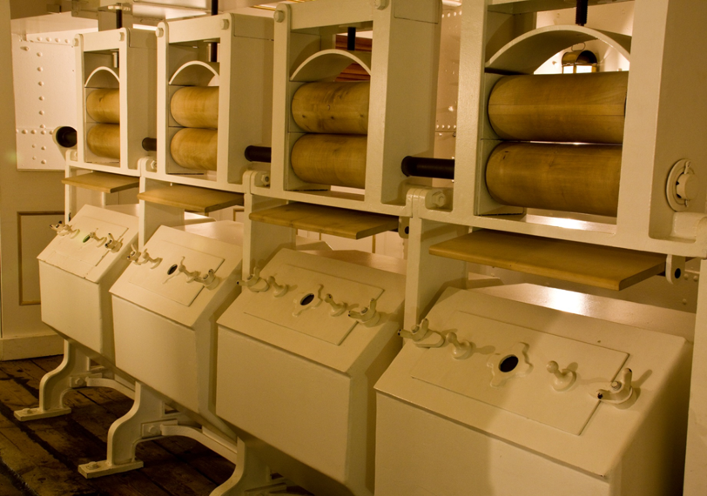
Washing machines in the laundry
The first Captain of HMS Warrior was Hon Arthur Cochrane ably supported by his chosen Executive Office Commander George Tryon who between them successfully led the complement of the Ships Company of 730 which included a detachment of Marines. Cochrane was a very experienced Sea Captain an excellent man manager with a knowledge of engineering. This was a benefit to the Admiralty to get this new ship into an effective fighting machine. HMS Warrior had 10 years of active service with the Channel Fleet. Then due to the rapid advancement in technology and ship building was put into Reserve. But she never had to fire a shot in anger and so proved herself to be the ultimate deterrent. In Reserve she was tasked with Coast Guard duties in Portland and in 1882 Greenock. In 1903 she became the Torpedo Boat and Destroyer Depot ship. She was then in 1904 paid off and converted to become Vernon 3. Based in Portsmouth where the Gunwharf Shopping Complex is now. She was used for accommodation and classrooms and remained in this role until 1924 when she was then converted into an oil fuel pontoon. Warrior was then towed down to Pembroke Dock where she remained as a fuel pontoon and a hulk until 1979.
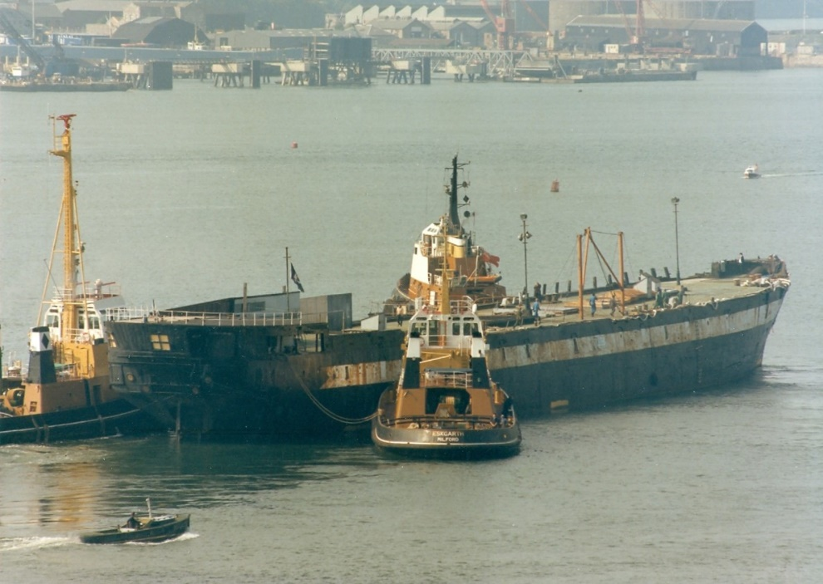
Warrior heading for Hartlepool.
It was in 1979 that Warrior was discovered after a visit to Pembroke Dock by HRH Prince Phillip who saw the hulk and enquired what it was and commented that it would be a shame to lose its heritage. Sir John Smith a successful businessman raised and underwrote £7m to get Warrior restored and on 3rd September 1979 Warrior arrived in Hartlepool to begin restoration. The skills required for the restoration were varied but held mainly by an elder generation. Hartlepool was going through a change and so young 16 and 17-year-olds were recruited as apprentices to learn the skills with a view to creating an industry of restoring similar vessels. The latest being Trincomalee which has remained in Hartlepool.

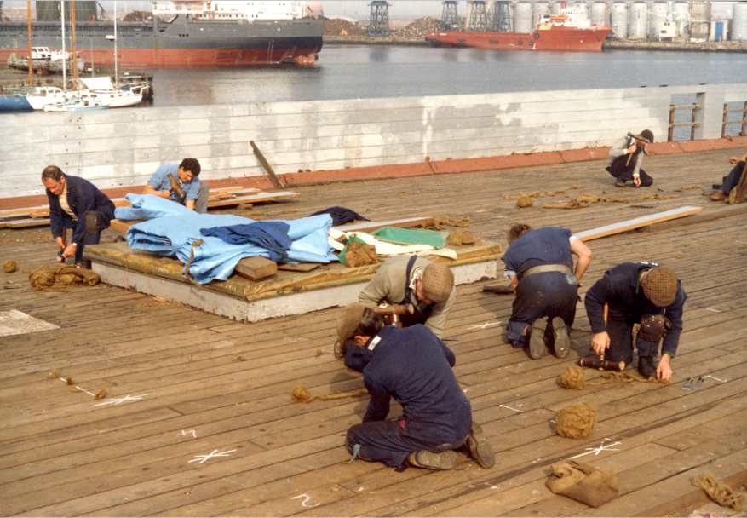
Restoration of the upper deck with Caulkers and Apprentices
HMS Warrior 1860 was completed and returned to Portsmouth to a tumultuous welcome on 16th June 1987 where she remains on a purpose-built berth. Now part of Portsmouth Historical Dockyard and recently been taken over by National Museum Royal Navy HMS Warrior receives up to millions of visitors a year.
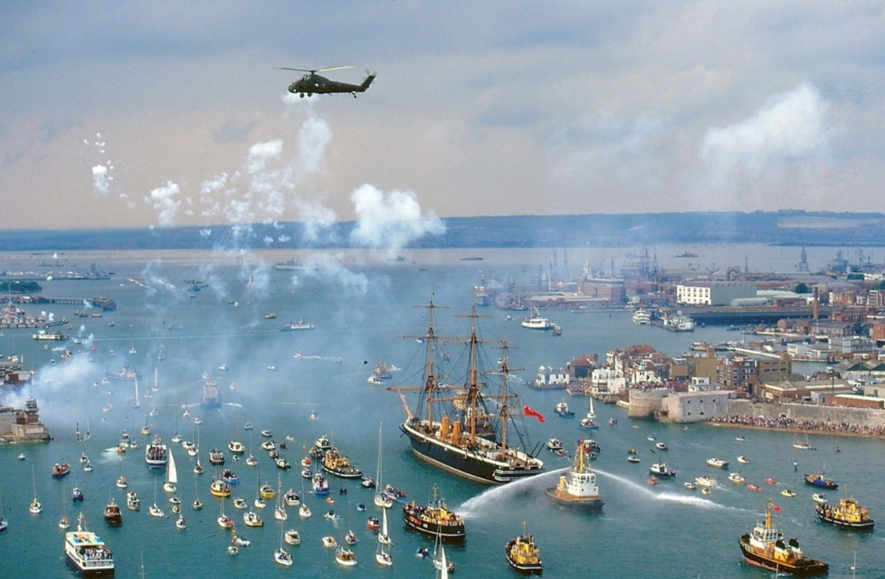
Welcome Home HMS Warrior
However, the restoration and upkeep continue with help from NMRN and Heritage Lottery Fund. The bulwarks have recently been replaced and the rigging and the upper Mizzen Mast have undergone significant refurbishment. The aim now is to educate by working with schools and an Outreach programme and ensure HMS Warrior remains as part of our Naval Heritage for many years to come.

SOLENT EXPLORER CRUISE – Saturday April 9th.
Following two earlier cancellations as a result of both the Covid Pandemic and hurricane conditions it was a case of third time lucky. The cruise took place in perfect, albeit chilly at times, conditions. Passengers were afforded outstanding views of the commercial shipping in Southampton and the assembled fleet of Royal Navy shipping, including the two new Aircraft Carriers in Portsmouth. The cruise, also, took in runs along the rivers Hamble, Medina and Beaulieu so far as Bucklers Hard. The sailing was enlightened by the informative commentary provided by our amiable and knowledgeable skipper of the “SOLENT CAT”, Lee Rayment. Many thanks to all of those who supported the cruise. Suggestions for future cruises are always welcomed be-it river, canal or sea. All proposals will be evaluated. Please e-mail : poolemaritimetrust@aol.com
Some pictorial highlights. Many thanks to : Mike Tedstone, Jan Marsh, Martin Cleaver and Julie Reid for the following photographs.
“SOLENT CAT” ARRIVING ‘LIGHT SHIP’ FROM COWES
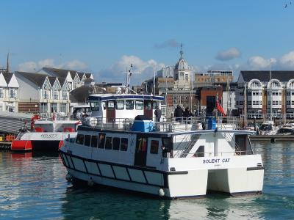

PREPARING TO DEPART TOWN QUAY, SOUTHAMPTON, BATHED IN THE MORNING SUN
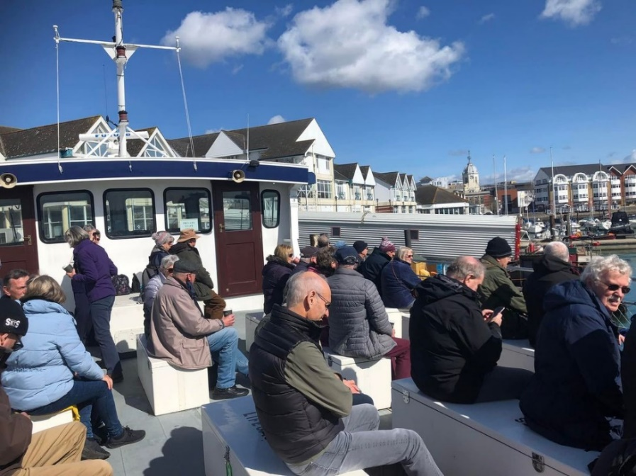
BUCKLERS HARD ON THE BANK OF THE BEAULIEU RIVER.

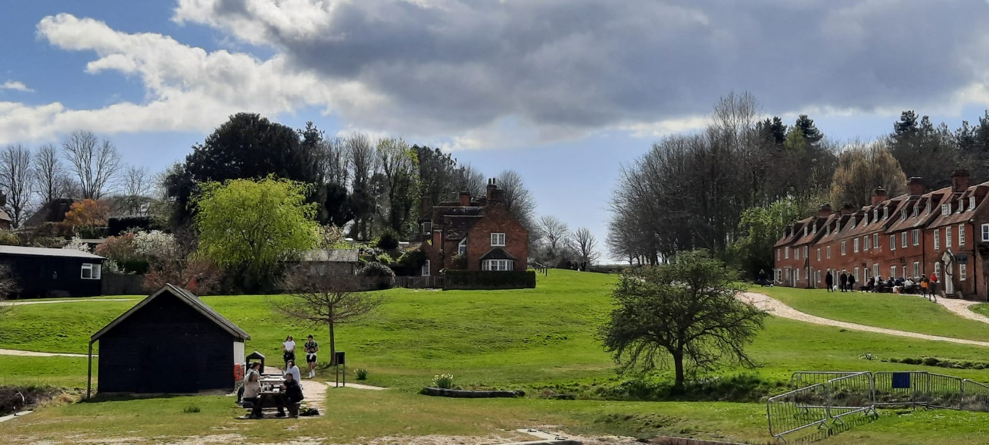

OUTWARD BOUND – FROM SOUTHAMPTON

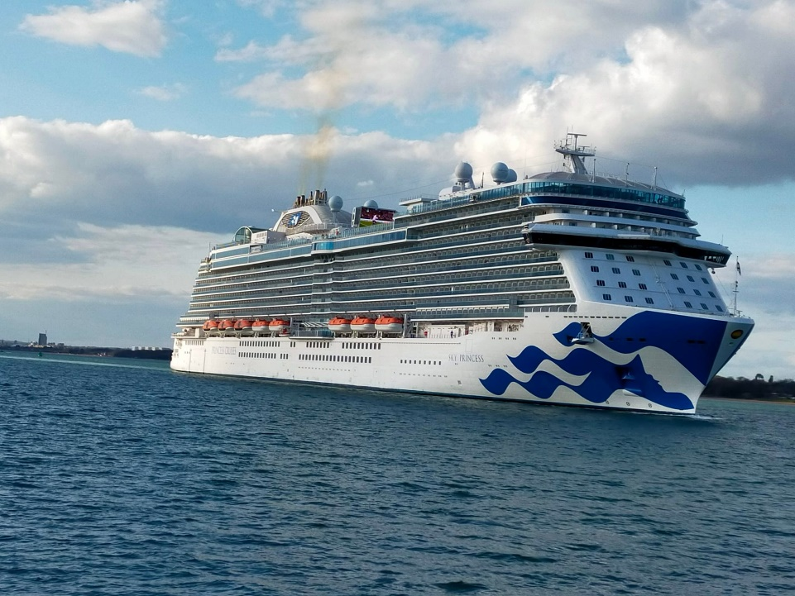

THE PRESERVED STEAMSHIP “SHIELDHALL” BEING PREPARED FOR A BUSY SUMMER

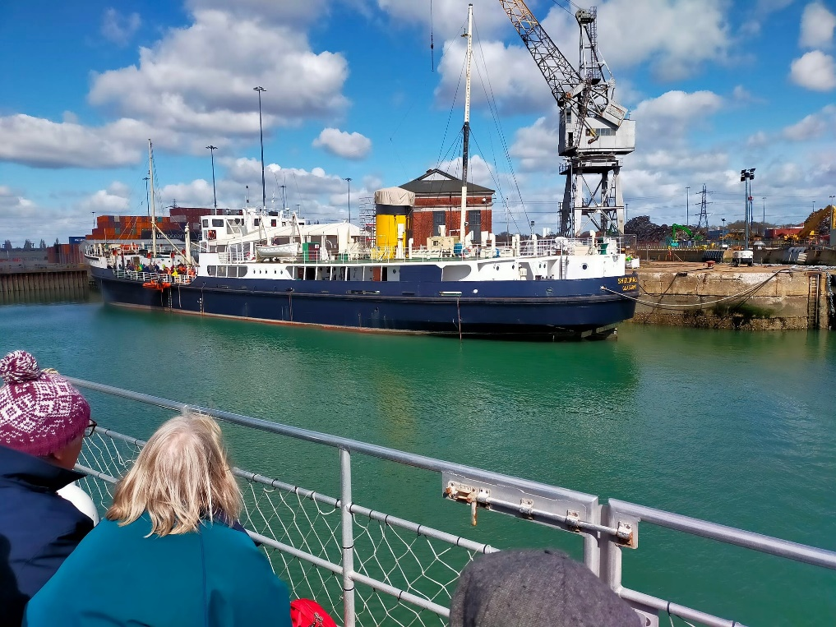
CLOSE-UP TO THE WARSHIPS IN PORTSMOUTH HARBOUR
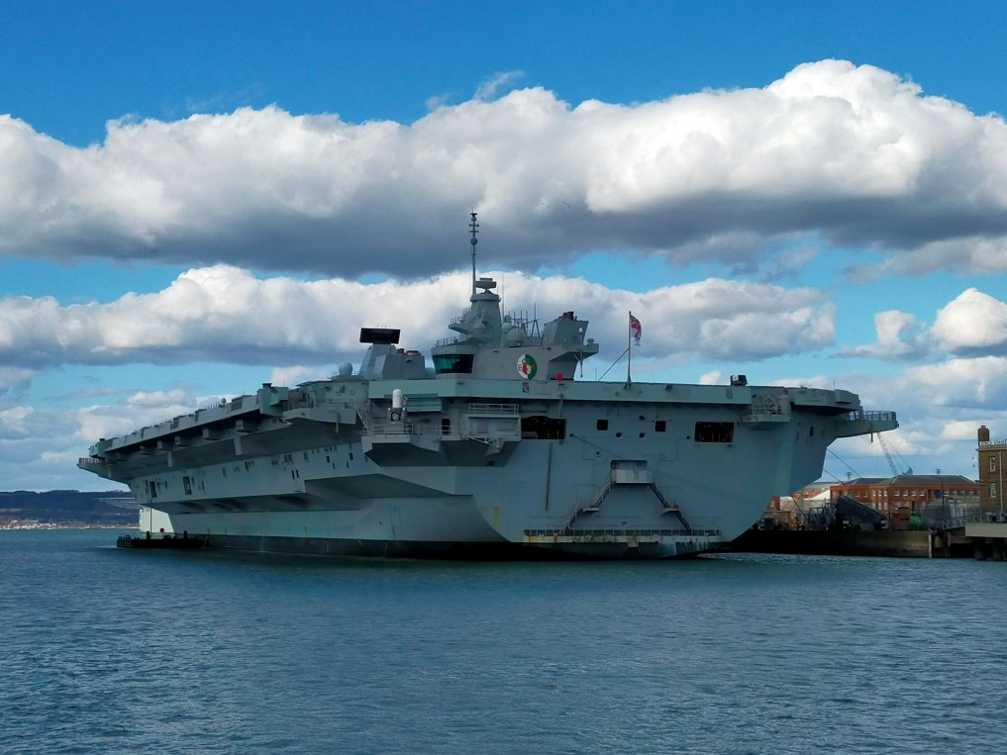

FOLLOWING ON FROM THE SOLENT CRUISE REPORT IT IS INTERESTING TO READ THE FOLLOWING RECORD OF A VISIT TO
SOUTHAMPTON DOCKS IN THE 1950’S.

Efforts to contact the author have proved unsuccessful. In the unlikely event we have inadvertently contravened any copyright we will unreservedly apologise.

The Queen and the Green Goddess
A Day trip to Southampton

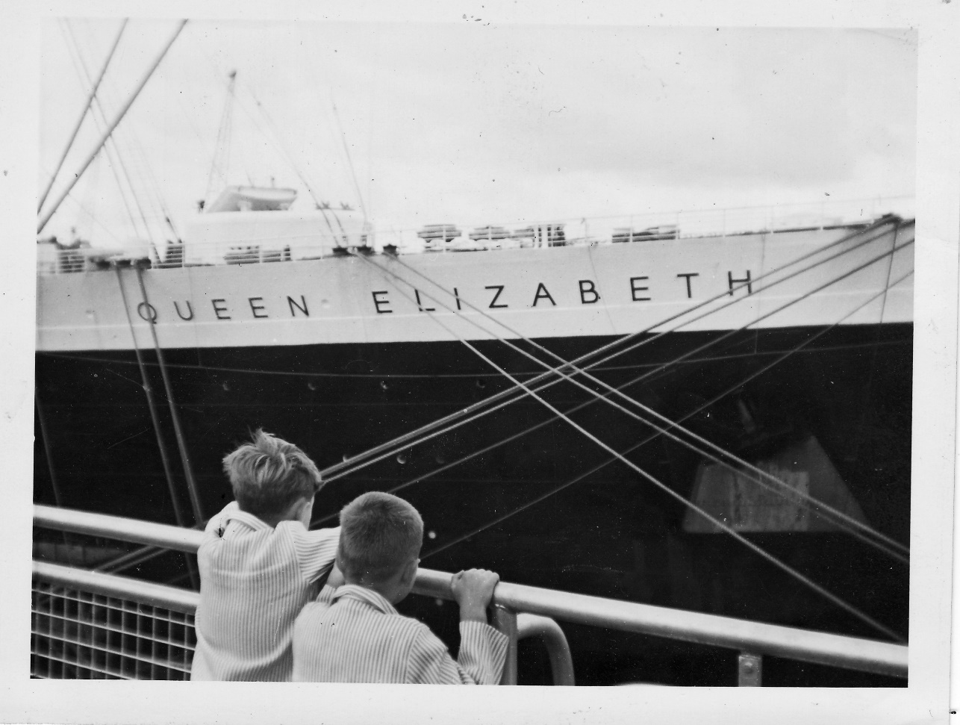

Now this is going to be a bit of a heady read this as it’s a cross between a trip back in time and a Time Line. What are we talking about you ask? The ongoing saga of lost photos and stories continues and now we have turned up some piccies of what was the very first purpose built cruise liner and our part in her career. Back in the day my Uncle John was an airline pilot for BOAC. He arrived in this position having served in the Pacific during WW2 and then moved onto ferrying aircraft down to Africa and eventually flying for South African Airways who became part of BOAC. He had a very nice house high above Sidmouth in Devon and we’d often go and visit during the summer holidays. As we were car-less we'd catch the Atlantic Coast Express out of Waterloo, usually pulled by a mighty Oliver Bullied designed Merchant Navy Class locomotive all named after Shipping Lines, I’ve got Netherland Line, Ellerman Line, Holland America Line, Clan Line and Elders Fyffes listed in my Ian Allan spotter’s book (amongst others). With the best looking cast driving wheels ever fitted to a steam engine these were magnificent. The set (carriages) was made up in order of dropping the coaches at the various Junctions on the way so we’d be sat near the back in the ‘Waterloo’ bit and our coach would be slipped at Sidmouth Junction and coupled up to the local service, seamless travel, but it was a bit of a bummer if you spent too much time in the restaurant car and sailed through your Junction!

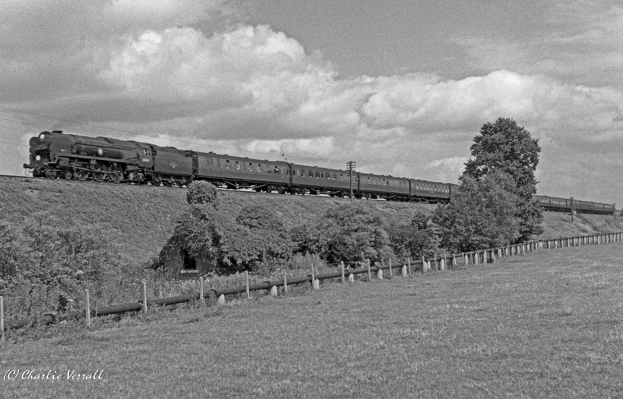
The picture is Netherlands Line taken in 1962 and we were probably in one of the last three coaches. One of the highlights, and the first thing we usually did when alighting at Sidmouth station, was to get a local paper to find out the times of the passing liners as they sailed out into the Atlantic or were returning to Southampton. On this particular occasion Caronia and Queen Elizabeth were due and a plan was hatched to catch the train, probably another Bullied hauled number, to Southampton and see them in port. Somehow the old man reckoned that we could go by train right into the Ocean Terminal. Which is what we did, quite how I cannot remember but it was pretty special.(This would be Southampton Terminus, known locally as the Docks Station – Ed). That’s the connection out of the way but what needs to be borne in mind is when all this happened and the date we, my brother and I, got taken to Southampton to see RMS Queen Elizabeth and the Caronia. We reckon it was back in 1963 and little did we realise it then but the sun had almost set on the scheduled Trans-Atlantic crossing and both ships would be retired within a few years and both lost at sea in unfortunate circumstances.
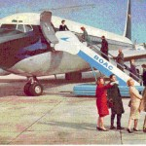
Although the age of jet travel had, pardon the pun, taken off with the arrival of the Comet and later the Boeing 707, back in 1963 Turbo prop Britannias were still operating the North Atlantic routes, joined by the popular VC10 the following year. It wouldn’t be until 1971 that the first BOAC Jumbo jets entered service and mass air transportion really began. The fares were high even for the equivalent of steerage and the age of cheap flights didn’t happen until Mr. Laker came along and made flying the Atlantic accessible and affordable. Strange as it may seem now but it was only back in 1977 that he founded the idea of the ‘no frills airline’ that we all enjoy today.
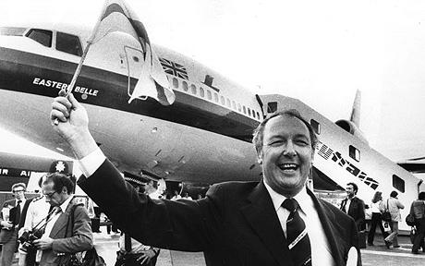

It is fair to say his business plan got rather overstretched but he was, in the end, forced out of business by the big players who could afford to lose a few quid here and there. When Virgin came along, using lessons learnt from Sir Freddie and capitalising on the use of the interweb, the game plan was changed forever and now you can surf the net and get some quite extraordinary deals on Trans-Atlantic flights most days of the week. So, taking a step back, what was the crack in 1963 when my brother and I leant against the viewing balcony on the Ocean Terminal in Southampton? By 1959 the numbers crossing the Atlantic by air had almost matched those sailing and by 1964 the age of the scheduled Trans-Atlantic liner service pretty much came to an end. The last ships to be built as ocean liners were launched in the early sixties but their careers in that role were short and they were soon being used for cruises rather than scheduled services. By 1969 the big liners like the Queen Elizabeth and Queen Mary and SS United States had been retired and today the only scheduled service between Southampton and New York is by Queen Mary 2 between April and October and these days they are known as ‘cruises’ and there are only a few of them. If you have a fear of flying and have to travel by ship the best way to do it today is aboard a freighter or on a re-positioning voyage. Ah! The romance of the sea!

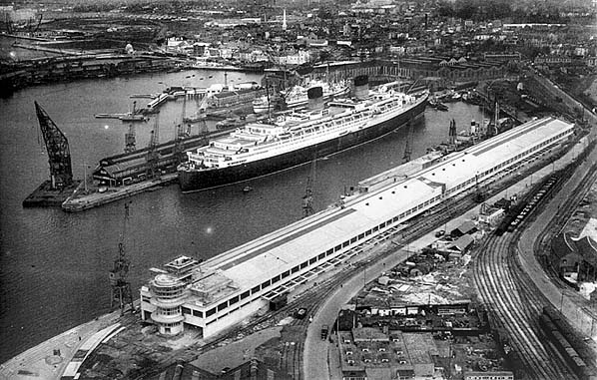

The Ocean Terminal we went to was a splendid building completed in 1950 and benefited from a public gallery so that you could wave bye-bye as the ship shoved off and that and was where we headed. There was a purpose-built rail link that brought the special Boat Trains which ran from Waterloo right alongside. The decision to go down to the Docks came about mainly because the old man had never seen the RMS Caronia, famous for being painted a very pleasing pale green and known affectionately as ‘The Green Goddess’, no relation to the fire engines may I add, and was due into Southampton around noon but there had been some question as to what time it would be passing Sidmouth or indeed if it would come in close enough to see, so it was sandwiches and an early start. The Queen Elizabeth was being restocked and was due to sail in a few days time so we would see her later in the week. There was plenty of to-ing and fro-ing and loading of cases and stores but not a soul on the decks, which seemed a bit odd, however we duly stood on the viewing platform by the bows and had our pictures taken.

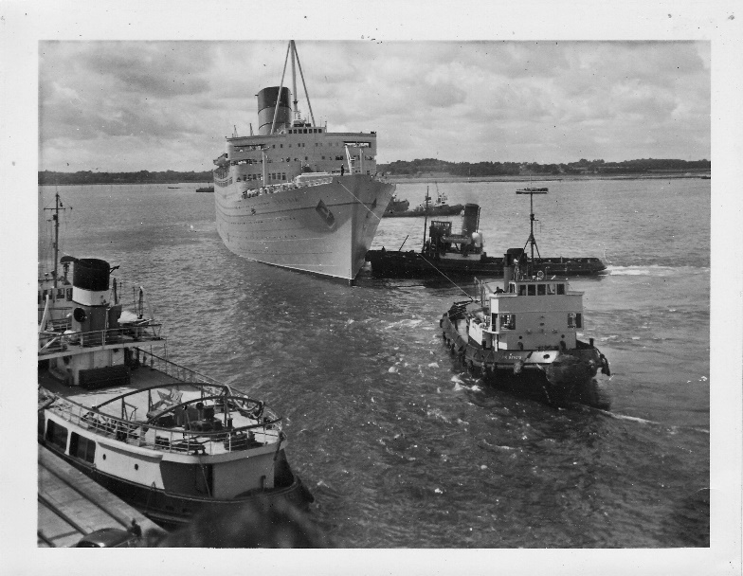

The Caronia came up the Test under tow chaperoned by busy, fussy tugs in the afternoon and what a sight she was. She looked stunning in a truly lovely shade of green and with a huge single funnel she was every inch an oversized gentlemans’ yacht. It was, however, claimed that the huge funnel could be a bit of a problem in strong crosswinds! When you look at the sweeping lines and raked bow it makes the modern cruise liners look like cargo vessels the stacked containers simply having windows punched in them. Some say the new ships are simply huge floating blocks of flats but that is being a tad rude about blocks of flats. I have to say I could well understand, even at that age, why my dad had wanted to see her. Truth be told she is probably the most under-rated ship ever built and as far as the very rich and famous were concerned the most popular. It is reported a few very wealthy souls actually lived aboard all year round at some cost so friendly and accommodating were her crew. When cruising they would put up a sign above the gangplank simply saying ‘Welcome Home’, now that’s thoughtfulness for you. We watched awestruck as a tug gently nudged her alongside, most professional my brother and I thought.

The Caronia was built for Cunard White Star at John Brown’s Shipyard on Clydebank in Glasgow and launched in 1947 and her maiden voyage to New York departed from Southampton in January 1949. At 34,183 tons she was the first ship to be purpose built as both a Trans-Atlantic liner and a cruise ship with mixed first and second class cabins that could be converted to all first for the top of the range cruises. With an almost one to one passenger crew ratio she offered the highest standards of any ship in service. She had bathroom and shower facilities in every cabin (including fresh water), air conditioning throughout and the first outdoor swimming pool. During the time she was operated by Cunard she developed an enviable reputation for quality and luxury travel and only in her final years did she fail to return a profit. It wasn’t for nothing that she became known world-wide as ‘The Millionaires Yacht’. In the first couple of years she operated mainly on the Atlantic Service but back in 1951 she completed a World Cruise lasting 111 days, covering 32,000 miles and visiting 35 ports which cost between $3400 to $30,000 depending on your cabin. Perhaps her most notable cruise was the 37 day Coronation Cruise of 1953. It was marketed as "a truly once-in-a-lifetime European holiday, arriving in England just in time for the pageantry of Coronation and the celebration of the Queen’s birthday, including preferred seats for the Coronation Procession" and to ensure only the well rich would be aboard suites for this special voyage were a very handsome $12,000 (all fares on her were quoted in dollars). By 1960s things were changing and despite a refit in 1965, with dwindling passenger numbers and the arrival of the more modern and cost-effective cruise ships, not helped by a depression along with dock and seaman strikes,

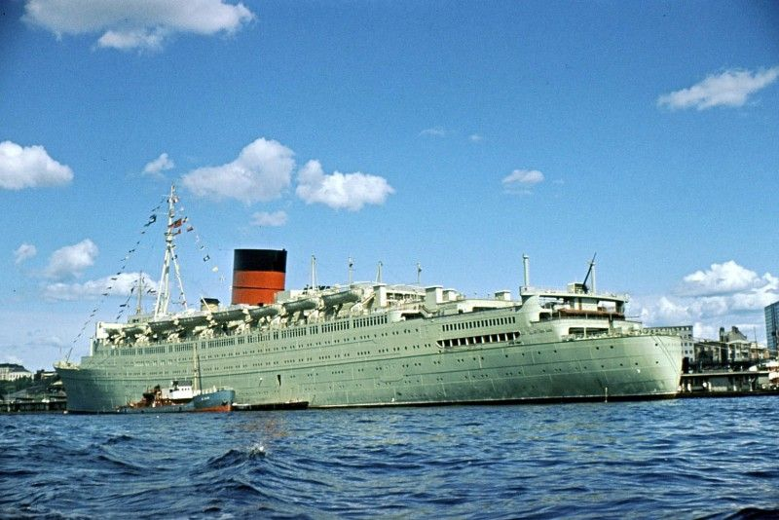

Cunard withdrew her and the Queen Mary from service in 1967. Her last voyage under the Cunard flag was, most appropriately, from New York to Southampton on 24th November 1967 docking at Berth 101 where the crew of 600 stood down.

Following her retirement, after her return to Southampton, after a number of potential sales, including one to the Swedish Government to be used as a temporary office whilst the new Parliament building was being constructed she was eventually sold, complete with all her fittings, to Star Shipping in 1968, renamed SS Columbia and went to Greece for a somewhat dubious refit during which Andrew Konstaninidis took control of Star Line and renamed her SS Caribia, re-painted her white and formed Universal Cruise Lines to operate her as a Caribbean cruise ship sailing under the Panamanian flag. On 14th February 1969 the Caribia’s maiden cruise departed six days late and on her return on the morning of the 28th February, 400 of the 500 passengers petitioned the company complaining about ‘inadequate service, inadequate food, improperly functioning equipment and generally unsatisfactory conditions’. Unbelievably that afternoon 325 passengers embarked for her next cruise. Tragically five days into the cruise an explosion in the generator room killed one crew member and seriously scalded another. The accident resulted in the total loss of electrical power to the ship. After drifting for some 20 hours temporary repairs were successfully completed and steam was finally raised allowing her to head slowly back to New York.
Back in New York all further cruises were cancelled and legal battles raged in the form of lawsuits and claims against the cruise promoters and operators. Konstaninidis stated that he would restore the ship to operate a regular New York to the Bahamas service but there was no money available to repair her, a figure that quickly rose to an estimated $2m. Eventually, still moored in New York and now sporting a parking ticket, she was reluctantly sold to a Taiwanese ship breakers for scrap and on 27th April 1974 she departed from the Bush Terminal in Brooklyn, towed out by the German ocean-going tug ‘Hamburg’ behind a 1,500 yard five and a half inch steel cable. The cable itself connected to the tug by a short heavy nylon hawser allowing it to be cut free if needed, something that eventually proved a blessing. The planned 100 day voyage went well and after passing through the Panama Canal Captain Spannhake, a very experienced tug captain, headed for Hawaii and a planned refuelling stop. En-route one of the Hamburg’s engines broke down but eventually they made it into Honolulu and repairs were made. Setting sail from Hawaii they ran into further trouble when one of the turbo-chargers on the starboard engine packed up considerably reducing power. As if this wasn’t enough, now running well behind schedule, they ran headlong into Typhoon Mary as they approached Guam. Captain Spannhake called Apra Harbour requesting assistance but the strong winds that were now gusting to 45 knots and a very heavy swell meant that the Navy and Coast Guard tugs were unable to leave the harbour in time. By now they were in a position to attempt a dash for the entrance but the strong winds and current were pushing both vessels towards the Glass breakwater, The Hamburg swung astern and attempted to prevent the Caribia from going aground but the reduced power from the engines and the sea, now running with 40 foot waves, defeated her and 800 yards out from the breakwater the towline was cut.
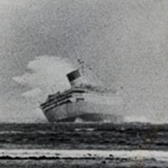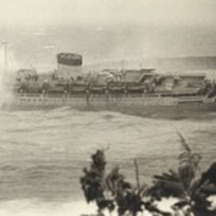

The Hamburg immediately swung out to avoid going aground on Orote Point opposite leaving the once majestic Caronia on her own and she ran into the breakwater just before nine o’clock in the morning. The Coastguard managed to get the three crewmen off and by early afternoon the continual battering by the strong sea took its toll on her hull and she broke apart leaving only the bow section on the rocks the rest sliding into the harbour entrance.
It was four days before scanning equipment could be used to find out exactly where the rest of the ship lay and the harbour entrance could be safely re-opened. Hamburg’s owner’s were ordered to post a bond of $3m dollars pending a $4m dollar claim by the US Government for salvage and damages. The legacy of the Caribia wasn’t quite over yet. During the salvage work Navy divers came across an old landing craft right next to the wreck still containing 50 tons of explosives. It took the Explosive Ordinance Division 952 dives totalling 388 hours to clear it before work could continue. Despite warnings and ‘prohibited’ signs going up local divers helped themselves to just about anything that could be unscrewed especially the portholes which now apparently grace many a home on the island! Finally in 1975 the Nippon Salvage Company from Japan were contracted to clear her for scrap achieved by cutting the entire ship into 400 ton sections, a job that was completed in 1977.
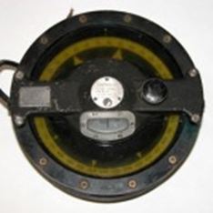
The project was managed by the US Army Corps’ of Engineers, Pacific Ocean Division (POD) and as a memento of the largest salvage operation ever undertaken by the Corps, the Caribia’s compass was presented to them and is now in the Corps’ Museum collection housed in the Office of History. In some ways it was a good way for her to go and one of these days we’ll stop off in Guam and go and have a look through one of her portholes.
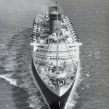
The Queen Elizabeth made her last crossing of the Atlantic in 1968 having carried 2,300,000 passengers and sailed a total of 3,472,675 miles. She was originally sold to a group of Philidelphia businessmen with the intention of setting her up in the Everglades as a hotel and tourist attraction but after losing money and being declared a fire hazard she was sold by auction to Hong Kong tycoon C. Y. Tung who planned to use her as a combined cruise ship and floating University. Her engines and six of her 12 boilers were made operational and she attempted to sail to Hong Kong Harbour but ended up having to summon help when she got down to only three working boilers and a fire broke out in number 4 Boiler Room. She was towed to the island of Aruba off the Venezualan coast where more boiler tubes were fitted and she finally got away making Hong Kong Harbour where she underwent a £5m major refit which included refurbishing all the boilers and overhauling the engines and meeting all the latest fire regulations. All that was left to do was to dry-dock her and she would be ready for service. It seemed there would be a happy ending after all but on the 9th January 1972, just before the work was completed, she mysteriously caught fire, burnt out and finally capsized, mainly the result of the thousands of gallons of water pumped into her in the attempt to put the fires out.
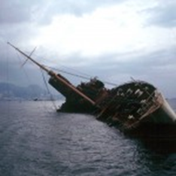

Various theories have been put forward to explain the incident including an insurance scam and a dispute between Tung, who was a Chinese Nationalist, and the Communist-dominated ship construction unions but whatever happened she was broken up where she lay and the remains blown up. Contrary to myth and legend a fair amount of her remains still lay under the mud in Hong Kong Harbour just off Container Terminal 9. The Southampton Ocean Terminal we visited was demolished in 1983 but, like the Caronia and Queen Elizabeth, not without a struggle. It turns out that the contractor employed to demolish the behemoth managed to destroy his crane when the wrecking ball bounced off the concrete wall and smashed into it effectively putting him out of business. Three out of three then
Just in case you don’t think we can link this up to balloons, some years back I flew the Unipart Oil Can from the Southampton Balloon Festival that used to be held on Southampton Common. It was a morning flight and I flew solo for some reason. The lower winds were generally northerly light and variable with the upper wind having a fair smattering of east in it. Keeping low it was apparent that I could get over the docks, maybe land there and if not then, with a bit of luck, climbing would take me across the Test and up towards Totton and Ashurst on the edge of the New Forest. I had always wanted to see them from the air and this could be the day. All went better than expected and I dropped down literally just to the east of the Royal Pier, I would have liked to have sailed down the Ocean Dock but it wasn’t to be. Still heading south, now very low down, as I came out into the Test the mighty Oilcan turned left and started heading for Southampton Water. This was just brilliant but I had to keep just above the water, more than ten foot up and I was back crossing the river. I was so busy keeping the thing low and being famous waving to some fishermen on the Town Pier that I sort of forgot where I was. Suddenly it seemed I was looking down the Ocean Dock. This was quite the most amazing thing and there wasn’t a soul about. It was huge and somehow, in my mind, a bit dark and foreboding but the water had the faintest of ripples across it and almost sparkled. I did some serious smiling. Unfortunately, there weren’t any ships in but to be honest I could see the Queen Elizabeth’s stern, a sliver of smoke rising from a funnel. All was good. Whilst I was busy looking up at the enormous quays and down the Dock realisation dawned that I was going completely the wrong way but looking back up the Test I could see balloons apparently over Totton so I reasoned all should be good. Now I was gently paralleling the South Dock and closing on the mouth of the Itchen, time to go up. Now I was looking down on the Docks complex and heading away from my possible trip down Southampton Water. There is no way I would ever have seen the Ocean Dock from that perspective unless it was in a canoe. I eventually ended up somewhere south of Marchwood where a very nice farmer who gave us some goose eggs. Now if I’d had a camera!!!!

Ed’s note : The withdrawal of “CARONIA” was not unexpected to those working aboard. She was constructed immediately after the war and many of the materials used were said to be of a poor standard reflecting the availability at the time. Her plumbing and electrical wiring were constantly failing and causing problems towards the end of her career – a sure death knell for any ship.

NEWS FROM THE LIBRARY AND ARCHIVE COLLECTION.
The Trust has been favoured with four recent notable donations.
The family of the late Mr. G. Williams have generously donated a very large collection of books that were delivered on a pallet via a courier from Lancashire. Only a chance encounter with a mutual friend led the Trust to receive this wonderful donation. Mr. Williams was a life-long shipping enthusiast who had accumulated a very large collection of many rare and interesting titles. His family were seeking an appreciative home for the collection and the Trust’s name was mentioned.
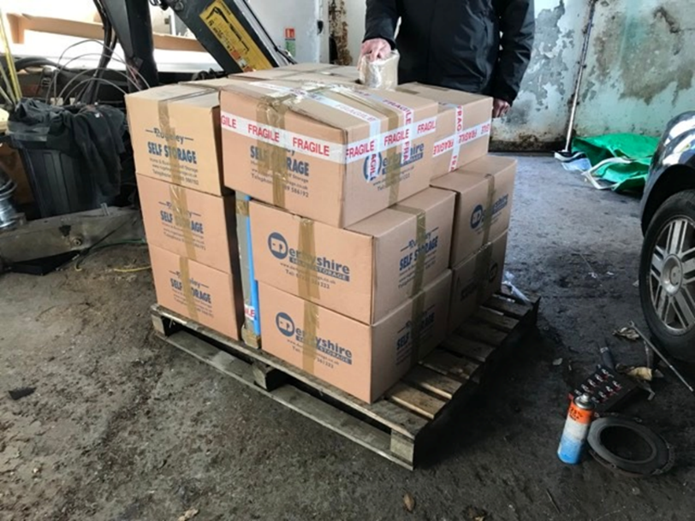

We have received a wonderful ‘fun’ model of an American river steamboat courtesy of Betty from Christchurch.
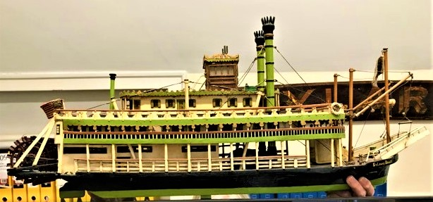

The Trust are indebted to the Commodore and crew of the Royal Motor Yacht Club for donating the splendid chart table and remarkable collection of historic charts from around the world.
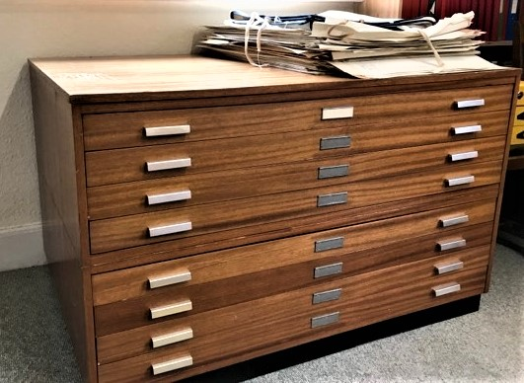

Finally, very many thanks to Sheffield resident, Jim Chisholm, who posted the large parcel
of historic maritime ephemera.

CORDITE FACTORY MODEL
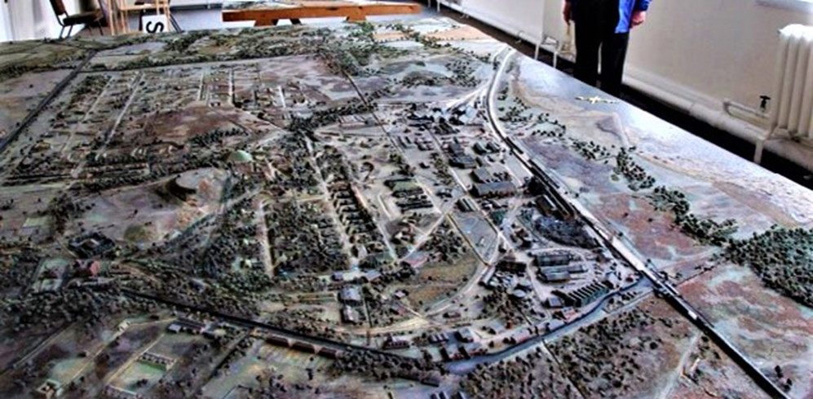
The Trust have been fortunate in securing the remarkable model of the Royal Naval Cordite Factory at Holton Heath. The model was constructed, accurate in every detail, during the Second World War. It acted as an instant guide to all aspects of the site and, in the event of an emergency, escape routes and isolation plans could be readily identified. As may be seen from the image, above, the model is very large and breaks down into manageable sized sections.

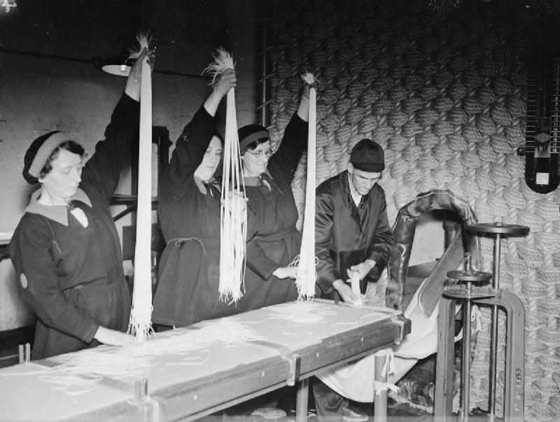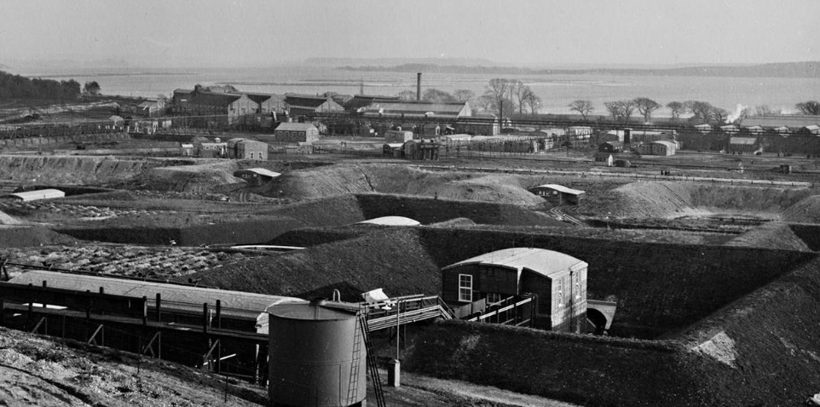
Storage has proved an issue. However, thanks to the generosity of an anonymous doner the Trust have been afforded some dry and clean storage facilities off-site. Jack Hawkins and Peter Burt have duly installed the shelving (below) that will suffice until a more permanent location with public access can be acquired.

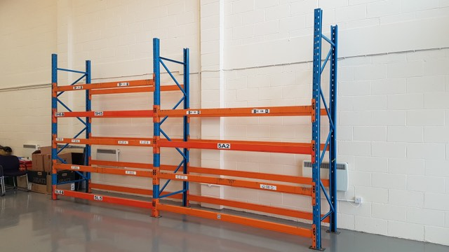

Storage facilities at Canford Cliffs library have been, much improved, thanks to efforts, again, of Jack and Peter enabling far more material to be displayed. The library collection passed the remarkable 2,600 titles milestone a couple of weeks ago. The library is open to all. Members may borrow books at no charge and non-members and visitors can use the facility and are invited to make a modest donation. Only members may take publications from the premises.

THE REVIVAL OF A RAILWAY LINK TO POOLE DOCK ESTATE ?
During April work began clearing the disused and overgrown Hamworthy branch line, and it is reported that some railway sleepers are to be renewed. It is believed that Cemex wish to send out aggregates from its port facility by train, instead of by lorry. The track which is the responsibility of PHC within the port area was covered over a few years ago to create a new roadway and storage area.
(Kevin Mitchell)

BOLSON’S PLEASURE BOAT “MATAPAN”
Always a favourite with passengers and fondly remembered by many,the converted World War ll Fairmile launch “MATAPAN” was acquired by Bolsons in 1952. She underwent a series of layout changes throughout her long career. In 1952 “MATAPAN” had no funnel but trim otherwise as in the picture (with the company founder’s initials, JB, on the funnel). The funnel was fitted c 1953/4 and the seating moved forward to the bow. In 1958, following the reformation of the company, JB replaced by C on the funnel. The breached Boscombe Pier, seen in the background, was rebuilt in 1960.
By 1962 the Man Overboard Boat had moved to midships, the aft mast, and additional aft belting had been removed, and a new bridge windscreen had been added.
As such this image can be dated earliest 1954 latest 1957.(With thanks to Bolson historian Chris Wood).
In the 1950’s “MATAPAN” and her near sister “DUNKIRK” primarily operated cruises from Bolson’s East Beach jetty at Bournemouth ‘Through The Dorset Lakes’. A magical sounding cruise amid the islands and glorious Poole Harbour scenery. With the changing holiday scene and the demise of the paddle steamers, “MATAPAN” then renamed “POOLE BELLE” (2) alternated with one of her fleet-mates on the Bournemouth – Swanage ferry service. She survived until the end of the glorious summer of 1976.
Her memory lives on with her nameboard gracing the Poole Maritime Trust office wall at Canford Cl
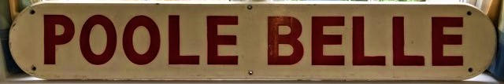
PORT UPDATE by Kevin Mitchell
During March Condor Voyager took over Channel Islands sailings from Condor Liberation for a couple of weeks. Condor Ferries’ relief freight ferry Arrow arrived on 3rd April for lay-up on the New Quay Extension.
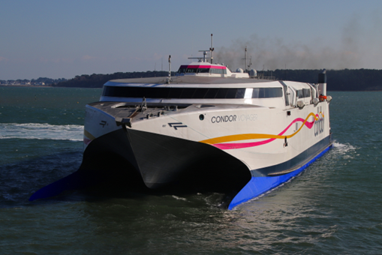

On charter from the Isle of Man Steam Packet, Arrow had been operating between Portsmouth and the Channel Islands.
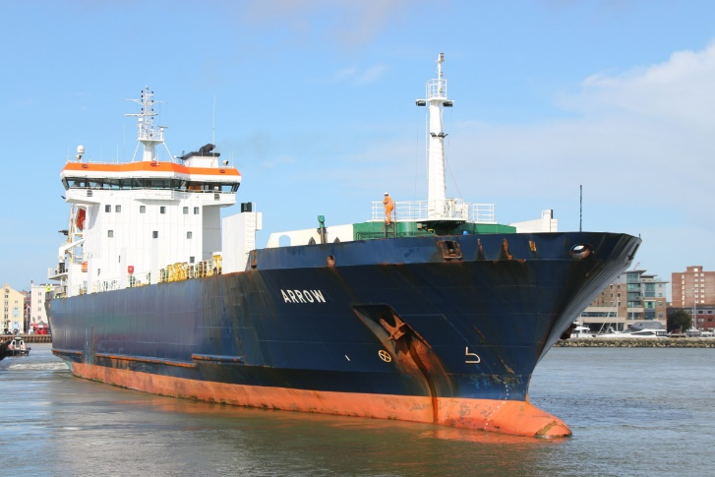
She made further short visits over the coming weeks, finally sailing from Poole back to her homeport of Douglas on 20th April. The Barfleur made a welcome return to Poole on the morning of 13th April, just missing the 30 year anniversary since her maiden arrival when she was brand new for Truckline Ferries on 4th April 1992. Barfleur sailed back to Cherbourg at her regular time of 08.30, leaving the berth with two long horn blasts followed by another, longer, one as she passed The Haven and the Sandbanks ferry.
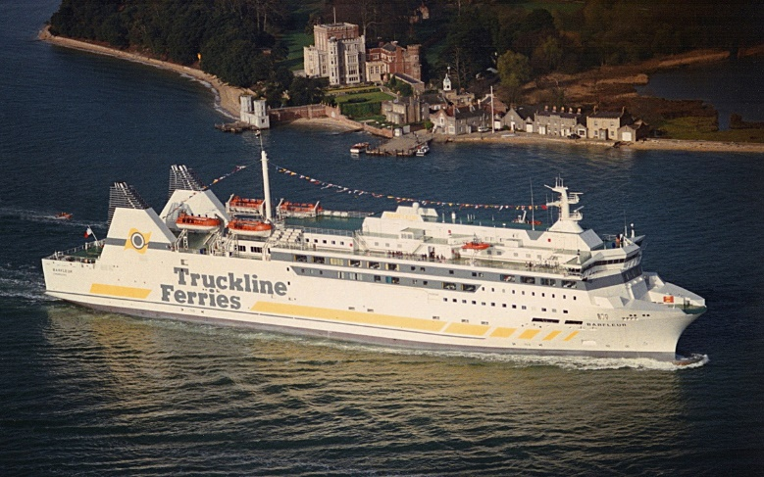
On 8th March Deo Volente was due into Poole from the Spanish port of Alcudia to unload yachts, but was refused permission to enter port as some of its cargo was suspected to be Russian owned.
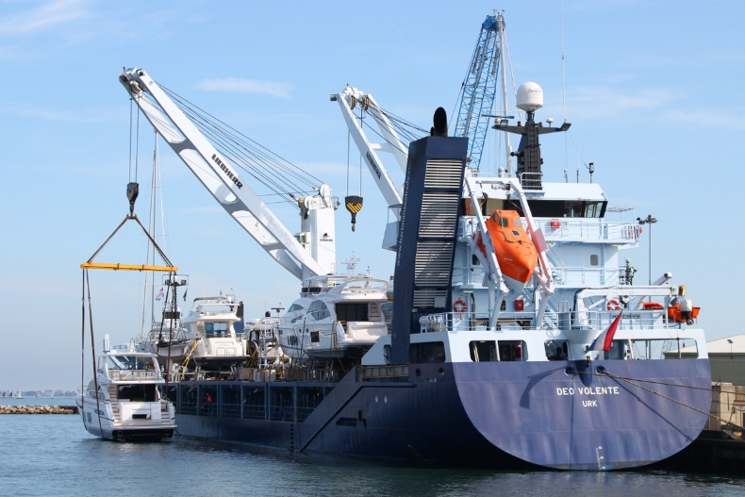

Deo Volente instead headed towards Portsmouth, where it was also denied a berth, so carried on to Cuxhaven in Germany. On 14th March the Starclass Yacht Transport ship Eemslift Hendrika berthed at Poole, having sailed from the French port of Ouistreham.
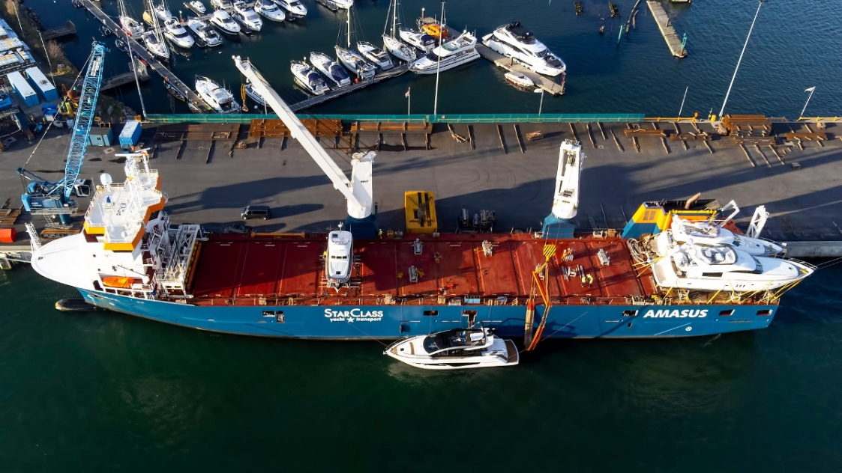

She made the headlines last year after encountering difficulties in heavy seas off Norway, during which some of her cargo was lost overboard. The crew were rescued and the abandoned ship was taken in tow, and thankfully returned to service. This photo of Eemslift Hendrika alongside South Quay on 14th March was taken by Darryl Morrell. She sailed to Malaga the next day.
On 2nd April City Cruises’ Fortuna entered service for the first time from Poole, she will join sister vessel Solent Scene on the Poole to Swanage run. On 6th April the company added another boat to the Poole fleet with the delivery of Purbeck Pride, pictured here on crew training that day. Purbeck Pride was surplus to requirements as Greenslade’s Pleasure Boats were not awarded the contract to run to Brownsea Island this year, Brownsea Island Ferries being the successful bidder.
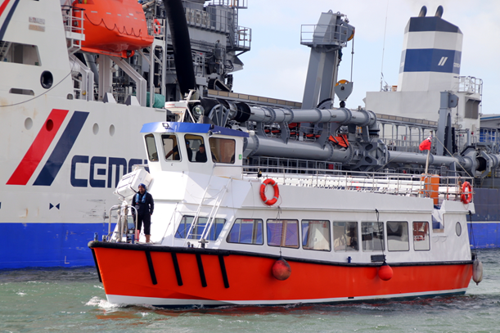

The Solent Cat arrived at Poole from Cowes on 28th April for another summer charter by City Cruises. On 3rd April Dorset Cruises’ Dorset Queen made its first trip in two years thanks to Covid from Poole Quay along the River Frome to Wareham.

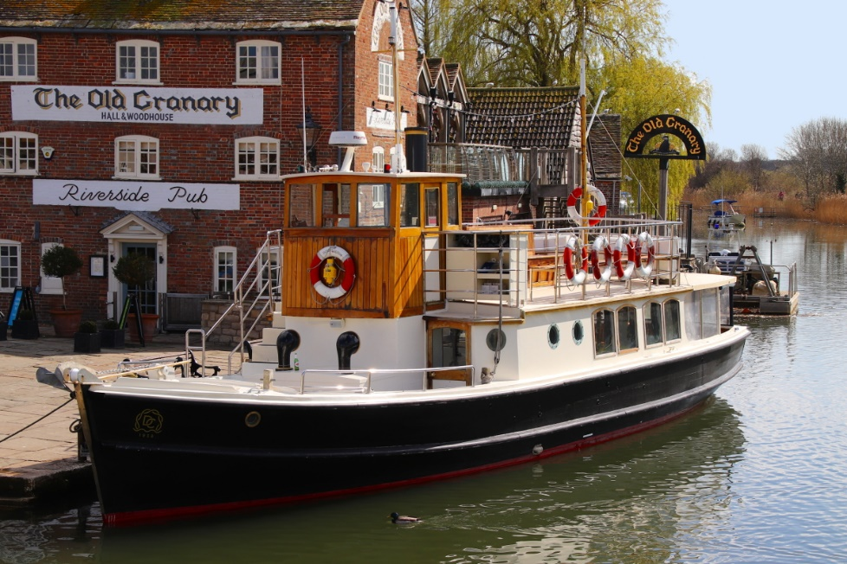
She is pictured here alongside the quay at Wareham that day. This Dunkirk Little Ship of 1938 vintage has been repainted this year with a black hull and gold detailing. Finally, the Dorset Belle resumed trips from Bournemouth Pier also during April.
The German vessel Deutschland became the first cruise ship to visit this year when she arrived from Dover on the morning of 26th April.
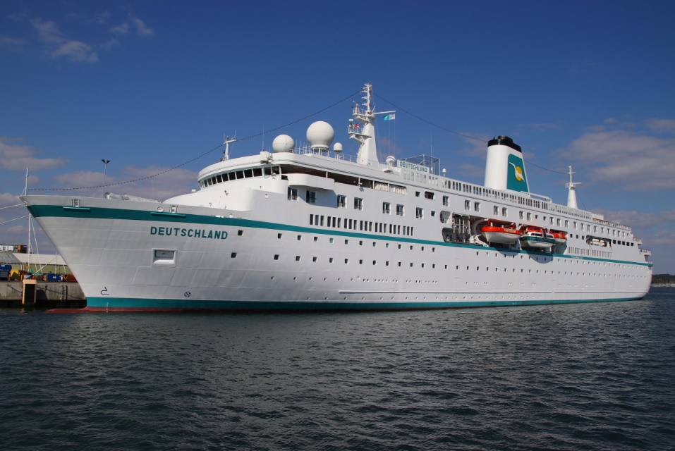
This was also her maiden call at Poole, the captain being presented with the traditional plaque by the Harbour Master. The Deutschland is a fine, traditional looking ship but was in fact built as recently as 1998. She sailed that evening for the French port of Rouen,giving a long whistle blast as she passed The Haven, which was answered by the Sandbanks chain ferry. Fleet mate Amadea is due at Poole in June.
POOLE MARITIME TRUST
FUTURE OUTINGS AND SUMMER ACTIVITIES
Full details to be circulated shortly.
PHOTOGRAPHIC COMPETITION – OPEN TO ALL

MEMBERS EVENING VISITING BROWNSEA CASTLE WITH DRINKS AND CANAPE ON THE TERRACE.

A VISIT TO PORTSMOUTH DOCKYARD WITH A GUIDED TOUR OF H.M.S. WARRIOR AND THE MARY ROSE.

BOAT AND STEAM RAILWAY TRIP TO SWANAGE AND CORFE CASTLE.

THE DORSET BRANCH OF THE WORLD SHIP SOCIETY
The Dorset Branch of the World Ship Society meets on the second Saturday afternoon of the month between September and May at The Centre – Ferndown in East Dorset, 2.15pm for a 2.30pm start. Following our success using Zoom in 2020/21, all meetings are now “hybrid” sharing our Dorset venue event with a wider member community via Zoom and giving local members the choice between getting together or enjoying the meeting at home. Our nine meetings per year have been widely acknowledged as informative and well presented, attracting popular and respected speakers from the local, national and international ships, shipping and maritime history scene. Visitors to our branch are always welcome ~ in person or via Zoom ~ please get in touch. Initial invitations come with no obligation and we hope you enjoy the afternoon.For details of our future events programme please see www.shipsdorset.org/events … and do contact us. Hybrid meetings now allow us to welcome you wherever you are in the world! Email us via info@shipsdorset.org or to find out more see www.shipsdorset.org
WSS DORSET 2022 MEETING PROGRAMME
May 14th 2022 ~ 154 Days aboard 4 Post-War Liners ~ with Steve Pink
Nevasa, Edinburgh Castle, Pendennis Castle & Reina del Mar … ship facts, brochure graphics, images & stories.
~ ~ ~
September 10th 2022 ~ Ocean Liner Extraordinaire: The Fabulous Normandie ~ with Bill Miller ~
She was "floating Ginger Rogers" ... pure Art Deco, top heavy with glamour & the finest Atlantic liner ever ... she was triumph, innovation, notation, but the victim of a far too short life at sea.
~ ~ ~
October 8th 2022 ~ Thirty Days of September ~ with Krispen Atkinson ~
Images and commentary recalling Krispen's busiest ship spotting month ever, travelling through Europe and a visit to Singapore.
~ ~ ~
November 12th 2022 ~ ss Rotterdam of 1959 - My favourite ship of all time ~ with David Trevor-Jones ~
Recalling the heyday of Holland America’s Rotterdam (V) and her ongoing life as cruise ship, hotel and city attraction.
~ ~ ~
December 10th 2022 ~ Port of Rotterdam 2018 Panorama ~ with Neil Davidson ~
A private cruise around Europe's largest port - and a look at a vibrant city.

IT IS WITH GREAT REGRET WE ADVISE YOU OF LONG STANDING POOLE MARITIME TRUST MEMBER BRENDA DYER’S PASSING.
BRENDA’S LATE HUSBAND NORMAN WAS PREVIUSLY COMMODORE OF THE ROYAL MOTOR YACHT CLUB.
OUR CONDOLENSCES GO OUT TO HER FAMILY AT THIS SAD TIME.

POOLE MARITIME TRUST
First Floor
Canford Cliffs Library
6 Western Road
Canford Cliffs
Poole BH13 7BN

Tel : 01202-706673 e-mail : poolemaritimetrust@aol.com

WWW.poolemaritimetrust.org

JOIN OUR FACEBOOK GROUP AND BE KEPT UP TO DATE WITH ALL THAT TAKES PLACE IN AND AROUND POOLE HARBOUR

